

BANK OF ISRAEL

Office of the Spokesperson and Economic Information

December 25, 2024

Press Release:

# The public's financial assets portfolio in the third quarter of 2024

* **In the third quarter of 2024, the balance of the public’s financial assets portfolio increased by approximately NIS 221.7 billion (3.9 percent), to about NIS 6 trillion.**
* **The increase in the portfolio’s value in the third quarter was mainly due to increases in the balance of equities in Israel (10.5 percent), and in the balance of corporate bonds(5 percent).**
* **The balance of the asset portfolio managed by institutional investors increased in the third quarter by approximately NIS 114 billion (4.3 percent), to NIS 2.77 trillion at the end of the quarter.**
* **Institutional investors’ rate of exposure to foreign assets declined by about 0.3 percentage points to approximately 46.7 percent, and their rate of exposure to foreign currency increased by about 0.5 percentage points to about 24.1 percent at the end of the quarter.**
* **The value of the portfolio managed by mutual funds in Israel increased by approximately NIS 39.6 billion (7.6 percent) in the third quarter, to NIS 557.8 billion. There were net new investments, mainly in funds specializing in foreign equities and in shekel money market funds.**

# 1. The public’s total assets portfolio

**In the third quarter of 2024,** the balance of the public’s financial assets portfolio increased by approximately NIS 221.7 billion (3.9 percent), to about NIS 6 trillion (Figure 1). The weight of the public’s financial assets portfolio relative to GDP increased by approximately 7.6 percentage points, to about 306 percent at the end of the quarter, as a result of an increase in the asset portfolio that was 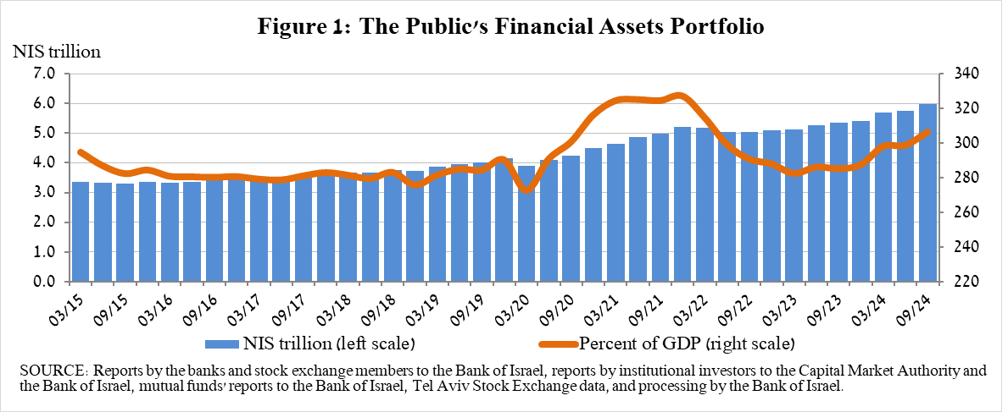greater than that of the GDP.

**2. Analysis of the changes in the overall portfolio**

Over the course of the third quarter, there were increases in the balances of the public’s holdings in all components of the portfolio. The increases in equities in Israel (10.5 percent), other assets (5.6 percent), and corporate bonds (5 percent) were notable.

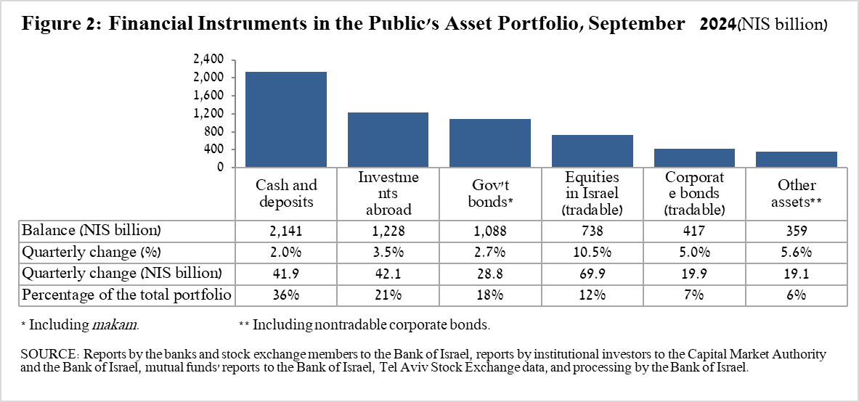

* The balance of **cash and deposits** increased during the third quarter by about NIS 41.9 billion (2 percent) to about NIS 2.14 trillion, which is about 36 percent of the total portfolio.
* The balance of **equities in Israel** increased by about NIS 69.9 billion (10.5 percent), mainly in view of price increases on the equity indices, which were partly offset by net realizations (estimated at about NIS 3.5 billion).
* The balance of **government bonds** (tradable and nontradable) and ***Makam*** increased during the quarter by about NIS 28.8 billion (2.7 percent) to about NIS 1.09 trillion at the end of the quarter. The increase was mainly due to the increase in tradable government bonds (about NIS 26.8 billion), mainly as a result of capital raised.
* The balance of **tradable corporate bonds in Israel** increased by about NIS 19.9 billion, to about NIS 417 billion at the end of the quarter, due to a combination of price increases and net investments (estimated at about NIS 11 billion).

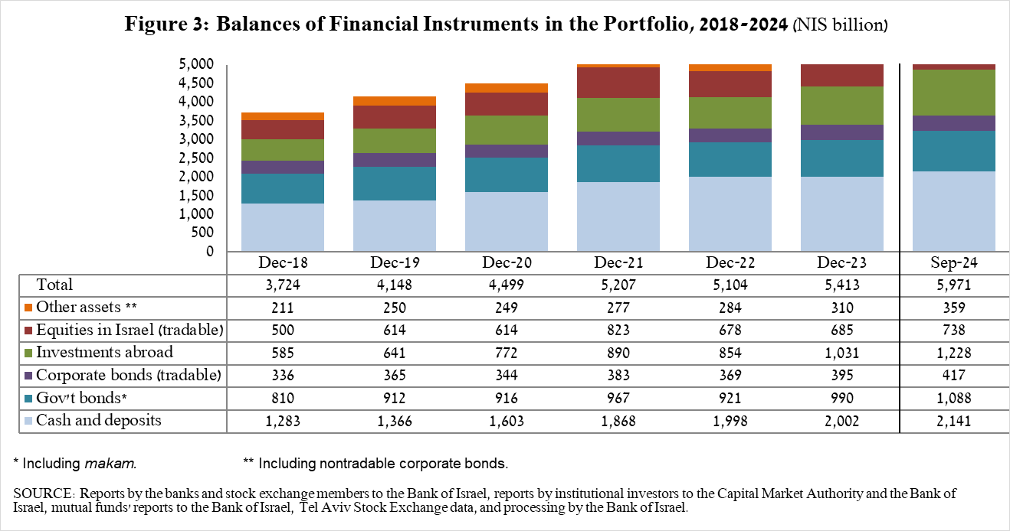

The balance of investments abroad increased by approximately NIS 42 billion (3.5 percent) during the quarter, to NIS 1.23 trillion at the end of the quarter, constituting approximately21 percent of the total asset portfolio. The development in the balance of investments abroad was mainly due to the following components:

* The balance of **equities held abroad** increased by approximately NIS 28 billion (4.2 percent), to about NIS 698 billion. This was mainly the result of price increases and net investments, (estimated to be about NIS 15.8 billion).
* The balance of **tradable (corporate and government) bonds abroad** increased by approximately NIS 7.6 billion (2.8 percent) during the quarter, to about NIS 279.9 billion. This increase was mainly due to price increases, and net investments totaling about NIS 4.3 billion.
* The balance of **investment funds** increased by about NIS 6 billion (2.6 percent) to about NIS 249.3 billion at the end of the quarter.

As a result of the developments during the quarter, there was a decline of about 0.1 percentage points (from 27.7 percent to 27.6 percent) in the share of foreign currency assets.

# 3. The portfolio managed by institutional investors[1]

* **The balance of assets managed by all institutional investors** increased in the third quarter by about NIS 114 billion (4.3 percent), to about NIS 2.77 trillion (approximately 46 percent of the public’s total financial assets portfolio). The increase in the balance was reflected in all institutional investors. The increase in the balance of the managed portfolio during the quarter was mainly due to price increases in the capital markets, and was reflected in the following components: government bonds and *Makam—*an increase of about NIS 39.4 billion (4.7 percent); ETFs abroad that track equity indices—an increase of about NIS 22.3 billion (11 percent), due to a combination of price increases and purchases; equities in Israel—an increase of about NIS 20.6 billion (9.4 percent), mainly in view of price increases; futures contracts abroad—an increase of about NIS 7.8 billion in the balance-sheet balance; and investment funds abroad—an increase of about NIS 6 billion (2.6 percent), while there was a decline equities abroad—about NIS 7.5 billion (4.5 percent) despite price increases.
* **Exposure of the portfolio managed by institutional investors[2] to foreign assets and to foreign currency**

In the third quarter of 2024, the rate of institutional investors’ exposure to assets abroad declined by about 0.3 percentage points, to approximately 46.7 percent of total assets. This was a result of an increase in the balance of institutional investors’ total assets (5.4 percent) that was greater than the increase in exposure to foreign assets (4.7 percent) in dollar terms.

The increase in the balance of exposure to foreign assets (about $15 billion) was mainly due to increases in exposure through futures contracts and options on foreign equity indices (about $6.5 billion) and in the balance of equities abroad (about $5 billion).

**Exposure to foreign currency** -

During the third quarter of 2024, institutional investors made net purchases foreign currency assets totaling about $6.9 billion—purchases of about $3.6 billion in assets denominated in and indexed to foreign currency (mainly ETFs and foreign equities traded in Israel and equities traded abroad, and the sale of bonds), and parallel net purchases of foreign currency via derivative financial instruments totaling about $3.3 billion, meaning a decline in futures transactions to sell foreign currency.

In this quarter, there was an increase in the rate of institutional investors’ exposure to foreign currency (including NIS/forex derivatives) of about 0.5 percentage points to a level of about 24.1 percent.

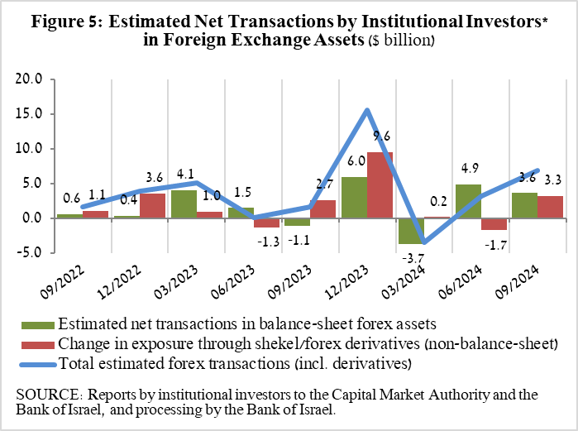

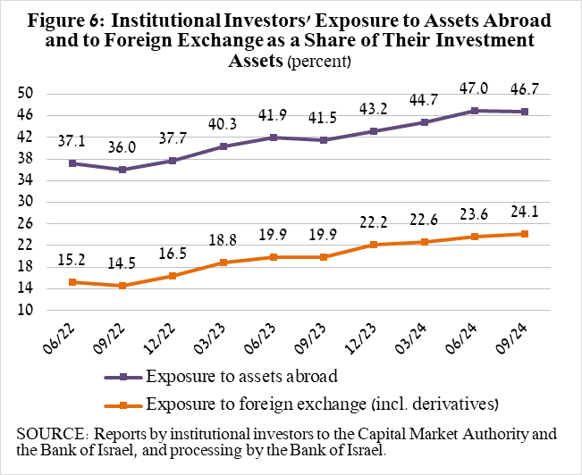

# 4. The portfolio managed by mutual funds

The value of the portfolio managed by Israeli mutual funds increased in the third quarter by approximately NIS 39.6 billion (7.6 percent), to about NIS 557.8 billion at the end of the quarter, constituting about 9.3 percent of the public’s asset portfolio.

The increase in the third quarter was mainly due to net new investment in the funds totaling about NIS 21.2 billion, and price increases. Most of the new investment was in shekel money market funds, totaling approximately NIS 15.3 billion, and in funds specializing in equities abroad, totaling about NIS 4.4 billion, further to the trend since mid-2023.

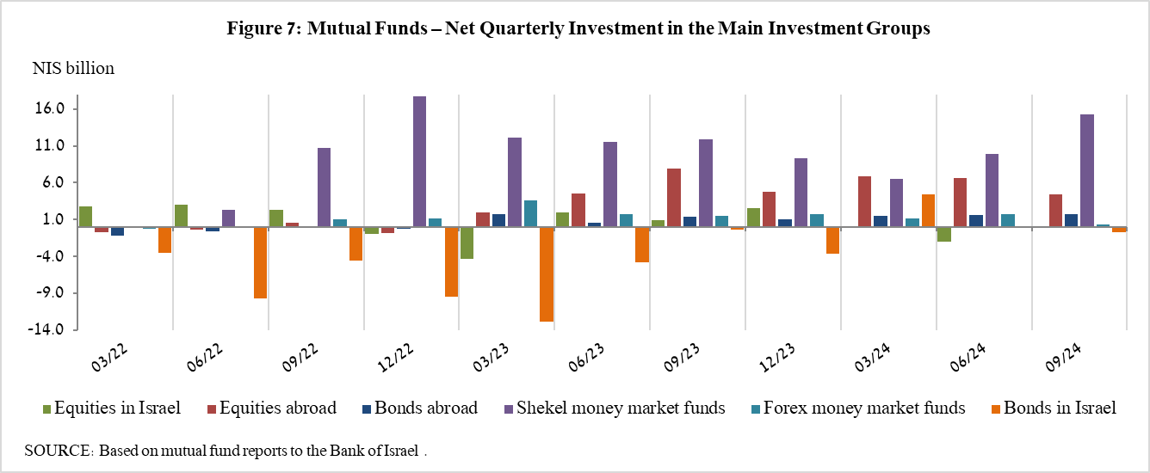

**Further information and details:**

Long-term tables on the asset portfolio are available here.

Long-term tables on institutional investors’ exposure to foreign exchange and to foreign assets are available here.

Long-term tables on mutual funds are available here.

1. Excluding mutual funds.
2. Estimates of members’ exposure (rather than exposure of the institutional investors themselves) to various risks in the portfolio managed for them by the institutional investors (excluding insurance policies with a guaranteed yield, where the risk is taken on by the institutional investors). For additional details on definitions, terms, and explanations, see “Measuring the Exposures of Institutional Investors to Foreign Currency and to Foreign Assets” in the Bank of Israel’s *Statistical Bulletin* for 2016.