

BANK OF ISRAEL

Office of the Spokesperson and Economic Information

June 25, 2024

Press Release:

Debt Developments in the Nonfinancial Private Sector,

First Quarter of 2024

Following is a summary of developments in nonfinancial private sector debt in the first quarter of 2024:

* In the first quarter of 2024, the balance of **nonfinancial private sector** debt renewed an increase, both with regard to the **business sector** and with regard to the **household sector**, by approximately 1.5 percent, following its decline in the preceding quarter in view of the Swords of Iron War. However, the annual growth rate in this balance remained low compared to preceding quarters.
* The balance of **business sector** debt increased by about 1.8 percent (about NIS 23 billion) during the quarter, to about NIS 1.3 trillion. This was mainly due to net debt raised via tradable bonds in Israel as well as bank loans and nonbank loans.
* The spread between yields on corporate bond included in the Tel Bond 60 Index and yields on CPI-indexed government bonds, narrowed this quarter by approximately 0.26 percentage points, and in April–May 2024 it continued to contract, reaching the lowest level in 4 years—about 1.09 percentage points.
* The balance of **household debt** increased during the quarter, by a moderate rate of approximately 0.9 percent (about NIS 7 billion), to about NIS 800 billion, as a result of a moderate increase in the balance of **housing deb.** The increase in the debt balance of households also derived from an increase in the **nonhousing debt** balance originating in an increase in the balance of debt to banks and to credit card companies.

**The nonfinancial business sector’s[1] outstanding debt**

* In the first quarter of 2024, the **balance of business sector debt** renewed its increase, by approximately NIS 23 billion (1.8 percent), to a level of about NIS 1.3 trillion. This followed a decline in it in the previous quarter in view of the Swords of Iron War. However, the slowdown continues in the annual growth rate of this balance, which began in the second half of 2022.
* The increase in the debt balance this quarter derived mostly from net debt raised totaling NIS 19 billion, which was focused on tradable bonds in Israel as well as bank loans and nonbank loans. A depreciation of about 1.5 percent in the shekel vis-à-vis the dollar and an increase of about 0.3 percent in the CPI[2] also contributed to an increase in the value of the foreign currency denominated, foreign currency indexed, and CPI indexed debt; these increases were partly offset by net bond redemptions of tradable bonds abroad (Figure 1).
* These effects led to the annual growth rate of the debt to nonbank lenders increasing to about 3 percent, compared with a rate of near zero in the previous quarter, while the annual growth rate in debt to banks continued to decline in this quarter as well, pursuant to a decline that began in the second half of 2022, but remains positive (about 5 percent). Note as well that over the past 5 years the annual growth rate of debt to banks is higher than the annual growth rate of debt to nonbank lenders (Figure 2).
* In the first quarter of the year, the **business sector** **issued** about NIS 17 billion in bonds, with about two-thirds of them issued in January, higher than the average quarterly issuance of the previous 4 quarters (about NIS 13 billion per quarter). About 53 percent of the issuances in this quarter were carried out by companies in the real estate and construction industry, which continues to lead in bond issuances, similar to previous years (Figure 3).

In April–May 2024 as well, companies from the real estate and construction industry continued to lead in funds raised—about 71 percent of total funds of NIS 6 billion raised in those months, were carried out by them. (Figure 3)

* In the first quarter of 2024, **the spread[3] between yields on corporate bonds that are included in the Tel Bond 60 Index and the yields on CPI-indexed government bonds** narrowed to about 0.26 percentage points to 1.18 percentage points, in April–May 2024 this spread continued to narrow, reaching 1.09 percentage points, and even reached the lowest level in 4 years (Figure 4).

**Table 1: The Composition of Business Sector Debt**



**Figure 1: Estimated Net Quarterly Quantitative Change in Business Sector Debt**

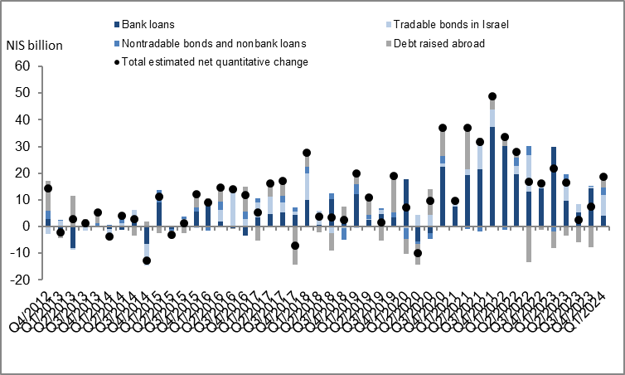

**Figure 2: Rate of Change (Year on Year) in the Business Sector's Bank and Nonbank Debt**

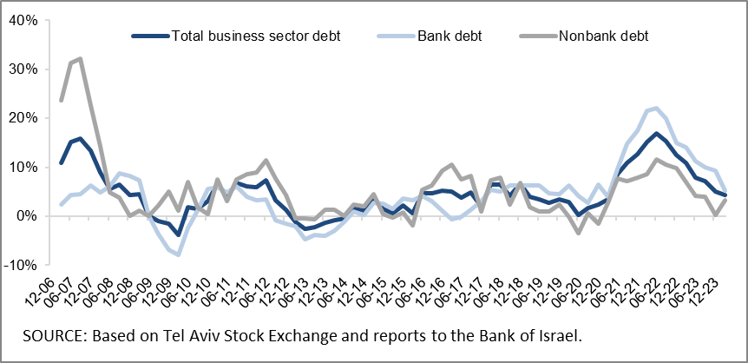

**Figure 3: Nonfinancial Business Sector Bond Issuance during the quarter, by Industry**

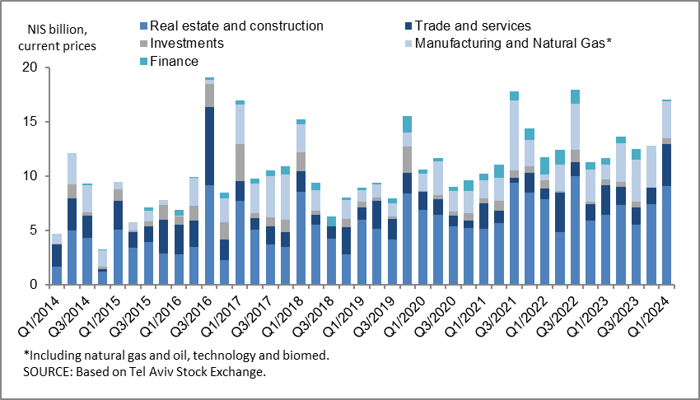

**Figure 4: Spread between Indexed Corporate Bonds (Tel-Bond 60) and Indexed Government Bonds (monthly average)**

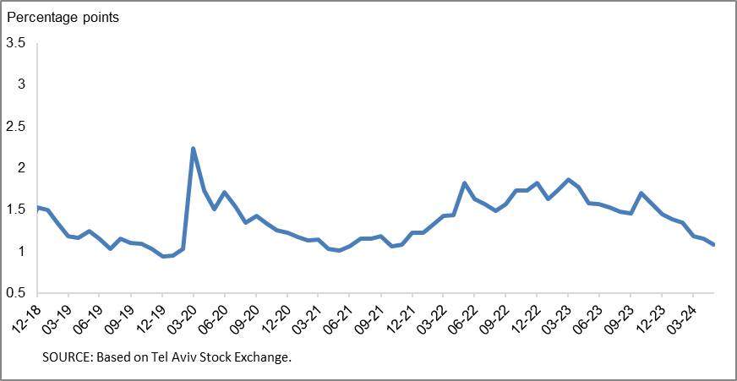

**Household debt**

* In the first quarter of 2024, the **balance of households’ outstanding debt** renewed an increase, by a moderate rate of about 0.9 percent (about NIS 7 billion) after declining in the preceding quarter, and totaled NIS 800 billion.
* The balance of **housing debt** continued to increase during the first quarter, by a moderate rate of about 0.9 percent (about NIS 5 billion), to about NIS 573 billion, mostly to banks. **Nonhousing debt** renewed its increase this quarter at a rate of about 1 percent (about NIS 2 billion) to NIS 227 billion, after a decline due to an increase in the balance of debt to banks and to credit card companies.
* As a result of these effects, the annual growth rate of housing debt continued to slow this quarter as well, to 4 percent, following the trend of decline in it from the end of 2021; while the annual growth rate of nonhousing debt increased slightly but was still negative at about -2 percent (Figure 5).
* The moderation of the increase in housing debt is a result of the slowdown in new mortgage borrowing from the banks. In the first quarter of 2024, after adjusting for seasonal effects, new mortgages taken out totaled about NIS 18 billion, slightly lower than the corresponding period of the previous year (about NIS 19 billion). In April 2024, there was a slight decline, mostly seasonal, in new mortgage volume, and they totaled, seasonally adjusted, NIS 6.2 billion. However, in the following month—May 2024—an increase is apparent in the scope of new mortgages taken out, totaling a seasonally adjusted NIS 7 billion (Figure 6).

**Table 2: Outstanding Debt Balances of Households1**



**Figure 5: Rates of Change in Households’ Housing and Nonhousing Debt, Current Quarter vs. Corresponding Quarter of Previous Year**

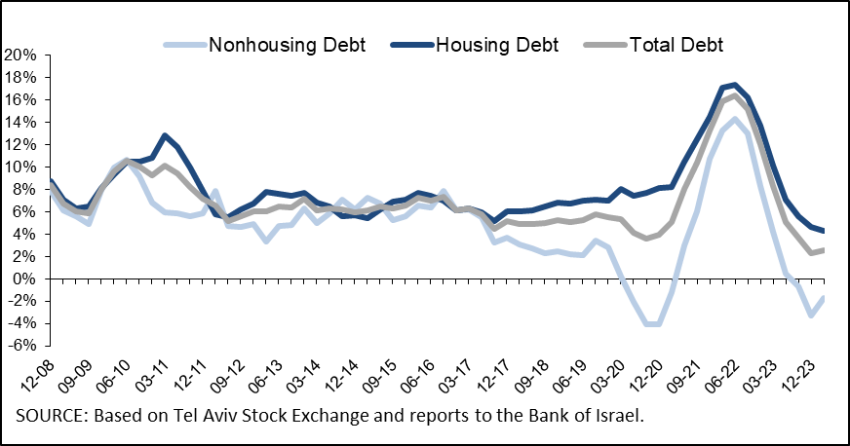

**Figure 6 :Amount of New Home Purchase Loans Provided by Banks to the Public (Mortgages)**

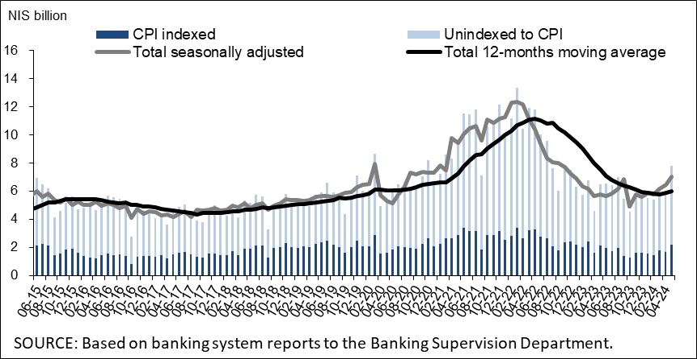

Links to Data and Statistics on the Bank of Israel website:

<https://www.boi.org.il/en/economic-roles/data-and-statistics/money-and-debt-aggregates/debt-and-credit/>

1. Israeli firms, excluding banks, credit card companies, and insurance companies.
2. CPI-indexed balances are calculated in accordance with information known at the time the financial statements are prepared, so that a change in the CPI refers to a change between the known CPI and the CPI in the month preceding that.
3. The change in the spread from one quarter to the next is calculated as the difference between the average spread in the final month of the reviewed quarter and the average spread in the final month of the previous quarter.