

BANK OF ISRAEL

Office of the Spokesperson and Economic Information

June 5, 2025

Press Release:

Foreign Exchange Reserves at the Bank of Israel, May 2025

Israel’s foreign exchange reserves at the end of May 2025 stood at $223,626 million, an increase of $1,591 million from their level at the end of the previous month. The level of the reserves relative to GDP was 40.8% percent (Figure 1).

The increase was mainly the result of a revaluation[1] that increased the reserves by approximately $2,446 million. This increase was partly offset by the government’s foreign exchange activities totaling approximately $855 million.

**Israel's Foreign Exchange Reserves** ($ million)

|  |  |  |  |
| --- | --- | --- | --- |
| **Date** | **Reserves excluding IMF (including reserves bought under the natural gas purchase program)** | **Reserves at the IMF[2]** | **Total Foreign Exchange Reserves** |
| May 2025 | 219,073 | 4,553 | 223,626 |
| April 2025 | 217,489 | 4,546 | 222,035 |
| March 2025 | 214,394c | 4,416 | 218,810c |
| February 2025 | 215,898c | 4,356 | 220,254c |
| January 2025 | 211,710c | 4,358 | 216,068c |
| December 2024 | 210,170c | 4,400c | 214,570c |
| November 2024 | 212,684 | 4,416 | 217,100 |
| October 2024 | 211,638 | 4,436 | 216,074 |
| September 2024 | 215,807 | 4,570 | 220,377 |
| August 2024 | 212,847c | 4,538 | 217,385c |
| July 2024 | 209,141 | 4,493 | 213,634 |
| June 2024 | 205,854c | 4,427 | 210,281c |
| May 2024 | 206,035c | 4,475 | 210,510c |

**Figure 1**

**Level of foreign exchange reserves, and their ratio to GDP, 2007–2025**

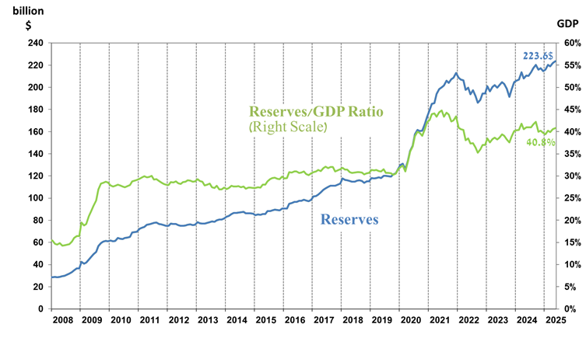

1. a Includes Bank of Israel payments and receipts in foreign currency.
2. b This column includes Special Drawing Rights (SDRs), the balance of NAB loans, and the balance of Israel's reserve tranche at the IMF.

   c Updated after the original date of publication.