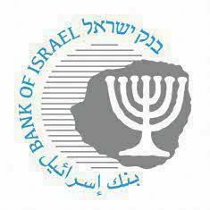

BANK OF ISRAEL

Office of the Spokesperson and Economic Information

July 7, 2021

Press Release:

Foreign Exchange Reserves at the Bank of Israel, June 2021

Israel’s foreign exchange reserves at the end of June 2021 stood at $200,175 million, an increase of $1,825 million from their level at the end of the previous month. The reserves represent 48.8 percent of GDP (Figure 1).

The increase was the result of foreign exchange purchases by the Bank of Israel totaling $3,166 million.

In contrast, the increase was partly offset by:

1. A revaluation[1] that decreased the reserves by approximately $1,057 million.
2. Government transfers to abroad totaling approximately $155 million.
3. Private sector transfers of approximately $129 million.

**Israel's Foreign Exchange Reserves (**$ million)

| **Date** | **Reserves excluding IMF (including reserves bought under the natural gas purchase program)** | **Reserves at the IMF[2]** | **Total Foreign Exchange Reserves** |
| --- | --- | --- | --- |
| June 2020 | 145,499 | 1,838 | 147,337 |
| July 2020 | 155,772c | 1,891 | 157,663c |
| August 2020 | 159,789 | 1,899 | 161,688 |
| September 2020 | 158,700 | 1,884 | 160,584 |
| October 2020 | 158,859c | 1,889 | 160,748c |
| November 2020 | 165,033c | 1,914 | 166,947c |
| December 2020 | 171,242c | 2,055 | 173,297c |
| January 2021 | 177,444c | 2,057 | 179,501c |
| February 2021 | 182,990c | 2,065 | 185,055c |
| March 2021 | 183,664c | 2,016 | 185,680c |
| April 2021 | 191,957c | 2,043 | 194,000c |
| May 2021 | 196,348 | 2,002 | 198,350 |
| June 20121 | 198,192 | 1,983 | 200,175 |

**Figure 1**

**Level of foreign exchange reserves, and their ratio to GDP, 2007–21**

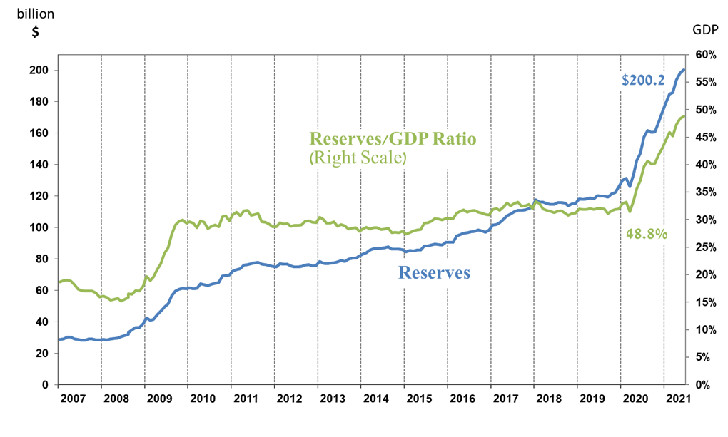

1. a Includes Bank of Israel payments and receipts in foreign currency.
2. b This column includes Special Drawing Rights (SDRs), the balance of NAB loans, and the balance of Israel's reserve tranche at the IMF.

   c Updated after the original date of publication.