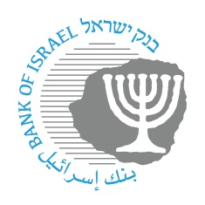

**BANK OF ISRAEL**

Office of the Spokesperson and Economic Information

July 2, 2023

Press Release:

**The Banking Supervision Department extends the length of time during which a bank account may be opened using an Immigrant Certificate**

Many steps are being promoted by the Banking Supervision Department to make things easier for new immigrants from Russia and Ukraine due to the ramifications of the war. Within such framework, the Banking Supervision Department announces that to ease things for immigrants and in order not to delay the process of opening an account for those who have not yet received their ID card, as of June 12, 2023 an extension will be granted for the length of time during which an account may be opened using an immigrant certificate, from 30 days to 90 days.

The extension of the period, from 1 month to 3 months, during which it will be possible to use an immigrant certificate in lieu of an ID card, will be valid through the end of 2023.

This step is in addition to other, published, steps, advanced by the Bank of Israel in order to make things easier for the new immigrants from Russia and Ukraine: <https://www.boi.org.il/en/communication-and-publications/press-releases/07-05-23/>