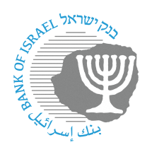
BANK OF ISRAEL
Office of the Spokesperson and Economic Information

August 16, 2023
Press release:

Currency Department Survey, 2020–2022

Bank of Israel Director General Shulamit Geri:
“As part of the Bank of Israel’s function to issue currency and regulate and direct the cash system in Israel, we ensure the availability and accessibility of cash to the public. The Bank of Israel does so alongside its activity to develop and advance other means of payment, both existing and future, so that the public is able to choose among the various means of payment in accordance with its preferences.”

Bank of Israel Currency Department Head Limor Goldstein:
“The Currency Department’s main function is to answer the demand for cash during routine and emergency times, while maintaining the quality of the banknotes and coins in circulation and reinforcing the public’s trust of our currency. The Bank of Israel works to ensure that the public continues to receive high-quality cash services securely and consistently across the country.”

The Bank of Israel today published the Currency Department Survey of its activities from 2020 to 2022. The issues addressed in the Survey include the development of currency circulation during those years; the system’s response to increased demand for cash during the COVID-19 crisis; the launch of a coin of appreciation dedicated to the medical and healthcare system in Israel for their contribution to the lives and health of Israel’s citizens during the COVID-19 crisis; emergency preparedness drills that the Department led to improve the currency system’s preparedness for nationwide emergencies; increasing public awareness and training merchants to identify counterfeit banknotes; trends in cash usage patterns from public opinion surveys; and a broad survey of the variety of services that the Department provided to the public during the reviewed years. An appendix to the Survey presents statistical data on the amount of currency in circulation, divided into banknotes and coins. Further information is available on the Bank of Israel’s website at www.boi.org.il/roles/banknotes.

In 2020, the first year of the COVID-19 crisis, cash circulation increased at a rate not seen since the Global Financial Crisis of 2008–2009. In the following two years, demand moderated but remained higher than in the years preceding the crisis. Overall, circulation increased by NIS about 32 billion (37 percent) from about NIS 87.2 billion at the end of 2019 to about NIS 119.4 billion at the end of 2022. At the beginning of the COVID-19 crisis, the Currency Department took a number of steps to ensure access to, and proper supply of, banknotes and coins to the public in accordance with increased demand. The increased demand for cash during the reviewed three-year period, and particularly during the COVID-19 period, illustrates the importance of cash as an essential national means of payment in Israel during both routine and emergency times, and its role in strengthening the public’s national security.

Development of currency circulation in Israel, 2020–2020 (year end, NIS billion)

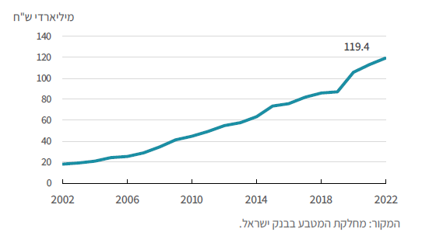

Periodic public opinion surveys conducted both in Israel and abroad examine cash use habits and the public’s perception of cash. The surveys show clear advantages of cash over other means of payment. These advantages include control over expenses, privacy, immediacy, liquidity, and finality of payment. The surveys also show a high desire on the part of the public to continue using cash alongside advanced means of payment.

Rate of the population that views the future use of cash as important
