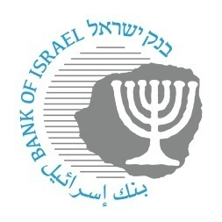

BANK OF ISRAEL

Office of the Spokesperson and Economic Information

November 7, 2023

Press Release:

Foreign Exchange Reserves at the Bank of Israel, October 2023

Israel’s foreign exchange reserves at the end of October 2023 stood at $191,235 million, a decrease of $7,318 million from their level at the end of the previous month. The level of the reserves relative to GDP was 36.8 percent (Figure 1).

The decline was mainly the result of:

1. Foreign exchange sales by the Bank of Israel totaling $8,209 million;[1]
2. A revaluation[2] that decreased the reserves by approximately $1,507 million;

The decrease was partly offset by government transfers from abroad totaling approximately $2,401.

**Israel's Foreign Exchange Reserves** ($ million)

|  |  |  |  |
| --- | --- | --- | --- |
| **Date** | **Reserves excluding IMF (including reserves bought under the natural gas purchase program)** | **Reserves at the IMF[3]** | **Total Foreign Exchange Reserves** |
| October 2023 | 186,675 | 4,560 | 191,235 |
| September 2023 | 194,025 | 4,528d | 198,553d |
| August 2023 | 198,338 | 4,518 | 202,856 |
| July 2023 | 200,086d | 4,579 | 204,665d |
| June 2023 | 197,363d | 4,513 | 201,876d |
| May 2023 | 195,100 | 4,521 | 199,621 |
| April 2023 | 197,390 | 4,505 | 201,895 |
| March 2023 | 195,951d | 4,535 | 200,486d |
| February 2023 | 191,987d | 4,292 | 196,279d |
| January 2023 | 196,460d | 4,525d | 200,985d |
| December 2022 | 189,742d | 4,476d | 194,218d |
| November 2022 | 189,997 | 4,421d | 194,418d |
| October 2022 | 184,531 | 4,311 | 188,842 |

**Figure 1**

**Level of foreign exchange reserves, and their ratio to GDP, 2007–2023**

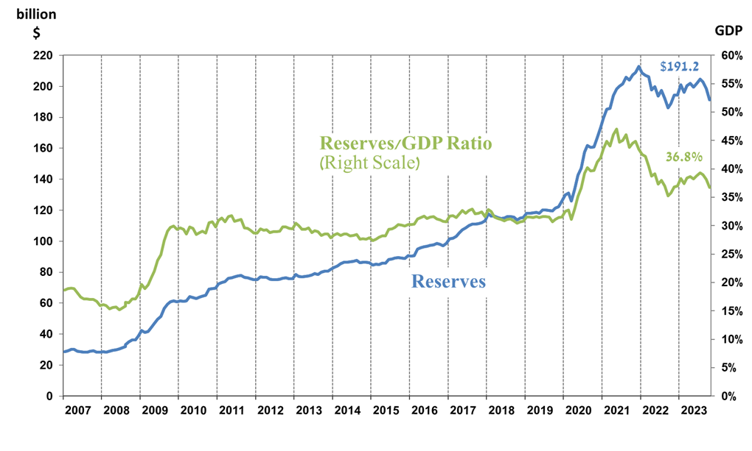

1. Within the framework of the $30 billion foreign exchange sales program that the Bank announced on October 9, 2023: <https://www.boi.org.il/en/communication-and-publications/press-releases/a09-10-23/>
2. b Includes Bank of Israel payments and receipts in foreign currency.
3. c This column includes Special Drawing Rights (SDRs), the balance of NAB loans, and the balance of Israel's reserve tranche at the IMF.

   d Updated after the original date of publication.