

BANK OF ISRAEL

Office of the Spokesperson and Economic Information

March 22, 2023

Press Release:

Israel’s foreign currency market in the fourth quarter of 2022

**1. The Exchange Rate**

**Mixed trend of the shekel alongside weakening of the dollar worldwide.**

During the course of the fourth quarter, there was a mixed trend in the shekel—it strengthened by approximately 0.7 percent against the US dollar, and weakened by approximately 7.7 percent against the euro. In addition, the shekel weakened by 2.7 percent against the currencies of Israel's main trading partners, in terms of the nominal effective exchange rate (i.e., the trade-weighted average shekel exchange rate against those currencies).

In parallel, the dollar weakened against the world’s major currencies (Figure 2)—by 7.8 percent against the euro, by 8.6 percent against the Japanese yen, and by about 7.1 percent against the pound sterling.

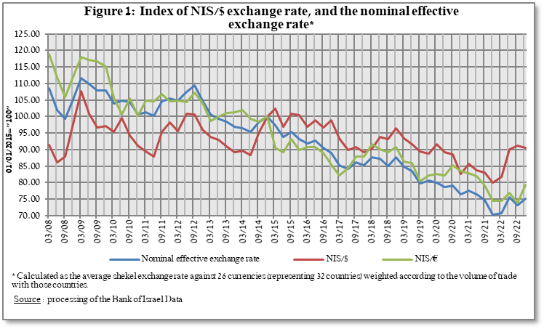

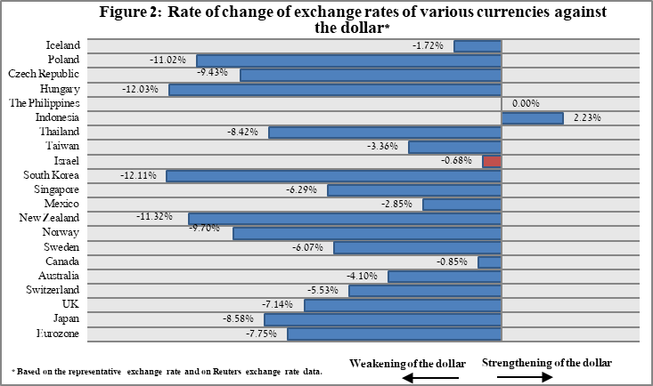

**2. Exchange Rate Volatility**

**An increase in actual volatility and an increase in implied volatility.**

The standard deviation of changes in the shekel/dollar exchange rate, which represents its **actual** volatility, increased during the quarter, to an average level of 12.3 percent.

The average implied volatility in over-the-counter shekel/dollar options, an indication of **expected** exchange rate volatility, increased to about 10.1 percent by the end of the quarter.

For comparison, the average level of implied volatility in foreign exchange options in the emerging markets was 13.7 percent at the end of the quarter, a decrease of 0.7 percentage points from its level at the end of the previous quarter. The average level of implied volatility in the advanced-economy markets was 11.2 percent at during the quarter, an increase of about 0.5 percentage points from the previous quarter (Figure 4).

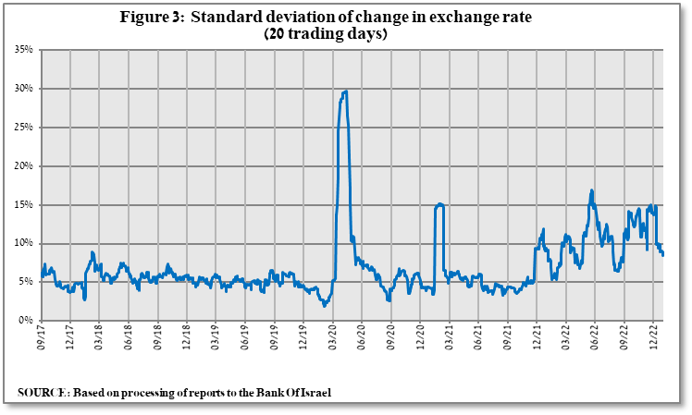

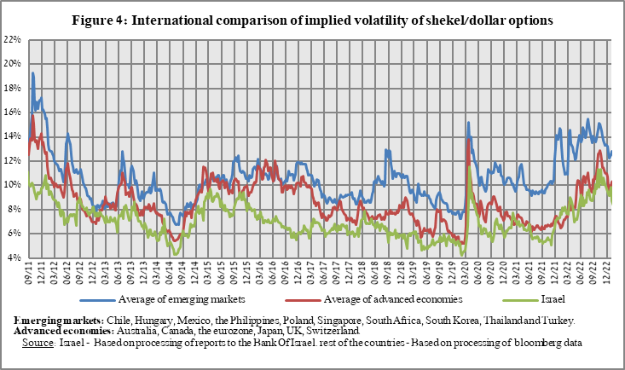

**3. The Activity of the Main Segments in the Foreign Exchange Market[1]**

An estimate of the activity of the **main** segments in the foreign exchange market indicates that during the course of the fourth quarter, **institutional investors (pension funds, provident funds, and insurance companies)** purchased foreign currency totaling about a net of $3.2 billionand **the business sector** purchased about $1 billion in foreign currency. **Nonresidents** sold a net of about $5.1 billion.

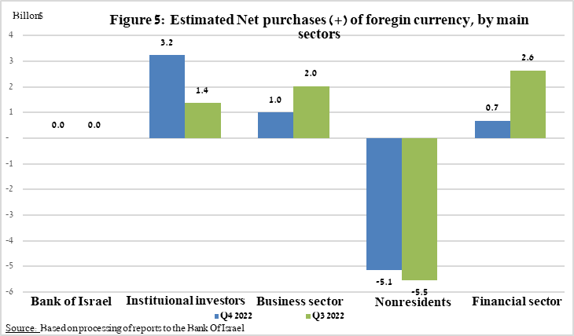

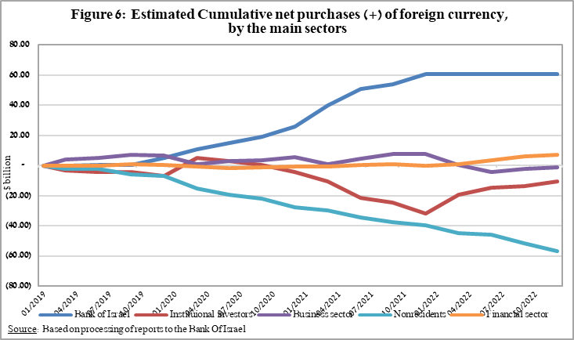

**4. Trading Volume in the Foreign Currency Market—Tables and Figures**

**Trading volume vis-à-vis the domestic banking system[2]**

**The average daily trading** **volume** declined by about 1 percent during the quarter to a level of $10.4 billion, with most of the decline due to a decrease in the daily trading volume of options transactions.

**Nonresidents' share of total trading volume vis-à-vis the domestic banking system** (spot and forward transactions, options, and swaps) decreased by about 6.4 percent to about 41.4 percent at the end of the fourth quarter.

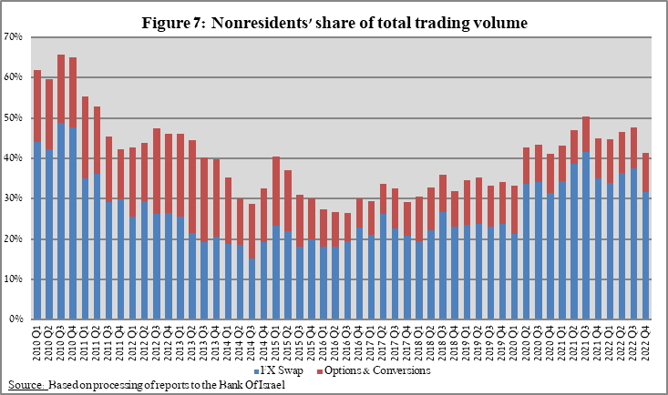



**Estimated total trading volume[3]—domestic banking system and foreign reporting entities**

The estimated total activity in transactions against the shekel reflected in reports from the domestic banking system and foreign reporting entities indicates that nonresidents’ relative share of trading volume in spot and forward transactions (excluding swaps and options) was 80.6 percent in the fourth quarter, and that trade between nonresidents constituted 69.5 percent of the volume, which had a daily average of $7 billion.



1. The main segments presented do not make up the entire market—for additional information, see the section on “The Database of Foreign Exchange Market Activity” in the Bank of Israel's "Statistical Bulletin" for 2018 (in Hebrew):

   <https://www.boi.org.il/he/NewsAndPublications/RegularPublications/Documents/MabatStat2018/shekel.pdf>
2. Volumes of trade only vis-à-vis the domestic banking system. From the beginning of 2020, the data do not include branches of foreign banks in Israel.
3. Total trading volume is an estimate of total activity in transactions against the shekel, based on reports by the domestic banking system and by foreign reporting entities.