

BANK OF ISRAEL

Office of the Spokesperson and Economic Information

September 22, 2024

Press Release:

Debt Developments in the Nonfinancial Private Sector,

Second Quarter of 2024

The following is a summary of developments in nonfinancial private sector debt in the second quarter of 2024:

* In the second quarter of 2024, the balance of **nonfinancial private sector** debt increased, both with regard to the **business sector** and with regard to the **household sector**, by a moderate rate of approximately 0.9 percent. This continued the slowdown in the annual growth rate of outstanding debt, which began in the second half of 2022.
* The balance of **business sector** debt increased by about 0.5 percent (about NIS 7 billion) during the quarter, to about NIS 1.3 trillion. This was mainly due to a low volume of net debt raised via bank loans and nonbank loans, mainly to the large business segment, and through direct loans from institutional investors. These effects were partly offset by net repayments of tradable bonds in Israel and of debt raised abroad.
* Bond issuances in the **business sector** in Israel totaled about NIS 9 billion during the second quarter, significantly lower than the quarterly average of the previous four quarters. About two-thirds of the bond issuances were made by companies in the real estate and construction industry, which continues to lead bond issuances similar to previous years.
* The balance of **household debt** also continued to increase during the quarter, to about NIS 812 billion, mainly due to an increase in the balance of **housing debt** (about NIS 10 billion, 2 percent), which was due to a recovery in new mortgage borrowing from banks. The balance of **nonhousing debt** also grew (by about NIS 2 billion, 0.7 percent), with the increase concentrated in outstanding debt to the banks.

**The nonfinancial business sector’s[1] outstanding debt**

* In the second quarter of 2024, the slowdown in the growth of the **balance of business sector debt** that began in the second half of 2022 continued, with the balance increasing by about NIS 7 billion (0.5 percent), significantly lower than in the previous quarter, to a level of about NIS 1.3 trillion.
* The increase in the debt balance this quarter derived mostly from a depreciation of the shekel by about 2.1 percent against the US dollar, and an increase of about 1.6 percent in the Consumer Price Index[2], which contributed to an increase in the value of foreign currency denominated, foreign currency indexed, and CPI indexed debt. A low volume of net debt raised through bank loans, mainly to the large business segment, and direct loans from institutional investors contributed to the increase. These effects were partly offset by net repayments of tradable bonds in Israel and of debt raised abroad (bonds and loans) (Figure 1).
* The annual growth rate of outstanding debt to nonbank lenders declined in the second quarter, to about 1 percent compared with a rate of about 4 percent in the previous quarter. The annual growth rate of debt to banks continued to decline in the second quarter, further to the decline that began in the second half of 2022, but remained positive (about 5 percent). It should be noted that in the past five years, the annual growth rate in outstanding debt to banks has been higher than the annual growth rate of outstanding debt to nonbank lenders (Figure 2).
* In the second quarter of the year, the **business sector** **issued** about NIS 9 billion in bonds, significantly less than the quarterly average of the previous four quarters (about NIS 14 billion per quarter). About 63 percent of issuances in the second quarter were carried out by companies in the real estate and construction industry, which continues to lead in bond issuances, similar to previous years (Figure 3).

In July–August 2024 as well, companies from the real estate and construction industry continued to lead in funds raised: About 63 percent of total funds of about NIS 11 billion raised in those months, were carried out by them. (Figure 3)

* In the second quarter of 2024, **the spread[3] between yields on corporate bonds that are included in the Tel Bond 60 Index and the yields on CPI-indexed government bonds** narrowed to about 1.15 percentage points. However, starting in June 2024 this spread widened, for the first time since October 2023 in view of the Swords of Iron War, reaching about 1.21 percentage points in August (Figure 4).

**Table 1: The Composition of Business Sector Debt**



**Figure 1: Estimated Net Quarterly Quantitative Change in Business Sector Debt**

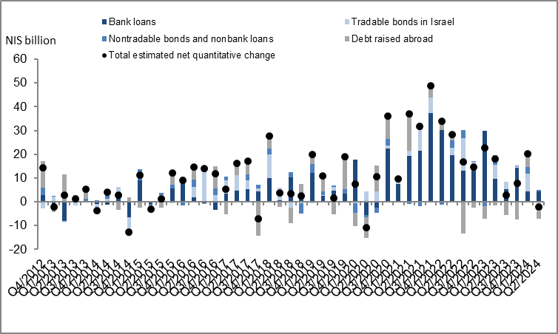

**Figure 2: Rate of Change (Year on Year) in the Business Sector's Bank and Nonbank Debt**



**Figure 3: Nonfinancial Business Sector Bond Issuance during the quarter, by Industry**

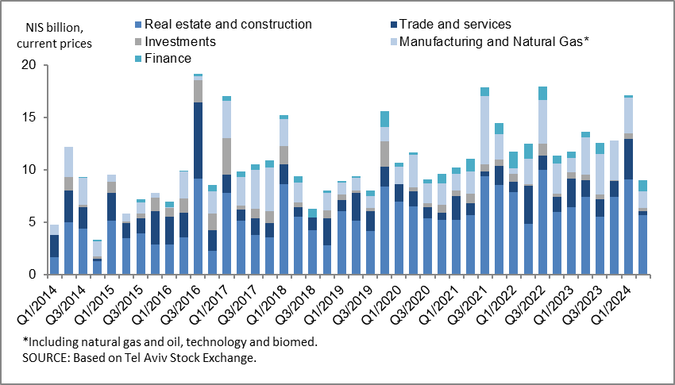

**Figure 4: Spread between Indexed Corporate Bonds (Tel-Bond 60) and Indexed Government Bonds (monthly average)**



**Household debt**

* In the second quarter of 2024, the **balance of households’ outstanding debt** continued to increase, by NIS 12 billion (about 2 percent) to about NIS 812 billion. Most of the increase was in the balance of **housing** debt, mostly to banks, which increased at a higher rate than in the previous quarter (about 2 percent compared with 1 percent in the previous quarter). **Nonhousing debt** increased by about NIS 2 billion (0.7 percent) to about NIS 229 billion, mostly in outstanding debt to banks, which constitutes about 72 percent of total nonhousing debt.
* The annual growth rate of housing debt increased to about 5 percent in the second quarter. The annual growth rate of nonhousing debt also increased, but was still negative at about -1 percent (Figure 5).
* The increase in housing debt is a result of the recovery in new mortgage borrowing from the banks, which began at the end of 2023. In the second quarter of 2024, after adjusting for seasonal effects, new mortgage borrowing totaled about NIS 21 billion, higher than the corresponding period of the previous year (about NIS 17 billion). In July–August 2024, the increase continued, mainly seasonal, with new mortgage borrowing averaging NIS 7.5 billion per month, seasonally adjusted (Figure 6).

**Table 2: Outstanding Debt Balances of Households1**



**Figure 5: Rates of Change in Households’ Housing and Nonhousing Debt, Current Quarter vs. Corresponding Quarter of Previous Year**

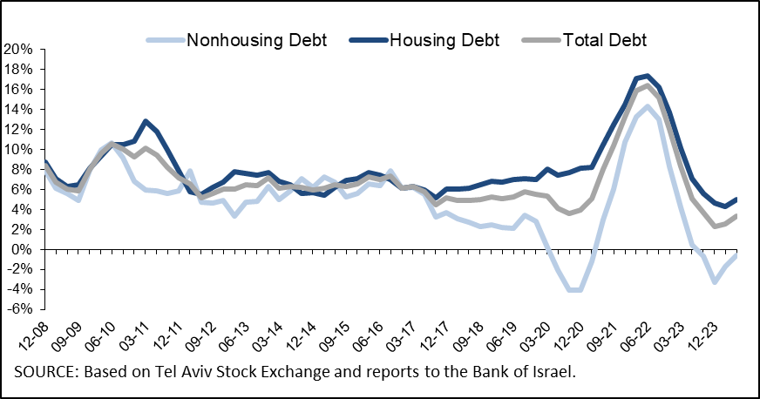

**Figure 6 :Amount of New Home Purchase Loans Provided by Banks to the Public (Mortgages)**



Links to Data and Statistics on the Bank of Israel website:

<https://www.boi.org.il/en/economic-roles/data-and-statistics/money-and-debt-aggregates/debt-and-credit/>

1. Israeli firms, excluding banks, credit card companies, and insurance companies.
2. CPI-indexed balances are calculated in accordance with information known at the time the financial statements are prepared, so that a change in the CPI refers to a change between the known CPI and the CPI in the month preceding that.
3. The change in the spread from one quarter to the next is calculated as the difference between the average spread in the final month of the reviewed quarter and the average spread in the final month of the previous quarter.