

BANK OF ISRAEL

Office of the Spokesperson and Economic Information

Press release

September 30, 2024

**The Rise in Food Prices in February 2024 – Analyzing the Role of Private Brands in Mitigating the Impact on Consumers:**

**Excerpt from the forthcoming Selected Research and Policy Analysis Notes**

* This analysis examines the impact of the price increase implemented by a major food supplier in February 2024 on prices in retail chains, focusing on the effect of this price increase on the pricing of similar products marketed as private brands by two retail chains.
* The analysis shows that in most cases, the prices of private brand products remained unchanged or changed only slightly. This is in contrast to the supplier's branded products, which tended to increase at higher rates.
* The analysis indicates that competition, reflected in the availability of similar products in a variety of brands, especially private brands, can help mitigate the impact of price increases by major food suppliers on consumers' overall food expenses.

In January–February 2024, roughly ten food suppliers announced price increases of up to 25 percent on some of their products, with these price increases taking effect at the beginning of February 2024. A new analysis by Gal Katz and Lidor Sela of the Bank of Israel Research Department focused on a case study of one of the food suppliers that announced price increases. The analysis examined how retail chains respond to announced price increases by the food supplier, particularly how they adjust the prices of similar products of their private brands. For this purpose, the price levels (per unit of the same product) of the supplier's products were compared to those of the private brand products in two major retail chains before and after the price increase announcement. One retail chain has two subchains—"Urban" and "Discount" (i.e., those that sell regular goods at lower prices than nondiscount chains, and in larger quantities)—and the other has only "Discount" branches.

A comprehensive analysis of the two retail chains examined shows that the prices of most of the supplier's products increased around February 2024, while the prices of most private brand products remained unchanged. Figure 1 illustrates this for the urban branches of the first retail chain examined. It shows that following the price increase announcement, the prices of all the supplier's products increased. However, the median prices of most private brand products remained unchanged throughout the examined period. For the second retail chain (for which no graph is attached), it was more challenging to get a clear picture. However, similar to the first retail chain, the median prices of most private brand products remained stable around the time of the supplier's price increase.

This analysis is also important in the context of the Consumer Price Index and especially the Food Price Index, which tracks the rate of change over time in the expenditure required to purchase a fixed basket of food products. This basket includes both branded products, like those of the examined food supplier and other food suppliers, and the private brands of retail chains. When retail chains avoid parallel increases in the prices of their private brands, and as the weight of private brands in household consumption increases, households’ actual expenditure may grow less than the price increases of food suppliers. In particular, consumers can "protect" themselves from price increases by consuming private brands, the prices of which—when food suppliers increase their prices—tend to increase less or even remain unchanged, at least within the examined period. Hence, it can be inferred that having a wide range of food suppliers can contribute to competition, which can moderate the impact of price increases by a single supplier on consumers' overall cost of living.

Another point addressed by the analysis is the source of the price increases. Two major reasons cited by suppliers for the price increases are the rise in raw material prices over the past year and supply chain difficulties. Considering what appears to be a supply shock, similar price increases could have been expected in the private brand products. However, despite this, the two retail chains avoided raising the prices of these private brand products or did so to a much lesser extent than the supplier's products. It is possible that retail chains avoided raising private brand prices to retain their customer base, while settling for lower profit margins. Another possibility is cross-subsidization, where the retail chain maintains fixed prices for certain products while raising prices for others, thereby maintaining overall profitability for the retail chain.

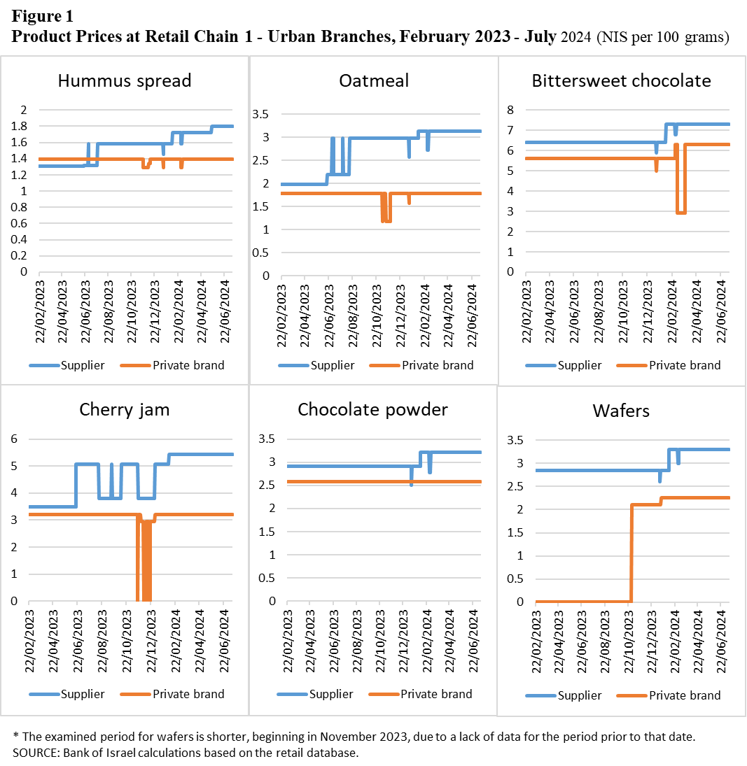

**Table 1: Rate of change in retail chain prices following the announcement of price increases by the suppler – Supplier’s product and private brand product** (percent)

|  |  |  |  |  |  |  |
| --- | --- | --- | --- | --- | --- | --- |
|  | Chain 1 – Urban | | Chain 1 – Discount | | Chain 2 | |
|  | Supplier | Private brand | Supplier | Private brand | Supplier | Private brand |
| Hummus spread | 8.4 | 0 | 9.2 | 0 | 10.2 | 11.2 |
| Oatmeal | 5.4 | 0 | 5.4 | 0 | 0 | 0 |
| Bittersweet chocolate | 14.1 | 0 | 15.3 | 0 | 2 | 0 |
| Cherry jam | 9.9 | 0.7 | 9.9 | 0.7 | 9.6 | 0 |
| Chocolate powder | 0 | 0 | 11.2 | 0 | 0 | -14.4 |
| Wafers | 14.7 | 7.1 | 15.4 | 7.1 | 17.1 | 0 |

*The rate of change is between the period before the price increase announcement (January 1–12, 2024) and the period after the increase (February 20–29, 2024).

**Background and data sources:**

The analysis is based on the Bank of Israel’s database. The raw data come from the retail chains’ mandatory disclosures pursuant to the "Price Transparency" Law (2014). These data include daily information on the prices of all products sold in large retail chains nationwide, along with information on basic product characteristics (e.g., manufacturer and weight). The raw price data were processed to reflect the actual consumer price, including all discounts. Additionally, prices were standardized to a uniform weight unit (100 grams) to allow comparisons between the prices of different brands. The analysis focused on six products that met the following three criteria:

1. The product was included in the round of price increases by the examined food supplier in February 2024.
2. Both retail chains had a similar private brand product.
3. Complete data were available for these products during the examined periods, and they appeared in at least 40 percent of the stores on all days.

It is important to recognize the limitations of this analysis. Due to the defined criteria, only six products were examined. Additionally, the analysis examined a specific price increase by one food supplier, although other food suppliers also raised prices. Therefore, while the analysis provides insights into price behavior in retail chains, it is based on a case study and not a comprehensive market examination.