

BANK OF ISRAEL

Office of the Spokesperson and Economic Information

March 20, 2025

Press Release:

Israel’s foreign currency market in the fourth quarter of 2024

**1. Exchange Rate Development**

**A strengthening of the shekel alongside a strengthening of the US dollar worldwide.**

During the course of the fourth quarter, the shekel strengthened by about 1.7 percent against the US dollar, and by 8.6 percent against the euro. In addition, the shekel strengthened by 6.1 percent against the currencies of Israel's main trading partners, in terms of the nominal effective exchange rate (i.e., the trade-weighted average shekel exchange rate against those currencies).

Worldwide, the US dollar strengthened against most of the world’s major currencies (Figure 2) during the quarter—including by approximately 9.9 percent against the Japanese yen, and by 7.5 percent against the euro.

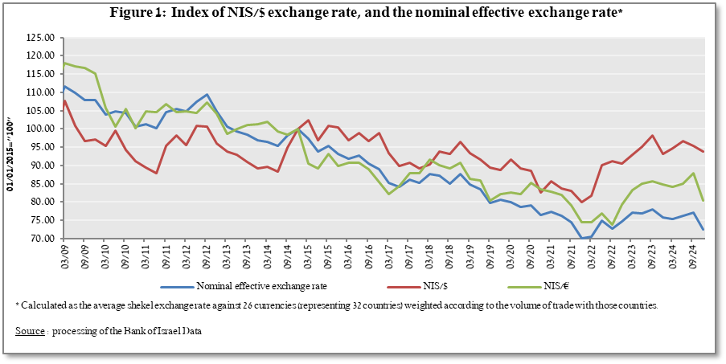

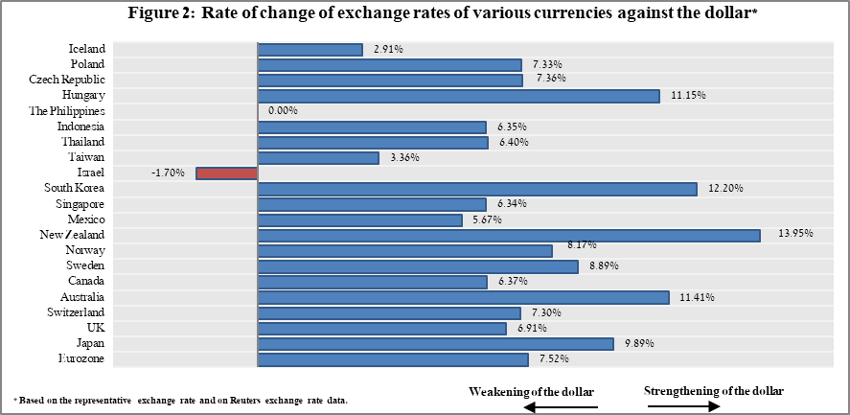

**2. Exchange Rate Volatility**

**A decline in actual volatility and a decline in implied volatility**

The standard deviation of changes in the shekel/dollar exchange rate, which represents its **actual** volatility, declined by 0.2 percentage points during the quarter, to an average level of 9.9 percent.

The average implied volatility in over-the-counter shekel/dollar options—those traded outside the stock exchange—which is an indication of **expected** exchange rate volatility, decreased by 0.7 percentage points during the quarter, to an average level of about 10.2 percent at the end of the quarter.

This is in contrast to the average level of implied volatility in foreign exchange options in emerging markets, which increased by 0.7 percentage points compared to the previous quarter, to 11 percent at the end of the quarter. There was a similar increase in its average level among advanced economies, to 8.1 percent at the end of the quarter (Figure 4).

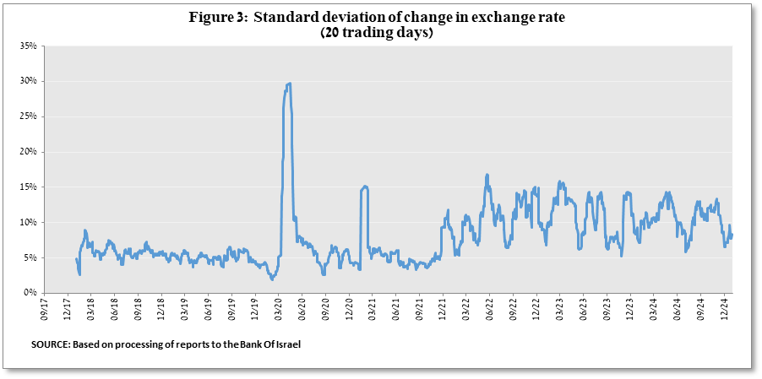

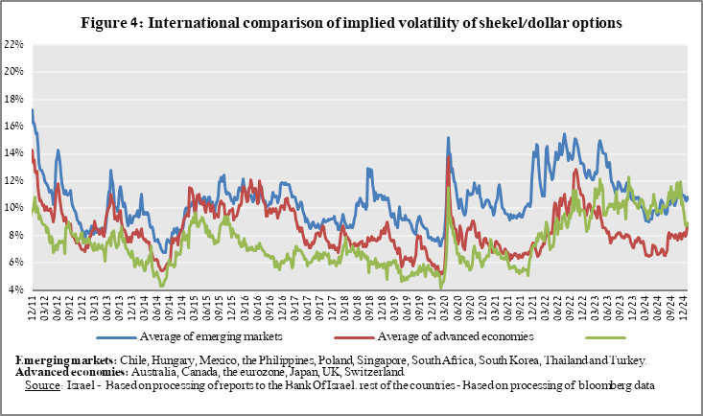

**3. The Activity of the Main Segments in the Foreign Exchange Market[1],[2]**

An estimate of activity by the **main** segments in the foreign exchange market indicates that during the fourth quarter **institutional investors (pension funds, provident funds, and insurance companies) and nonresidents sold a total of $4.9 billion and $4.4 billion, respectively, while the business sector and financial sector purchased foreign exchange at $4.7 billion and $1.2 billion, respectively.**

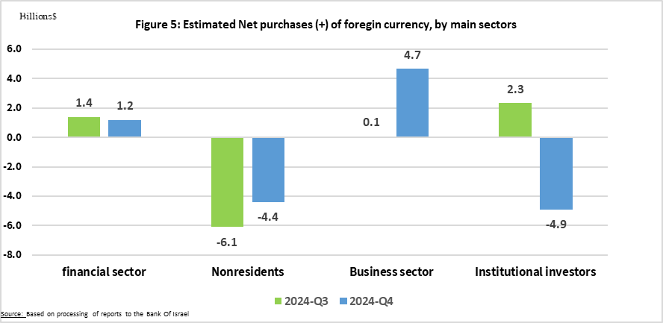

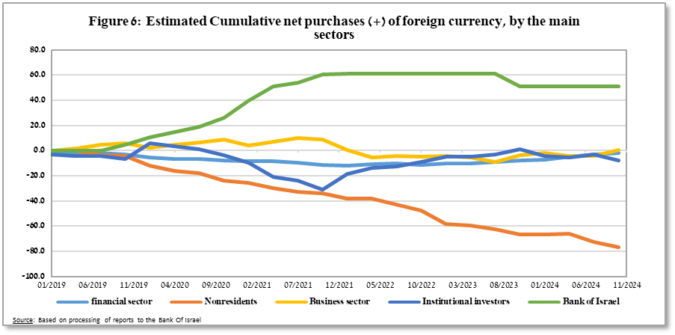

**4. Trading Volume in the Foreign Currency Market—Tables and Figures**

**Trading volume vis-à-vis the domestic banking system[3]**

**The average daily trading** **volume** increased by about 0.6 percent during the quarter to $13.2 billion, mainly due to an increase in the daily trading volume in swap transactions

**Nonresidents' share of total trading volume vis-à-vis the domestic banking system** (spot and forward transactions, options, and swaps) declined by about 2.3 percentage points to about 41.3 percent at the end of the fourth quarter.

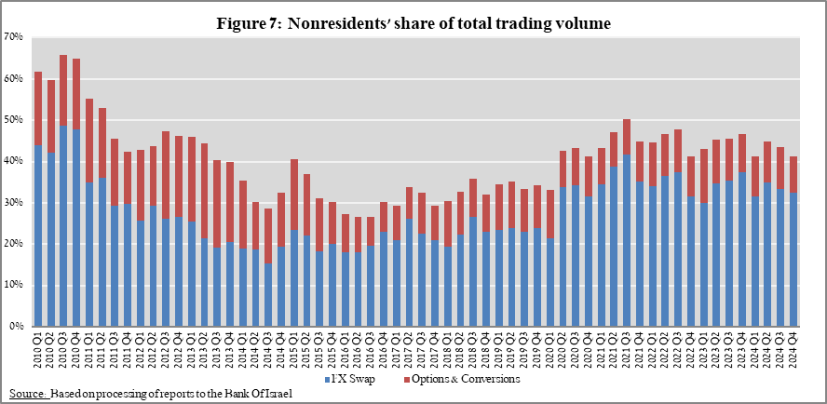

|  |  |  |  |  |  |  |
| --- | --- | --- | --- | --- | --- | --- |
| **Forex transactions with domestic banks, by instruments and derivatives ($ million)** | | | | | | |
|  |  | **Conversions (1)** | **Swaps1 (2)** | **Cross Currency swap2 (3)** | **Options3 (4)** | **Total volume of trade (1)+(2)+(3)+(4)** |
| **Fourth quarter 2024 (Not final)** | **Total** | **195,028** | **558,946** | **1,180** | **23,124** | **778,277** |
| **Daily average (59 days)** | **3,306** | **9,474** | **20** | **392** | **13,191** |
| **Nonresidents** | 59,655 | 253,262 | 517 | 7,608 | 321,042 |
| of which **Foreign financial institutions** | 59,009 | 253,262 | 517 | 7,608 | 320,395 |
| **Residents** | 135,373 | 305,684 | 663 | 15,516 | 457,235 |
| of which **Real sector** | 42,439 | 22,636 | 145 | 7,228 | 72,448 |
| **Financial sector** | 42,390 | 151,082 | 341 | 1,024 | 194,837 |
| **Institutions (incl. insurance companies)** | 27,092 | 98,810 | 0 | 4,958 | 130,860 |
| **Individuals** | 5,238 | 615 | 0 | 134 | 5,987 |
| **Other4** | 646 | 0 | 0 | 0 | 647 |
| **Domestic banks5** | 10,393 | 20,160 | 0 | 1,743 | 32,296 |
| **Third quarter 2024** | **Total** | **210,301** | **557,502** | **2,666** | **29,180** | **799,650** |
| **Daily average (61 days)** | **3,448** | **9,139** | **44** | **478** | **13,109** |
| **Nonresidents** | 70,248 | 266,837 | 736 | 10,496 | 348,317 |
| of which **Foreign financial institutions** | 69,577 | 266,837 | 736 | 10,496 | 347,645 |
| **Residents** | 140,053 | 290,665 | 1,930 | 18,684 | 451,333 |
| of which **Real sector** | 42,382 | 20,162 | 319 | 7,162 | 70,026 |
| **Financial sector** | 43,638 | 127,361 | 438 | 1,020 | 172,458 |
| **Institutions (incl. insurance companies)** | 29,388 | 115,194 | 453 | 6,958 | 151,993 |
| **Individuals** | 5,692 | 577 | 0 | 175 | 6,444 |
| **Other4** | 671 | 0 | 0 | 0 | 671 |
| **Domestic banks5** | 10,432 | 17,098 | 349 | 2,761 | 30,639 |
|  |  |  |  |  |  |  |
|  | 1 Only one leg of the swap, i.e., the nominal value of the transaction (in accordance with the BIS definition) | | | | | |
|  | 2 The exchanged founds through Cross Currency Swap transactions considered for the volume, as one leg only in cases where the two legs offset each other. | | | | | |
|  | 3 The national value, that includes purchases and sales of put and call options. | | | | | |
|  | 4 Including other entities such as portfolio managers, nonprofit organizations, national institutions, and those not included elsewhere. | | | | | |
|  | 5 Total interbank trade, divided by 2 | | | | | |

**Estimated total trading volume[4]—domestic banking system and foreign reporting entities**

The estimated total activity in transactions against the shekel, as reflected in reports from the domestic banking system and foreign reporting entities, indicates that nonresidents’ relative share of trading volume in spot and forward transactions (excluding swaps and options) was about 84 percent in the fourth quarter.

Trade between nonresidents constituted about 74 percent of the volume, which had a daily average of about $13 billion.

|  |  |  |  |  |  |  |
| --- | --- | --- | --- | --- | --- | --- |
|  |  | Relative share of total trading volume | | |  |  |
|  |  | Trade between nonresidents | Trade between a nonresident and a resident1 | Trade between the domestic banking system and residents | Total volume ($ million) | Daily average ($ million) |
| 2024-Q4 (Tentative figure) | Trading volume in spot and forward transactions | 74.1% | 9.3% | 16.6% | 793,206 | 13,003 |
| Trading volume in swap and options transactions | 49.0% | 24.8% | 26.1% | 1,211,096 | 19,854 |
| 2024- Q3 | Trading volume in spot and forward transactions | 73.9% | 10.0% | 16.2% | 844,378 | 14,311 |
| Trading volume in swap and options transactions | 49.2% | 26.4% | 24.5% | 1,253,728 | 21,250 |
| 1 Trade between a nonresident and a resident includes: (a) reports by foreign reporting entities regarding transactions with residents; and (b) reports by domestic banks regarding transactions with nonresidents. | | | | | | |

1. For additional information on the segments’ activity in the foreign exchange market, see “Statistical Bulletin 2024—Chapter D” :

   <https://www.boi.org.il/publications/regularpublications/statistic_bulletin/bulletin2024/>
2. The main segments presented do not make up the entire market—for additional information, see the section on “The Database of Foreign Exchange Market Activity” in the Bank of Israel's "Statistical Bulletin" for 2024 :

   <https://www.boi.org.il/publications/regularpublications/statistic_bulletin/bulletin2024/>

   From the beginning of 2020, the data do not include branches of foreign banks in Israel.
3.
4. Total trading volume is an estimate of total activity in transactions against the shekel, based on reports by the domestic banking system and by foreign reporting entities.