

BANK OF ISRAEL

Office of the Spokesperson and Economic Information

August 5, 2025

Press Release:

Israel’s foreign currency market in the second quarter of 2025

**1. Exchange Rate Development**

**A strengthening of the shekel against the background of a weakening of the dollar worldwide.**

In the second quarter of 2025, the shekel strengthened markedly, in view of improving investor sentiment after the events of Operation Rising Lion and the weakening of the dollar against major currencies worldwide. During the course of the quarter, the shekel strengthened by approximately 9.3 percent vis-à-vis the dollar and by 1.5 percent vis-à-vis the euro. In addition, the shekel strengthened by 6 percent against the currencies of Israel's main trading partners, in terms of the nominal effective exchange rate (i.e., the trade-weighted average shekel exchange rate against those currencies).

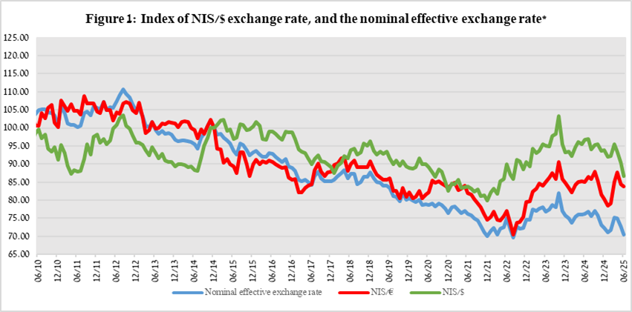Worldwide, the trend of dollar weakness continued, in view of the tension over the global trade war, and the continued lack of certainty over the US tariff policy. Among other things, the dollar weakened during the course of the quarter by 3.4 percent against the Japanese yen and by 7.8 percent against the euro (Figure 2).

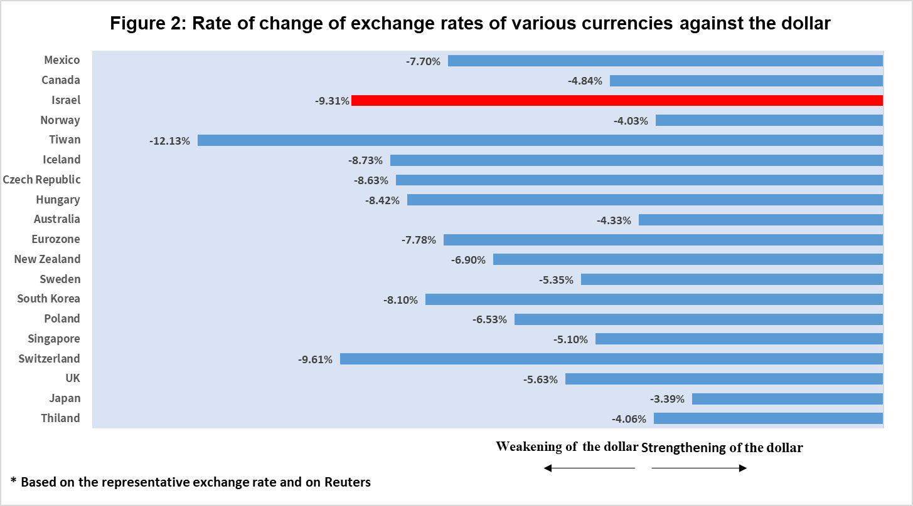

**2. Exchange Rate Volatility**

**Increase in actual volatility alongside an increase in implied volatility**

The average standard deviation of changes in the shekel/dollar exchange rate, which represents its **actual** volatility, increased by 3 percentage points during the quarter, to an average level of 11.1 percent.

The average implied volatility in over-the-counter shekel/dollar options —an indicator of expected exchange-rate volatility— increased by 1.1 percentage points during the quarter, to an average level of about 9.8 percent at the end of the quarter.

This is alongside the average level of implied volatility in foreign exchange options in emerging markets, which increased by 0.8 percentage points compared to the previous quarter, to 11.1 percent at the end of the quarter. In advanced economies, there was a moderate increase of about 0.8 percent in its average level, to about 9 percent at the end of the quarter (Figure 4).

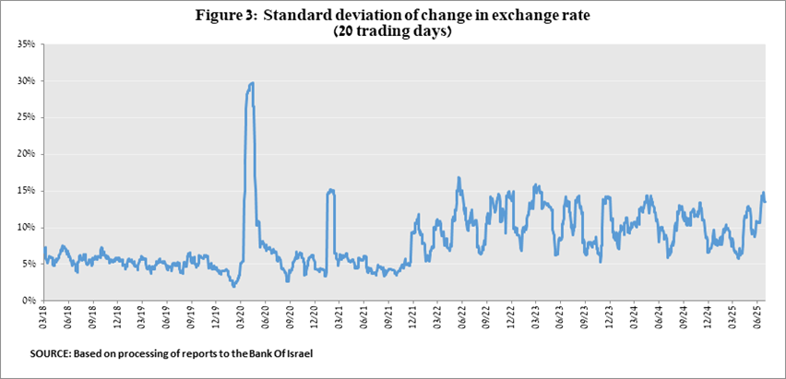

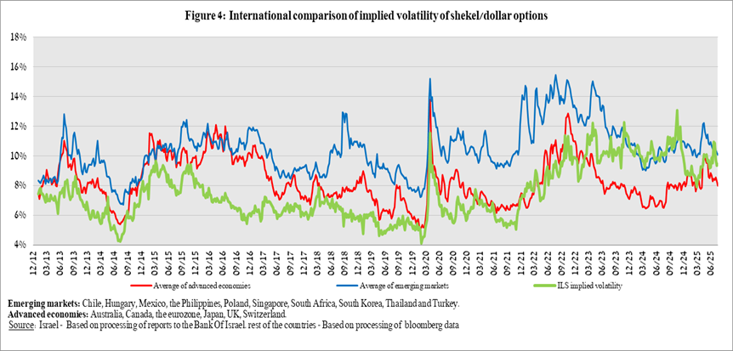

**3. The Activity of the Main Segments in the Foreign Exchange Market[1],[2]**

An estimate of activity by the **main** segments in the foreign exchange market points to heterogeneous developments: net FX sales by nonresidents and by the financial sector, which supported the shekel’s appreciation, versus FX purchases by the business sector. Nonresidents sold $8.9 billion in foreign exchange, while the business sector purchased about $5.3 billion in foreign exchange, due to an increase in net purchases by major importing companies and more moderate sales among exporting companies compared to the previous quarter. Among institutional investors (pension funds, provident funds, and insurance companies) there was moderate activity, as they purchased only $0.1 billion in foreign exchange during the second quarter. In contrast, the financial sector (mainly banks) sold about $0.2 billion in foreign exchange.

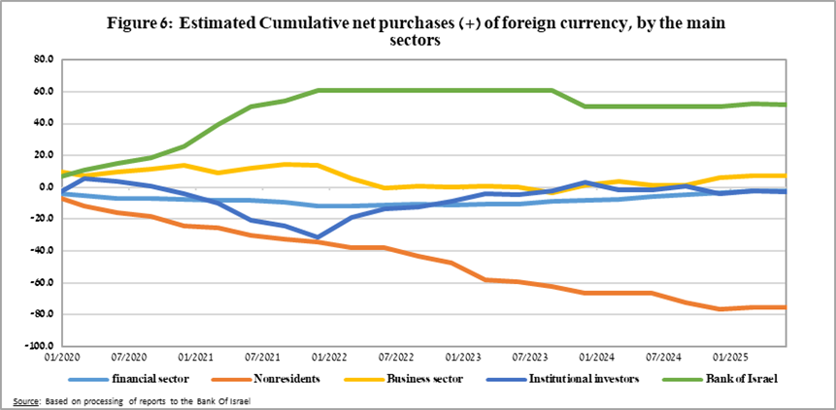

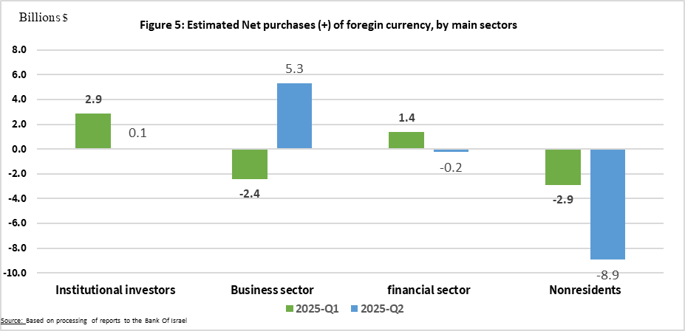

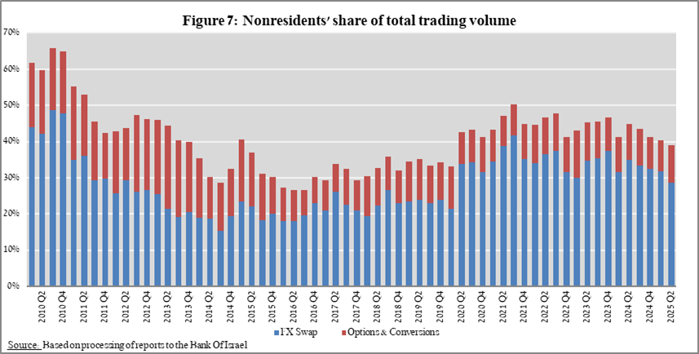

**4. Trading Volume in the Foreign Currency Market—Tables and Figures**

**Trading volume vis-à-vis the domestic banking system[3]**

**The average daily trading** **volume** increased by about 6 percent during the quarter to $14 billion, with most of the increase deriving from an increase in the daily trading volume in spot and forward transactions.

**Nonresidents' share of total trading volume vis-à-vis the domestic banking system** (spot and forward transactions, options, and swaps) declined by about 1.2 percentage points to about 39.12 percent at the end of the second quarter.

|  |  |  |  |  |  |  |  |
| --- | --- | --- | --- | --- | --- | --- | --- |
|  |  | **Conversions (1)** | **Swaps1 (2)** | **Cross Currency swap2 (3)** | **Options3 (4)** | **Total volume of trade (1)+(2)+(3)+(4)** | |
| **Second quarter 2025 (Not final)** | **Total** | **223,650** | **588,999** | **2,407** | **40,495** | **855,551** | |
| **Daily average (59 days)** | **3,666** | **9,656** | **39** | **664** | **14,025** | |
| **Nonresidents** | 75,797 | 243,946 | 857 | 14,059 | 334,659 | |
| of which **Foreign financial institutions** | 75,100 | 243,946 | 857 | 14,059 | 333,961 | |
| **Residents** | 147,853 | 345,053 | 1,550 | 26,436 | 520,892 | |
| of which **Real sector** | 47,625 | 26,938 | 410 | 8,589 | 83,560 | |
| **Financial sector** | 42,515 | 139,701 | 575 | 1,148 | 183,940 | |
| **Institutions (incl. insurance companies)** | 29,109 | 134,097 | 160 | 8,921 | 172,286 | |
| **Individuals** | 5,696 | 202 | 0 | 122 | 6,021 | |
| **Other4** | 698 | 0 | 0 | 0 | 698 | |
| **Domestic banks5** | 11,180 | 26,154 | 26 | 2,831 | 40,191 | |
| **First quarter 2025** | **Total** | **192,050** | **599,375** | **1,919** | **26,953** | **820,297** | |
| **Daily average (61 days)** | **3,098** | **9,667** | **31** | **435** | **13,231** | |
| **Nonresidents** | 62,964 | 260,197 | 764 | 7,389 | 331,314 | |
| of which **Foreign financial institutions** | 62,394 | 260,196 | 764 | 7,389 | 330,743 | |
| **Residents** | 129,086 | 339,178 | 1,155 | 19,564 | 488,983 | |
| of which **Real sector** | 41,844 | 24,572 | 361 | 8,139 | 74,916 | |
| **Financial sector** | 39,185 | 163,589 | 138 | 1,342 | 204,254 | |
| **Institutions (incl. insurance companies)** | 26,079 | 115,262 | 52 | 7,195 | 148,587 | |
| **Individuals** | 5,077 | 221 | 0 | 167 | 5,465 | |
| **Other4** | 570 | 1 | 0 | 0 | 571 | |
| **Domestic banks5** | 8,079 | 21,270 | 207 | 1,827 | 31,384 | |
|  |  |  |  |  |  |  | |
| 1 Only one leg of the swap, i.e., the nominal value of the transaction (in accordance with the BIS definition) | | | | | | | |
| 2 The exchanged founds through Cross Currency Swap transactions considered for the volume, as one leg only in cases where the two legs offset each other. | | | | | | | |
| 3 The national value, that includes purchases and sales of put and call options. | | | | | | | |
| 4 Including other entities such as portfolio managers, nonprofit organizations, national institutions, and those not included elsewhere. | | | | | | | |
| 5 Total interbank trade, divided by 2 | | | | | | | |

**Estimated total trading volume[4]—domestic banking system and foreign reporting entities**

The estimated total activity in transactions against the shekel, as reflected in reports from the domestic banking system and foreign reporting entities, indicates that nonresidents’ relative share of trading volume in spot and forward transactions (excluding swaps and options) was about 86 percent in the second quarter.

Trade between nonresidents constituted about 77 percent of the volume, which had a daily average of about $16.5 billion.

|  |  |  |  |  |  |  |
| --- | --- | --- | --- | --- | --- | --- |
|  |  | Relative share of total trading volume | | |  |  |
|  |  | Trade between nonresidents | Trade between a nonresident and a resident1 | Trade between the domestic banking system and residents | Total volume ($ million) | Daily average ($ million) |
| 2025-Q2 (Tentative figure) | Trading volume in spot and forward transactions | 77.1% | 9.0% | 13.9% | 568,113 | 9,313 |
| Trading volume in swap and options transactions | 49.4% | 24.0% | 26.6% | 902,726 | 14,799 |
| 2025-Q1 | Trading volume in spot and forward transactions | 77.0% | 9.0% | 14.0% | 1,011,645 | 16,317 |
| Trading volume in swap and options transactions | 52.3% | 21.4% | 26.3% | 1,375,130 | 22,180 |
| 1 Trade between a nonresident and a resident includes: (a) reports by foreign reporting entities regarding transactions with residents; and (b) reports by domestic banks regarding transactions with nonresidents. | | | | | | |

1. For additional information on the segments’ activity in the foreign exchange market, see “Statistical Bulletin 2024—Chapter D”.

   <https://www.boi.org.il/en/communication-and-publications/regular-publications/statistical-publications/statistical-bulletin-2024/>
2. The main segments presented do not make up the entire market—for additional information, see the section on “The Database of Foreign Exchange Market Activity” in the Bank of Israel's "Statistical Bulletin" for 2024

   <https://www.boi.org.il/en/communication-and-publications/regular-publications/statistical-publications/statistical-bulletin-2024/>
3. From the beginning of 2020, the data do not include branches of foreign banks in Israel.
4. Total trading volume is an estimate of total activity in transactions against the shekel, based on reports by the domestic banking system and by foreign reporting entities.