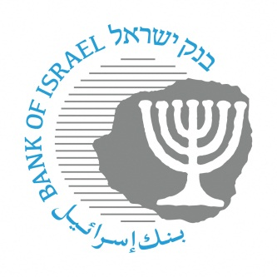

BANK OF ISRAEL
Office of the Spokesperson and Economic Information

August 3, 2021

Press Release

The Banking Supervision Department imposes a financial sanction on Max credit card company for honoring a charge on a cancelled credit card

A complaint from the public received at the Banking Supervision Department, regarding charging transactions on a cancelled credit card, indicated that in certain cases, Max It Finance Ltd. (hereinafter: "the Company") honored charges received in respect of an authorization to charge a credit card, despite the card having been cancelled.

An examination carried out by the Banking Supervision Department indicated that when a customer cancels a credit card, transactions received on that card, after the cancellation date, are blocked as required. However, an examination carried out as a result of clarifying the complaint from the public, cases were located in which the card was charged despite having been canceled. The examination indicated that when the credit card was blocked due to fraud, but subsequently it turned out that no fraud was perpetuated with the card, then authorized debit charges were able to be accepted despite the card having been cancelled.

Therefore, the Banking Supervision Department required that the company rectify the deficiency it found and prevent the recurrence of such cases. In addition, the Banking Supervision Department continues to examine the issue and is examining adopting other actions against the company, including crediting the relevant customers, to the extent they were adversely impacted.

The stance of the Banking Supervision Department, which was provided to the company, is that under the conditions discussed, the company was not permitted to allow transactions to go through on the customer’s account. The company’s activity is in contrast to Section 11(a) of Proper Conduct of Banking Business Directive no. 470 that deals with “Payment Cards”, which establishes that “an issuer shall not charge the account of a customer in respect of transactions carried out after the termination of the payment card contract, as noted in Section 4 of the Payment Cards Law”.

As the Banking Supervision Department found a deficiency in the Company’s conduct, it was decided to impose a financial sanction on the company in accordance with the Supervisor’s authority under Section 14h(a)(1) of the Banking Ordinance, at a total amount of NIS 900,000. This amount is after a reduction of 10 percent of the maximum amount of NIS 1,000,000 established in law. The reduction was made because the company stopped the violation after the Supervisor contacted it regarding the issue.

Supervisor of Banks Mr. Yair Avidan said, “The fairness of the relations between banks and their customers are is at the core of the Banking Supervision Department’s activity and I attributed great importance to that. The systems of relations vis-à-vis the customer has a clear and defined beginning and end, as established explicitly in Proper Conduct of Banking Business Directives. Therefore, it should not be that after the termination of a contract, that the customer’s account will be charged in respect of transactions carried out with the cancelled credit card. We intend to continue and enforce the carrying out of the Banking Supervision Department’s directives in order to ensure that the customers of the banks and credit cards are receiving fair and appropriate service.”

It was also noted that from now on, the consumer-related sanctions imposed on banks and credit card companies will be published in a central section on the Bank of Israel website, at https://www.boi.org.il/he/BankingSupervision/Pages/Financialsanction.aspx

The reduction is in accordance with Section 1(2)(b) of the Banking (Service to the Customer)(maximum reduction rates of financial sanction amounts) Rules, 5771-2011: https://www.nevo.co.il/law_html/law01/500_515.htm (in Hebrew)

