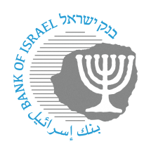
BANK OF ISRAEL
Office of the Spokesperson and Economic Information

October 9, 2023
Press release:

Bank of Israel activity in the foreign exchange market

The Bank of Israel announces a program to sell up to $30 billion in foreign exchange. The Bank will operate in the market during the coming period in order to moderate volatility in the shekel exchange rate and to provide the necessary liquidity for the continued proper functioning of the markets.

In addition to the $30 billion program, and as necessary, the Bank will provide liquidity to the market through SWAP mechanisms in the market of up to $15 billion.

The Bank of Israel will continue monitoring developments, tracking all the markets, and acting with the tools available to it as necessary.

