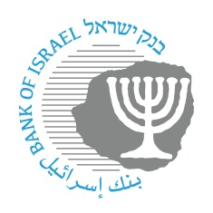
BANK OF ISRAEL
Office of the Spokesperson and Economic Information

December 5, 2023

Press Release:

The Bank of Israel Monetary Committee meets with financial forecasters

Governor of the Bank of Israel Prof. Amir Yaron and members of the Bank of Israel Monetary Committee today held a meeting with the group of forecasters that regularly provides the Bank of Israel with forecasts for inflation, the interest rate, and the exchange rate. The meeting provides an opportunity for exchanging opinions and assessments between the Bank of Israel and leading financial institutions in the economy.

The Governor, Prof. Amir Yaron, opened the meeting and referred to the various economic developments in view of the war and presented the main steps taken by the Bank in the various areas so far.

Following that, Inon Gamrasni, an economist in the Research Department, presented and explained the Research Department’s assessment as compiled and published on November 27, 2023, in parallel with the recent interest rate announcement.

The presentation used is attached.

The forecasters responded and conveyed their assessments of economic developments.

