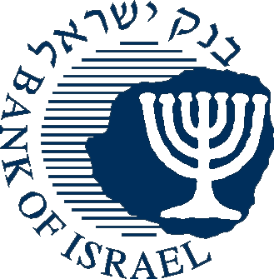

BANK OF ISRAEL
Office of the Spokesperson and Economic Information

Press Release
July 18, 2013

Declaration of Controlled Payment Systems

The Bank of Israel has declared the following payment systems to be controlled systems pursuant to the Payment Systems Law: the “credit, debit and transfer of payments” system, operated by the Masav company, and the “debit card services” and “automated teller machine” systems operated by the Shva company

Deputy Governor Dr. Karnit Flug, who is authorized to exercise the Governor’s powers under Section 9 of the Bank of Israel Law, 5770–2010, has declared the “credit, debit and transfer of payments” system operated by Banking Settlement Center Ltd. (Masav) and the “debit card services” and “automated teller machine” systems operated by Automatic Bank Services Ltd. (Shva) to be “controlled systems” in accordance with the Payment Systems Law, 5768–2008 (hereinafter: “the Law”). Section 2(a) of the Law authorizes the Governor to declare a payment system a controlled system if the conditions set forth in the law apply to it, including that the system is essential to the overall payments system in markets, and that there is a concern that improper, inefficient or non-credible activity in the system will harm the payments system in the markets.
The declaration means that the Bank of Israel is able to oversee the systems in order to ascertain their stability, efficiency and proper activity.
It is noted that Shva and Masav are also regulated in accordance with the Banking Law (Licensing), 5741–1981.
The “credit, debit and transfer of payments” system operated by Masav
This is a retail payment system that provides settlement services and a variety of other services to a broad number of parties. Among other things, the system carries out intra-bank transfers, inter-bank transfers, and various payments.
The system is a main payment system within the payments array in Israel, both due to its volume of activity and the amounts transferred through it, and due to the uniqueness of the services it provides and which serve as a central element of financial activity in the markets. The system is operated by Masav, a company owned by the five banks (Leumi, Hapoalim, Discount, First International and Mizrahi-Tefahot).

The “debit card services” system operated by Shva
This system serves as the infrastructure for the two-way transfer of messages between merchant acquirers and merchant businesses. The system collects and transfers transactions, approvals, and other details that are necessary for executing settlements and transactions via debit cards, and sorts and attributes the transactions to various merchant acquirers.
The system is a main payment system in the Israeli payments array, and brings together services that enable the execution of a wide variety of transactions by way of debit cards. The importance of the system’s operation is derived from the marked expansion in the volume and value of debit card activity that has taken place in the economy in recent years. The system is operated by Shva, a company owned by four banks (Leumi, Hapoalim, Discount and First International).
The “automatic teller machine” system operated by Shva
The system provides banking corporations with an interface for branding the networks of automatic teller machines. The system serves for the transfer of information regarding activities executed by customers via automatic teller machines that are not operated by the banking corporation with which the customer manages his account, and enables customers to withdraw cash efficiently and securely. The system is operated by Shva, a company owned by four banks (Leumi, Hapoalim, Discount and First International).

