

BANK OF ISRAEL

Office of the Spokesperson and Economic Information

September 17, 2017

Press Release

Israel’s International Investment Position (IIP), Second Quarter of 2017

* **In the second quarter of 2017, Israel’s surplus of assets over liabilities vis-à-vis abroad declined by about $1.8 billion (about 1.5 percent), in contrast with an increase of about $7.1 billion (6.5 percent) in the first quarter of the year. Outstanding liabilities to abroad increased by a greater amount than Israel’s assets vis-à-vis abroad.**
* **The increase in the value of the portfolio of Israelis’ assets held abroad in the second quarter ($9.4 billion, 2.4 percent) was a mainly result of an increase in the prices of foreign stocks and bonds ($3.1 billion, 0.8 percent) and an increase in Israel’s reserve assets ($5.5 billion, 5.4 percent).**
* **The increase in the gross balance of liabilities to abroad in the second quarter ($11.1 billion, 4 percent) was mainly a result of the flow of financial investments in stocks and bonds ($2.8 billion, 1 percent) and direct investments in shares ($2 billion, 0.7 percent), in parallel with an increase in the prices of Israeli shares held by nonresidents ($3.1 billion, 1.1 percent).**
* **The surplus of assets over liabilities vis-à-vis abroad in debt instruments alone (negative net external debt) increased in the second quarter of 2017 by about $1.6 billion (1.1 percent), to about $142 billion at the end of the quarter.**
* **The gross external debt to GDP ratio declined in the second quarter, to 26 percent at the end of June, the result of a negligible increase in the shekel value of gross external debt due to the appreciation of the shekel, in parallel with an increase in GDP.**

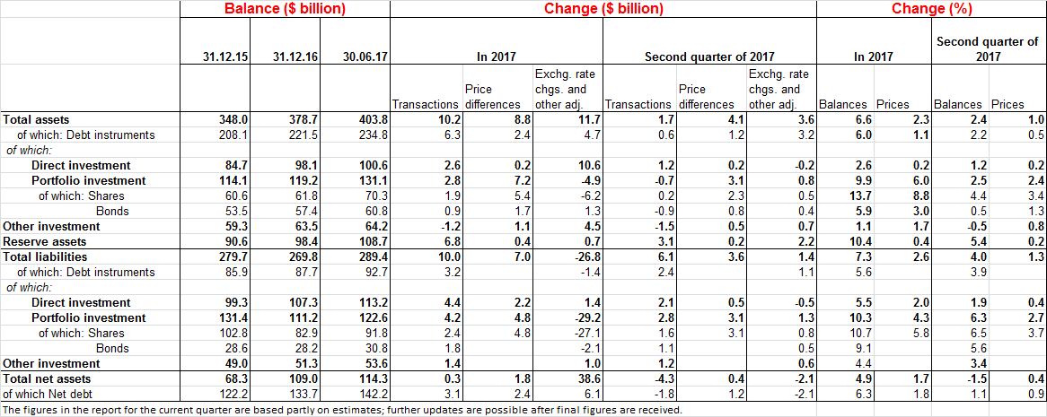

1. **Israel’s surplus assets over liabilities abroad**

**Israel's net assets abroad** (the surplus of assets over liabilities) declined by $1.8 billion (1.5 percent) in the second quarter of 2017, to around $114 billion at the end of June. There was an increase of $9.4 billion (2.4 percent) in the value of Israelis’ assets abroad together with an increase of $11.1 billion (4 percent) in the value of Israelis’ liabilities to nonresidents (Figure 1).

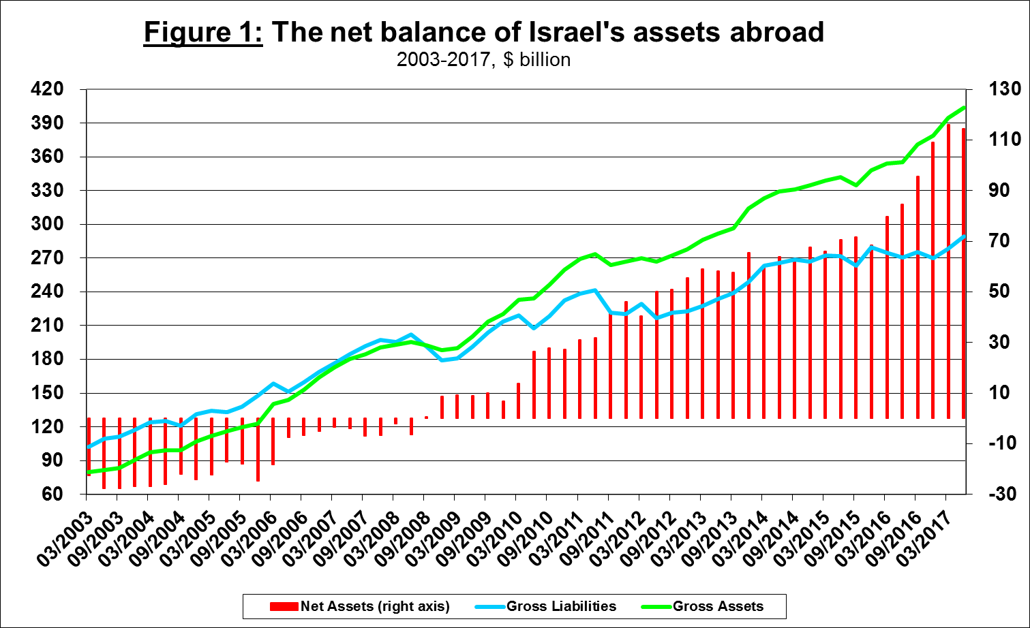

1. **The value of Israel’s assets abroad**

**The value of Israel's assets abroad** increased in the second quarter of 2017 by about $9.4 billion (2.4 percent), to about $404 billion at the end of June, mainly as a result of increases in the prices of tradable assets and in the balance of Israel’s reserves.

**The value of the financial investments portfolio** increased by about $3.3 billion (2.5 percent) in the second quarter. There were also increases in the prices of foreign shares that increased the value of Israelis’ financial portfolio abroad by about $2.3 billion (1.8 percent), and in the prices of foreign bonds, which led to an increase of about $0.8 billion (0.6 percent) in the portfolio.

**The value of direct investments abroad** increased by about $1.2 billion (1.2 percent) in the second quarter, mainly as a result of the flow of investments in share capital totaling about $0.6 billion.

**The value of other investments abroad** declined in the second quarter by $0.3 billion (0.5 percent), mainly due to net withdrawals of about $1.6 billion (2.5 percent) from Israelis’ deposits abroad, and of about $0.6 billion (0.8 percent) from deposits abroad by Israeli banks. There was also a decline of about $0.7 billion (1.1 percent) in customer credit during the second quarter. These were partly offset by an increase of $1.1 billion (1.6 percent) in the balance of loans provided by Israelis to nonresidents.

**The value of the foreign exchange reserves** increased in the second quarter by about $5.5 billion (5.4 percent), to $109 billion at the end of the quarter.

The **composition of Israelis’ securities portfolio abroad:**  During the second quarter of 2017, similar to the first quarter, there was an increase in the proportion of financial investments in foreign shares, in contrast with a decline in the proportion of deposits in banks (Figure 2).

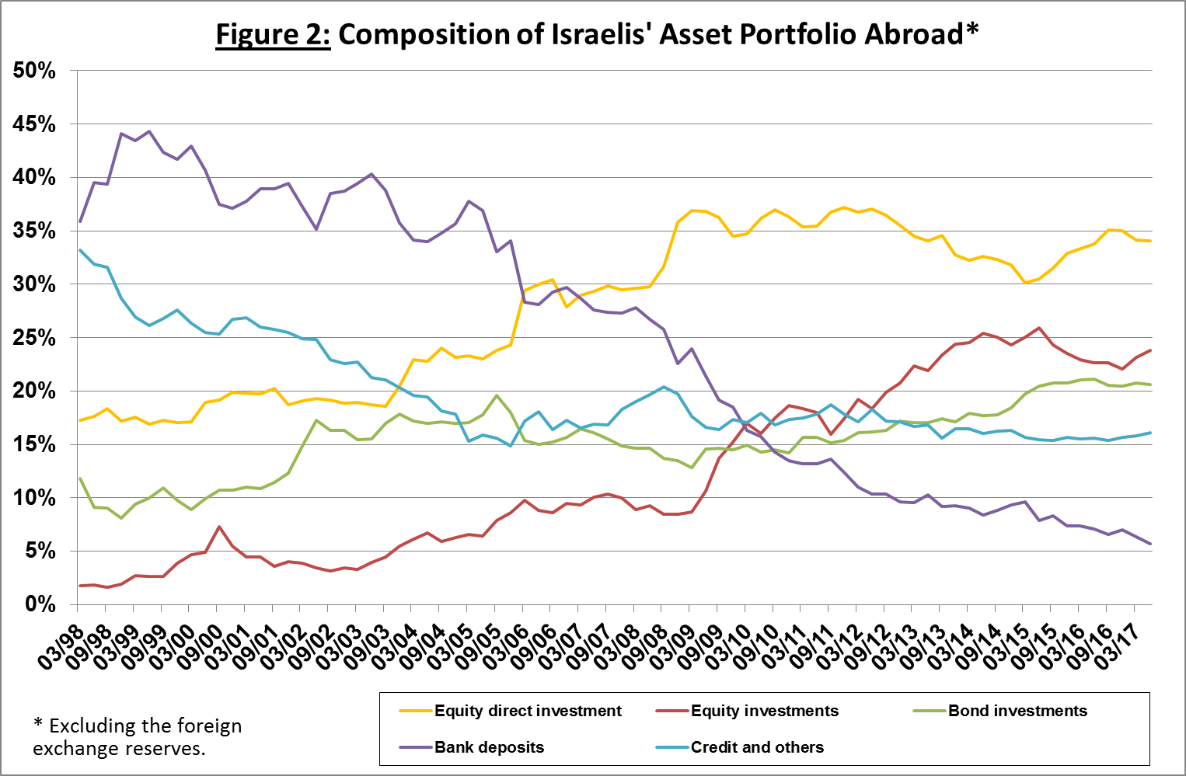

1. **Israel’s liabilities to abroad**

**The balance of Israel's liabilities to abroad** increased in the second quarter of 2017 by about $11.1 billion (4 percent), to about $289 billion at the end of June.

**The value of direct investments in the economy** increased by $2.1 billion (1.9 percent) in the second quarter, derived mainly from net direct investments in Israeli share capital ($2 billion, 1.8 percent).

**The value of financial investments (stocks and bonds)** increased by about $7.2 billion (6.35 percent) in the second quarter, mainly increases in the prices of Israeli shares held by nonresidents ($3.1 billion, 2.7 percent) and net investments in Israeli stocks and bonds totaling about $2.8 billion (2.4 percent) combined.

**The value of other investments** increased by about $1.8 billion (3.4 percent) in the second quarter, mainly due to an increase of about $0.9 billion (1.8 percent) in suppliers’ credit and an increase of about $0.7 billion (1.4 percent) in loans.

**The value of nonresidents' financial portfolio on the Tel Aviv Stock Exchange** increased in the second quarter by about $3.8 billion (11 percent), to about $38 billion at the end of June, further to an increase of $2.7 billion in the first quarter of the year. Most of the increase was due to an increase in the value of the balance of financial shares and bonds, mainly as a result of net investments (Figure 3).

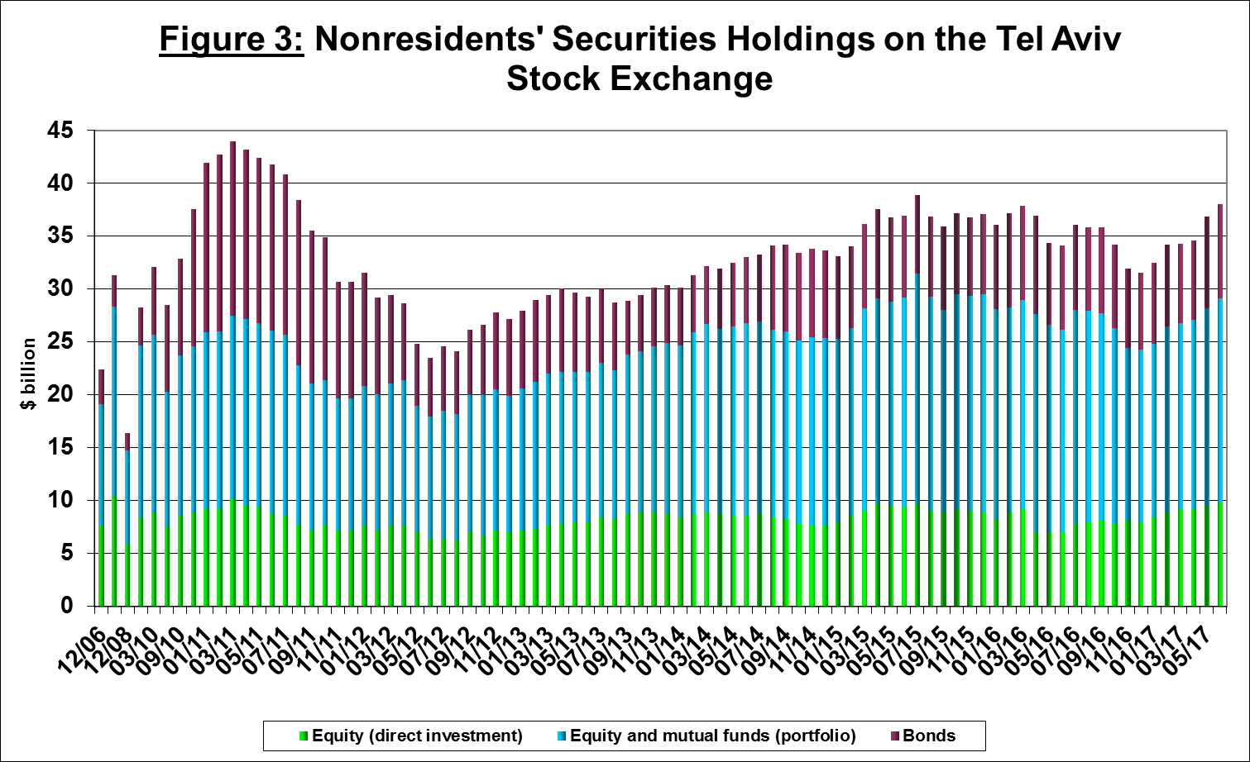

1. **The gross external debt**

**Israel's gross external debt** increased, by about $3.5 billion (3.9 percent) in the second quarter of 2017, to about $93 billion, mainly due to net investments by nonresidents in Israeli bonds and an increase in suppliers’ credit through loans.

**The ratio of gross external debt to GDP** declined in the second quarter, to 26 percent at the end of June, further to the downward trend that began in 2012. The decline was a result of a negligible decline in the shekel value of gross external debt as a result of the appreciation of the shekel, and an increase in GDP (1.1%). (Figure 4)

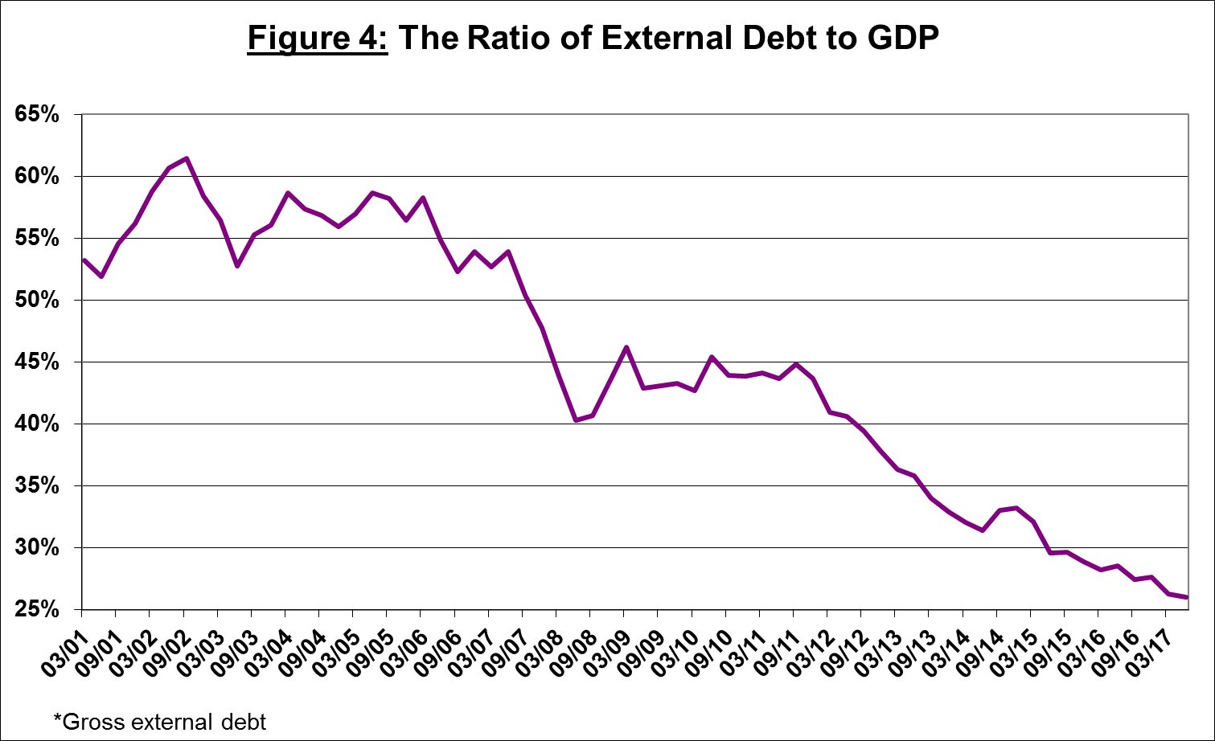

1. **The net external debt**

**The surplus of assets over liabilities vis-à-vis abroad** in debt instruments alone (negative net external debt) increased by about $1.6 billion (1.1 percent) in the second quarter, to about $142 billion at the end of June (Figure 5).

**The balance of short-term debt assets** (repayment/realization within a year) was about $157 billion at the end of June, mostly in the Bank of Israel’s foreign exchange reserves, reflecting a coverage ratio of 4.3 times short-term debt.

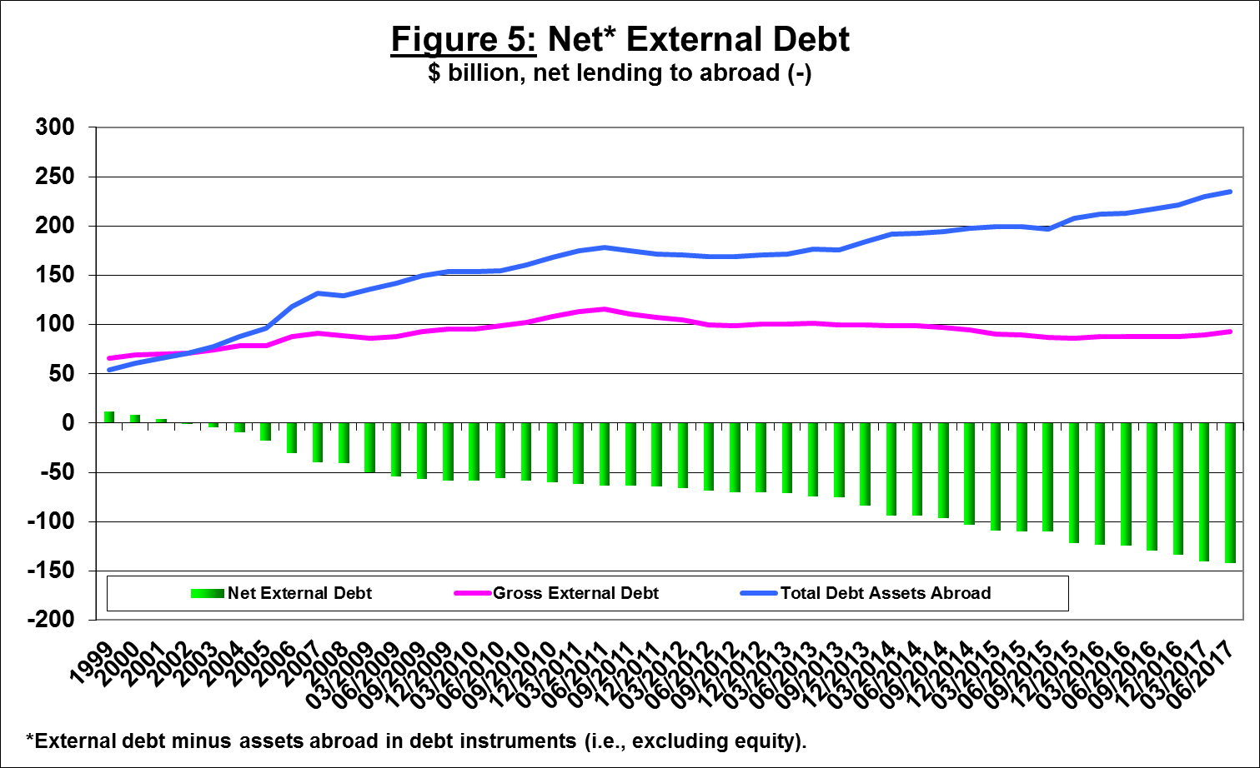

[For the complete data file, click here](http://www.bankisrael.gov.il/deptdata/pik_mth/pikmth_e.htm).