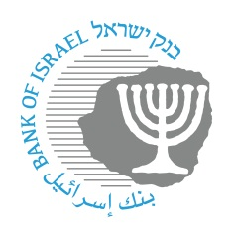

BANK OF ISRAEL
Office of the Spokesperson and Economic Information

Press Release

May 7, 2026

Press Release:

Foreign Exchange Reserves at the Bank of Israel, April 2026

Israel’s foreign exchange reserves at the end of April 2026 stood at $235,745 million, an increase of $6,326 million from their level at the end of the previous month. The level of the reserves relative to GDP was 38.4 percent (Figure 1).

The increase was mainly the result of a revaluation that increased the reserves by approximately $7,467 million. This increase was partly offset by the government’s foreign exchange activities totaling approximately $1,154 million.

Israel's Foreign Exchange Reserves ($ million)

Date | Reserves excluding IMF | Reserves at the IMF | Total Foreign Exchange Reserves
April 2026 | 231,130 | 4,615 | 235,745
March 2026 | 224,845^{c} | 4,574 | 229,419^{c}
February 2026 | 229,909^{c} | 4,636 | 234,545^{c}
January 2026 | 228,360^{c} | 4,682 | 233,042^{c}
December 2025 | 224,834^{c} | 4,674^{c} | 229,508^{c}
November 2025 | 226,794 | 4,631 | 231,425
October 2025 | 227,295 | 4,659 | 231,954
September 2025 | 227,246 | 4,634 | 231,880
August 2025 | 225,694^{c} | 4,626 | 230,320^{c}
July 2025 | 222,157 | 4,611 | 226,768
June 2025 | 223,651 | 4,599 | 228,250
May 2025 | 219,086^{c} | 4,553 | 223,639^{c}
April 2025 | 217,489 | 4,546 | 222,035

Figure 1
Level of foreign exchange reserves, and their ratio to GDP, 2008–2026

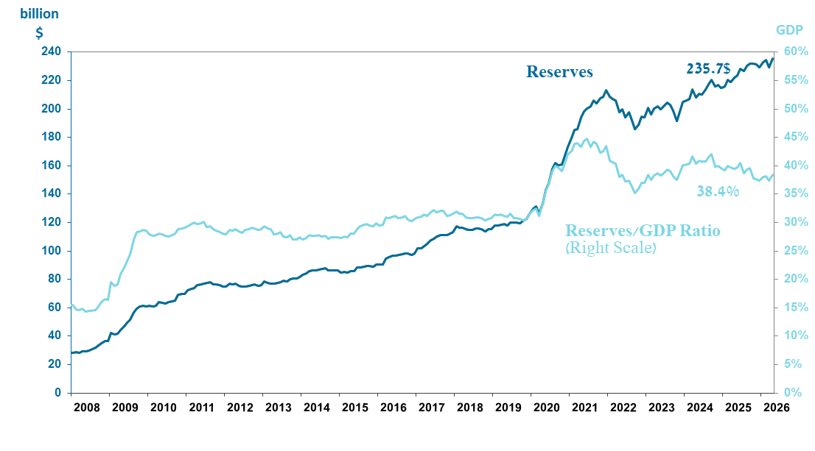

a Includes Bank of Israel payments and receipts in foreign currency.
^{b} This column includes Special Drawing Rights (SDRs), the balance of NAB loans, and the balance of Israel's reserve tranche at the IMF. c Updated after the original date of publication.

