

BANK OF ISRAEL

Office of the Spokesperson and Economic Information

May 8, 2024

Press Release:

Israel’s foreign currency market in the first quarter of 2024

**1. The Exchange Rate**

**Mixed trend of the shekel alongside strengthening of the US dollar worldwide.**

During the course of the first quarter, the shekel traded mixed. The shekel strengthened against the US dollar by approximately 1.5 percent and weakened against the euro by about 0.8 percent. In addition, the shekel weakened by 0.6 percent against the currencies of Israel's main trading partners, in terms of the nominal effective exchange rate (i.e., the trade-weighted average shekel exchange rate against those currencies).

In parallel, the US dollar strengthened against most major currencies (Figure 2) during the quarter—by approximately 2.3 percent against the euro, by about 6.9 percent against the Japanese yen, and by about 0.8 percent against the British pound.

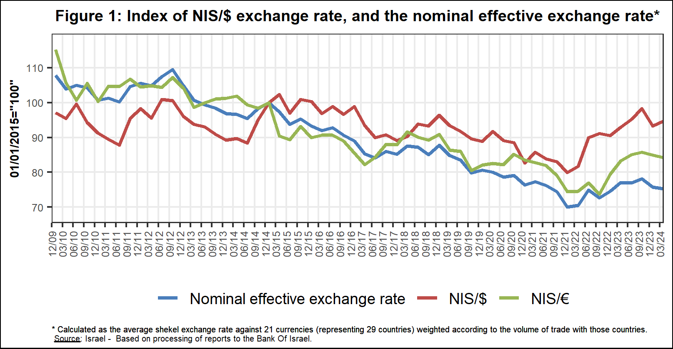

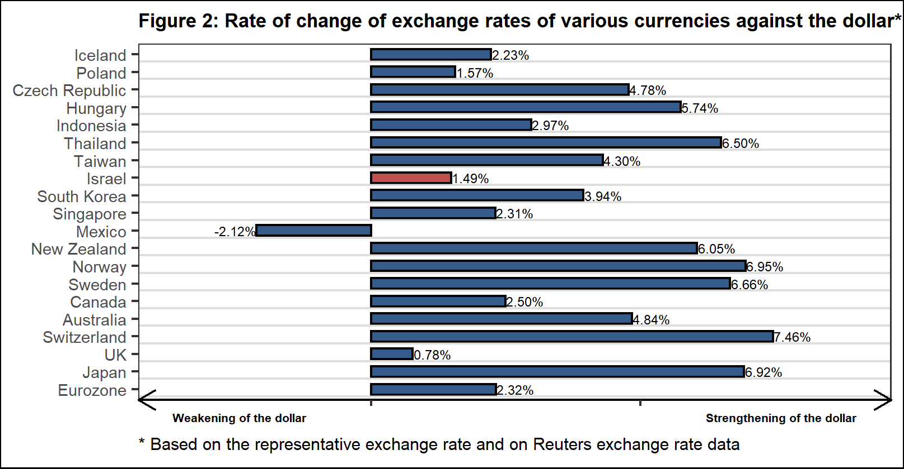

**2. Exchange Rate Volatility**

**An increase in actual volatility and a decline in implied volatility**

The standard deviation of changes in the shekel/dollar exchange rate, which represents its **actual** volatility, increased during the quarter, to an average level of 10.3 percent.

The average implied volatility in over-the-counter shekel/dollar options, an indication of **expected** exchange rate volatility, declined by approximately 0.4 percentage points, to about 10.1 percent by the end of the quarter.

For comparison, the average level of implied volatility in foreign exchange options in emerging markets was 9.7 percent at the end of the quarter, a decline of 1.4 percentage points from its level at the end of the previous quarter. The average level of implied volatility in advanced-economy markets was 7.1 percent during the quarter, a decline of about 0.6 percentage points from the previous quarter (Figure 4).

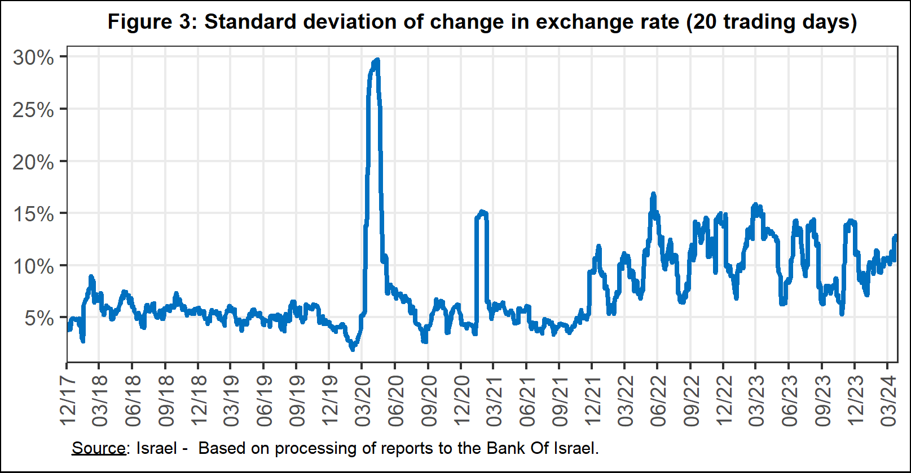

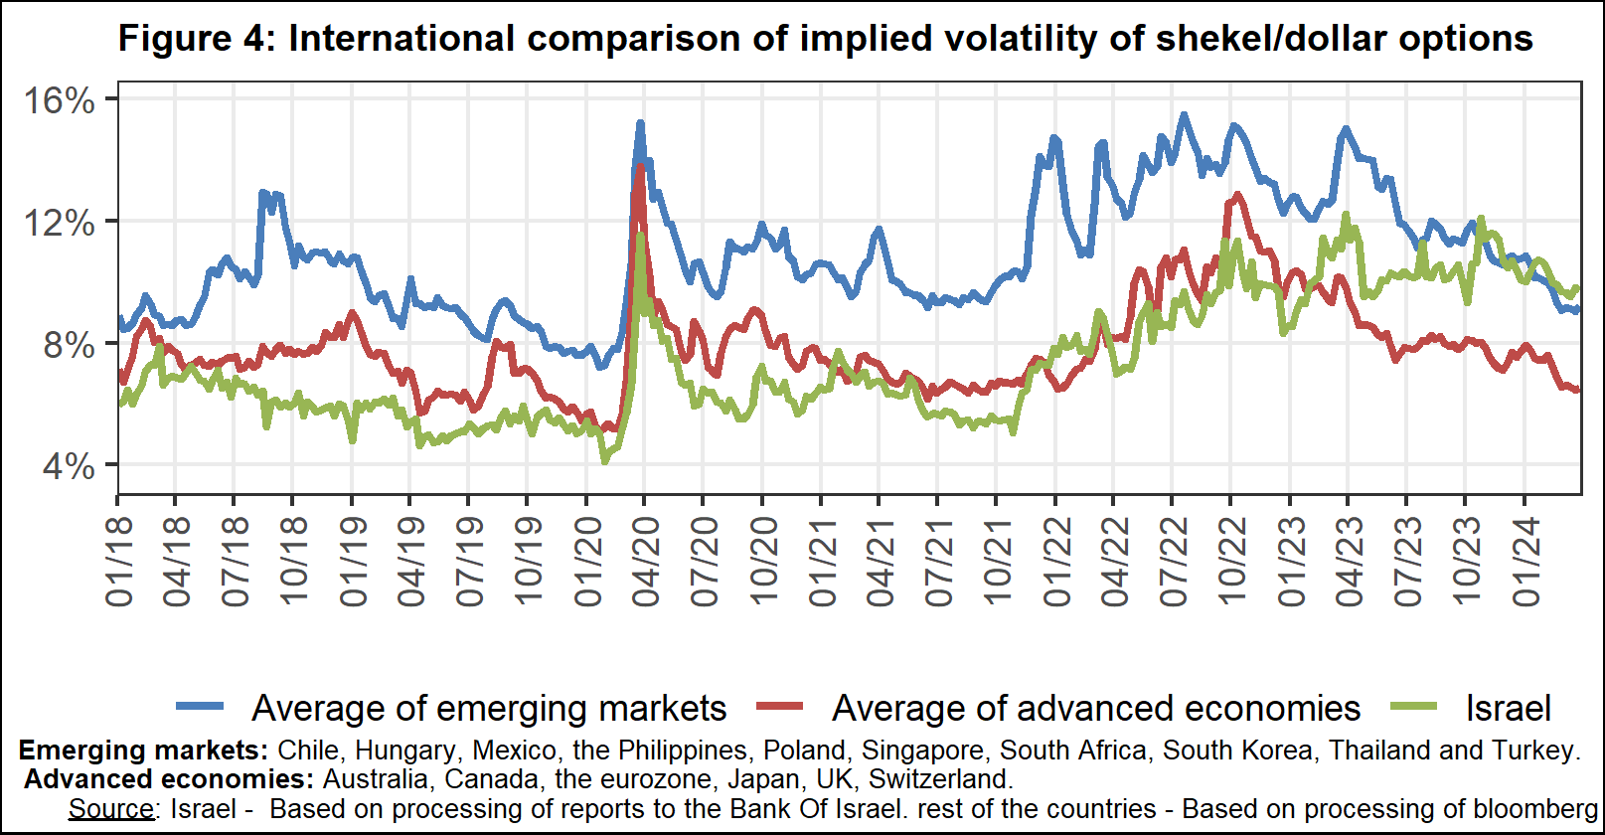

**3. The Activity of the Main Segments in the Foreign Exchange Market[1]**

An estimate of the activity of the **main** segments in the foreign exchange market indicates that during the course of the first quarter, **institutional investors (pension funds, provident funds, and insurance companies)** sold a net of about $5.3 billion, **the business sector** purchased a net of about $2 billion, and **nonresidents purchased a net** of about $0.6 billion.

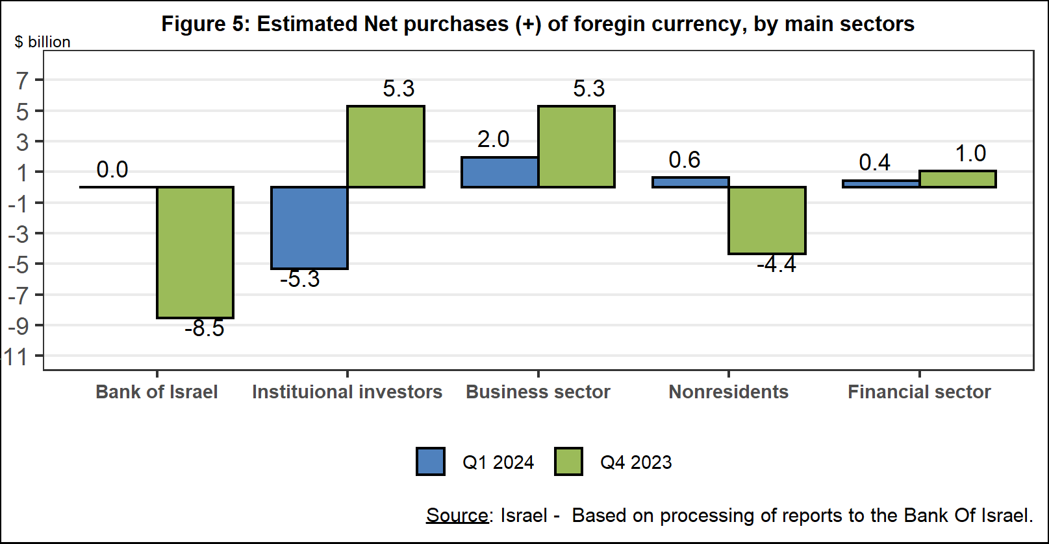

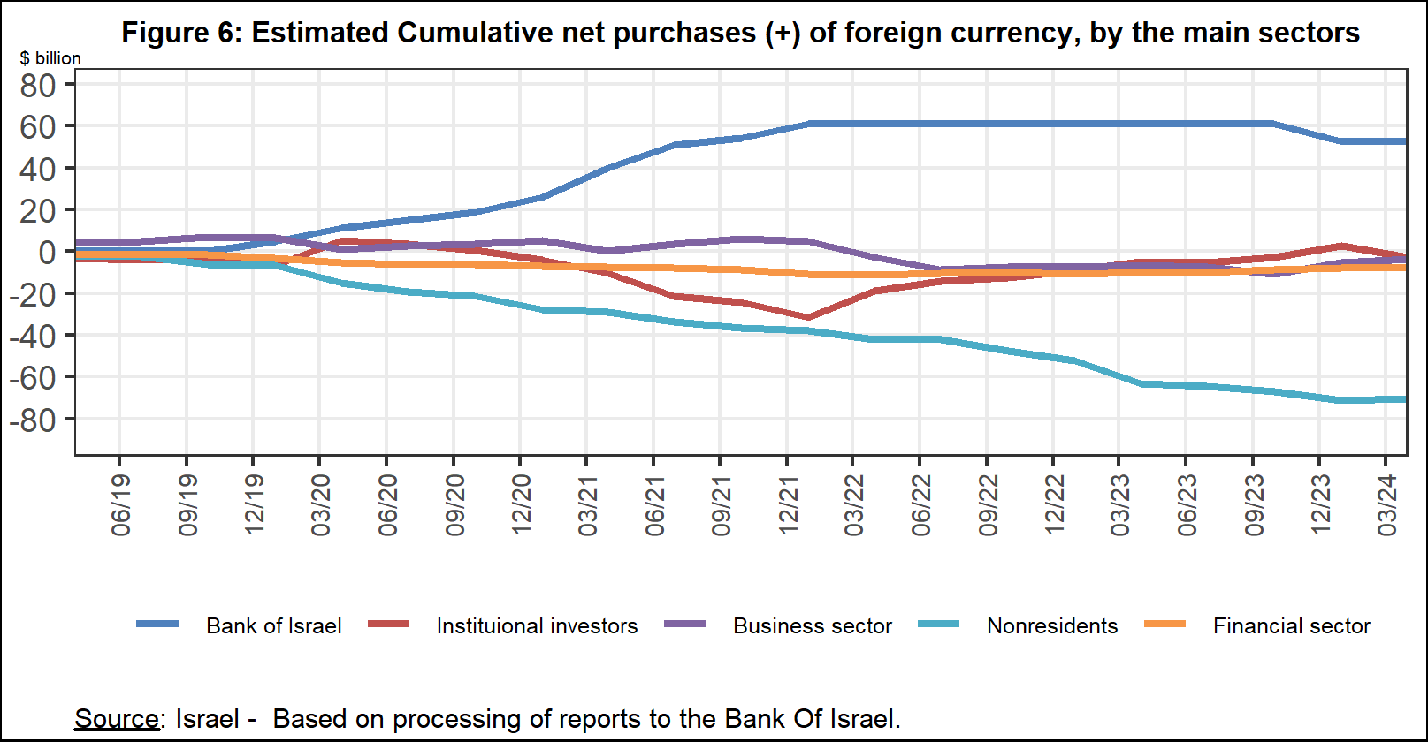

**4. Trading Volume in the Foreign Currency Market—Tables and Figures**

**Trading volume vis-à-vis the domestic banking system[2]**

**The average daily trading** **volume** declined by about 4.3 percent during the quarter to $10.1 billion, mainly due to a decline in the daily trading volume in options.

**Nonresidents' share of total trading volume vis-à-vis the domestic banking system** (spot and forward transactions, options, and swaps) decreased by about 5.3 percentage points to about 41.3 percent at the end of the first quarter.

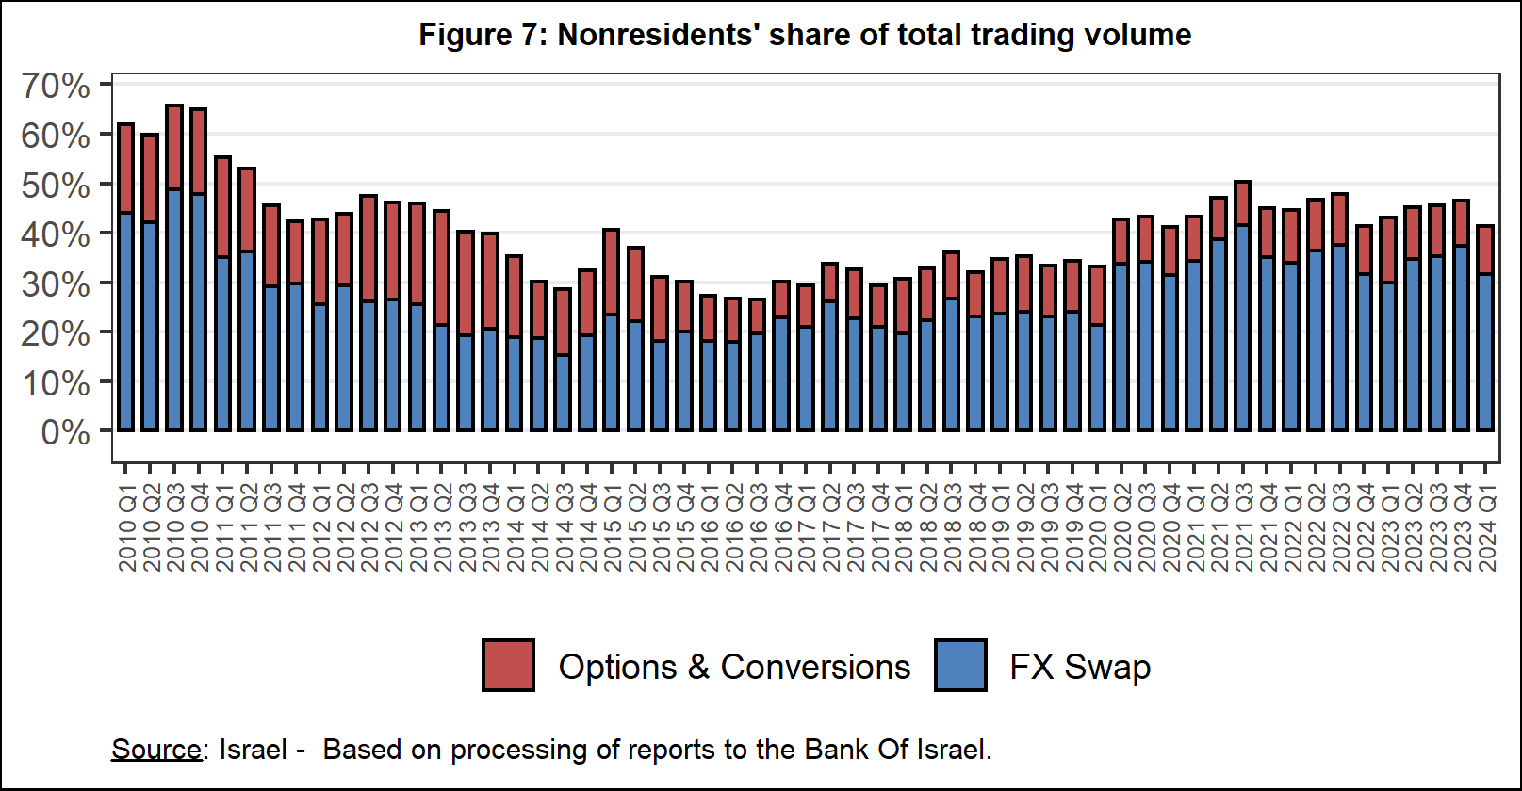



**Estimated total trading volume[3]—domestic banking system and foreign reporting entities**

The estimated total activity in transactions against the shekel reflected in reports from the domestic banking system and foreign reporting entities indicates that nonresidents’ relative share of trading volume in spot and forward transactions (excluding swaps and options) was 81.5 percent in the first quarter. Trade between nonresidents constituted 70.9 percent of the volume, which had a daily average of about $10.1 billion.



1. The main segments presented do not make up the entire market—for additional information, see the section on “The Database of Foreign Exchange Market Activity” in the Bank of Israel's "Statistical Bulletin" for 2018:

   https://boi.org.il/en/communication-and-publications/regular-publications/statistical-publications/statistical-bulletin-2018/
2. From the beginning of 2020, the data do not include branches of foreign banks in Israel.
3. Total trading volume is an estimate of total activity in transactions against the shekel, based on reports by the domestic banking system and by foreign reporting entities.