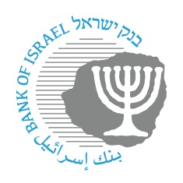

**BANK OF ISRAEL**

Office of the Spokesperson and Economic Information

February 7, 2023

Press Release:

**The Governor of the Bank of Israel met with members of the IMF delegation**

Governor of the Bank of Israel Prof. Amir Yaron and Bank of Israel staff met today with members of the IMF delegation who arrived for a short introductory visit in Israel, in view of the appointment of Mr. Miguel Segoviano, the new mission chief to Israel at the IMF. Mr. Segoviano heads a delegation that includes 3 additional members. This is a preliminary visit that was planned in advance, which began with a meeting with the Governor of the Bank of Israel, in order to meet the various relevant officials in Israel against the background of the change of members in the IMF’s delegation to Israel.

The delegation will hold several additional meetings with professionals in Israel and is expected to arrive in Israel again in May, for the ongoing annual meeting, as in every year. With the end of the visit in May, they are expected to publish initial remarks, followed later by a concluding report on the Israeli economy.

(Picture attached for your use, credit: Bank of Israel spokesperson.)

