

**BANK OF ISRAEL**

Office of the Spokesperson and Economic Information

October 25, 2021

Press Release:

New Research:

**Low Interest Rates and Banks’ Interest Margins: Does Deposit Market Concentration Matter?**

* **Research carried out at the Bank of Israel examined data on banks worldwide and found that the net interest margin (net interest income as a percentage of earning assets) is positively related to the level of short term interest rates in the economy.**
* **It was found that the positive relationship is stronger at low, near-zero, interest rate levels.**
* **It was also found that when the banking system is concentrated, changes in the interest rate have almost no effect on the net margin. However, in a low interest rate environment, interest rate changes impact the margin in concentrated markets as well.**

The connection between the level of the interest rate in the economy and bank performance is an important issue in understanding the impact of policy on the banking system and on economic activity, particularly the credit market.

New research conducted by Nimrod Segev, Sigal Ribon, and Miki Kahn of the Bank of Israel Research Department, in collaboration with Jakob de Haan of the University of Groningen, uses a broad and detailed database that incudes information on banks in OECD countries for 1995–2019. It examines the factors that impact banks’ net interest margin, and in particular how this spread is impacted by the short term interest rate environment in the economy and by the extent of competition in the country’s banking system. The research is part of a project within the framework of IBRN (International Banking Research Network), an international research group for collaboration among central banks on banking issues.

The research finds that the higher the short term interest rate in the economy is, the larger the net interest margin—the gap between interest income on credit and the cost of the banks’ sources. It also finds that in a concentrated banking system, interest rate changes have almost no impact on the net margin. However, in a low interest rate environment, interest rate changes impact on the margin in concentrated markets as well.

In recent years, particularly after the global financial crisis in 2008, the short term interest rates worldwide declined markedly, and in many countries they approached very close to zero. Figure 1 presents the range of interest rates in OECD countries over the years, and it indicates the notable downward trend.

**Figure 1**

**Short term interest rates in OECD countries, 1995–2019**

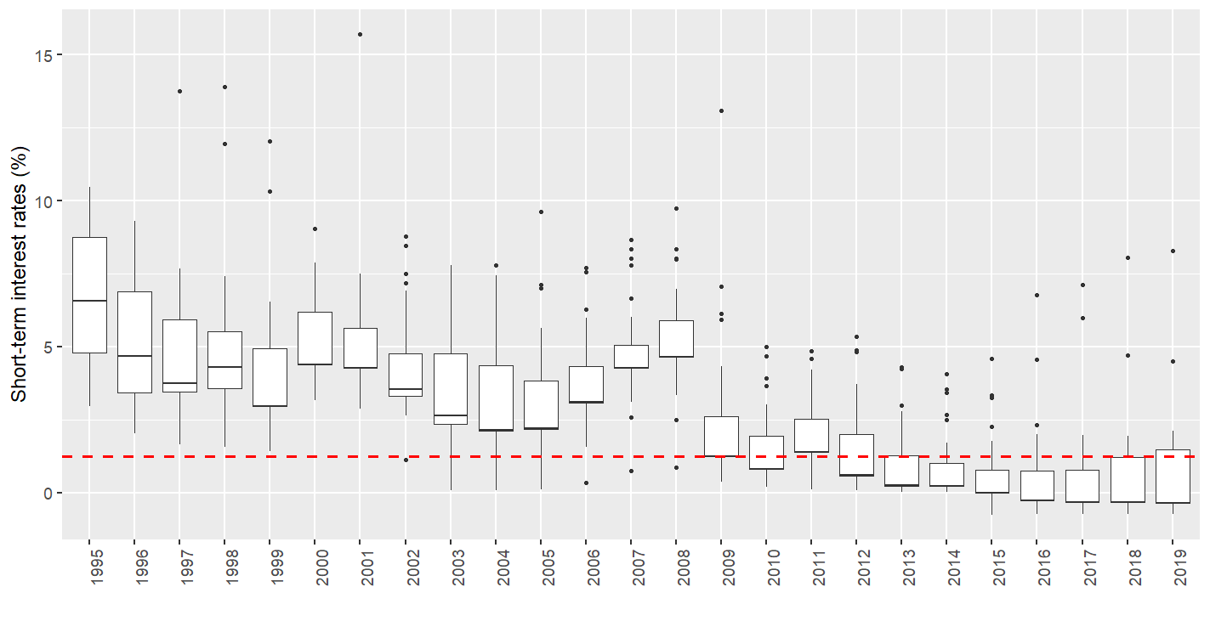

*The black line represents the median and the ends of the box represent the 25th and 75th percentiles of the interest rate in the sample countries. The ends of the lines represent the minimum and maximum values (excluding outliers), and the dots represent outlier observations that were not included. The dashed line represents the threshold interest rate (1.25 percent), below which we defined the interest rate as a “low interest rate”.

The research examines whether a low interest rate environment has a different impact on banks’ net interest margins. The research defines “low interest rate” similarly to other research around the world, as below 1.25 percent (indicated by the dashed line in the figure). Figure 1 indicates that interest rates have been low in most countries in recent years. The researchers found that in a low interest rate environment, changes in the short-term market interest rate have a greater impact on the net margin. This result reflects a greater impact on the income side and a weaker impact on the expenses side. That is, for example, when there is a decline in the interest rate, where the interest rate is already low, the banks’ interest income decreases markedly more than would have occurred in a high interest rate environment, while banks’ expenses decline only slightly, relative to the decrease that would have occurred in a high interest rate environment. This outcome is consistent with the assessment that as banks are limited in their ability to reduce the interest rate on retail deposits, and particularly to a negative interest rate, their ability to adjust their financing expenses is limited, and therefore the impact on the net margin is greater.

In the next stage, the researchers examined whether this phenomenon depends on the extent of banking system concentration in the various countries. The more banks that are active in a country, the lower the extent of concentration as measured in the research. There is considerable variance among the various countries—while, for example, in Germany there are more than 2,500 banks, and hundreds of banks in Austria, Italy, and Japan, in other countries only several banks operate.

It was found that the more concentrated the banking system is, the weaker the connection between market interest rate changes and changes in the net margin is, so that the net margin for banks in concentrated markets is not impacted, to a statistically significant extent, by changes in the interest rate. In a low interest rate environment, the net margin, even for banks that operate in a concentrated system, is impacted by a decline in the interest rate, though to a lesser extent than for banks in a more competitive banking system. This happens because even for banks in less competitive environments it is difficult to adjust downward their interest expenses (meaning the payment for sources for extending credit, and in particular the public’s deposits that they hold) when the interest rate is near zero. The table below indicates that the banks’ margins in a concentrated market are not impacted by changes in the interest rate when the interest rate environment is high, and the margins of banks in competition in a low interest rate environment are impacted to a much greater extent. A decline of 1 percentage point in the market interest rate will be reflected by a decline of 0.17 percentage points in the net interest margin of those banks.

**Table**

**The impact of a change in the interest rate on the banks’ margins in various situations**

|  |  |  |
| --- | --- | --- |
|  | **Concentrated market** | **Competitive market** |
| **High interest rate environment** | 0.0 | 0.07 |
| **Low interest rate environment** | 0.10 | 0.17 |

The researchers also examined the impact of low interest rates over time and found that the impact of a low interest rate on interest rate margins depends on the amount of time in which it remains there, although based on the results of the research, the impact increased only up to a specific point—about 4 years to 6 years. The reason may be that over time the banks learn to adjust their income and expenses structure to the low interest rate environment, for example by reducing the share of deposits in the financing sources for extending credit. However, based on the estimation, banks in countries with a more competitive banking system are more sensitive to the length of the period for which interest rates are low, while banks in countries with more concentrated banking systems are almost not impacted at all by long periods of low interest rates.