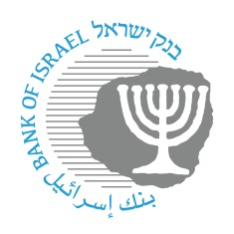
BANK OF ISRAEL
Office of the Spokesperson and Economic Information

May 30, 2023

Press Release:

Launch of “Awareness of Handling Digital Fraud Week”

The “Awareness of Handling Digital Fraud Week”— led by the Bank of Israel’s Banking Supervision Department, through the Association of Banks in Israel and the banking system and with the collaboration of the Israel Police and the Welfare and Social Security Ministry—will take place between June 4 and 15, 2023. During the week, there will be dozens of in-person lectures across the country to organizations, nonprofit associations, and assisted living facilities that registered in advance. In addition, there will be webinars for the public. All the lectures will be given in Hebrew, Arabic, and Russian.

The content that will be given over in the lectures will deal with the types of digital fraud; how to identify and take care regarding digital fraud and impersonation methods; when one must not click on links; how to securely access a bank account; provision of tips and tools for dealing with types of fraud; information on fraud methods that are aimed specifically at previous residents of the former Soviet Union, and more.

In addition, within the framework of this activity, a national public awareness campaign was launched with the goal of increasing the public’s awareness of the digital fraud phenomenon. In addition, a designated site was set up, which contains tips on the issue, relevant materials on “Digital Fraud Awareness Week”, as well as information on how to register for the Internet lectures (webinars), which will be held on the following dates:
June 8, 2023—19:00—lecture in Russian
June 13, 2023—19:00—lecture in Hebrew
June 14, 2023—19:00—lecture in Arabic

For additional details on the activity and to sign up for the webinar, click on the following link: https://financialforumil.com/ or search on Google for “Financial Education Forum”.

