

BANK OF ISRAEL

Office of the Spokesperson and Economic Information

July 21, 2016

Press Release

Companies Survey for the Second Quarter of 2016—Main Findings

**The Companies Survey for the second quarter of 2016 indicates that the business sector returned to the growth rate that has characterized it over the past three years. The weighted net balance for the second quarter is positive to a statistically significant degree (Figure 1 and Table 1). There are positive net balances in domestic-demand oriented industries—trade, construction and transport and communications. In contrast, in the manufacturing, services, and hotels industries, the net balances are near zero, indicating that in those industries the rate of change is lower. Expectations for the third quarter among the various industries are in line with the net balances of the current quarter, other than in the services industry, where a marked expansion in activity is expected (despite a near-zero net balance).**

**Figure 1**

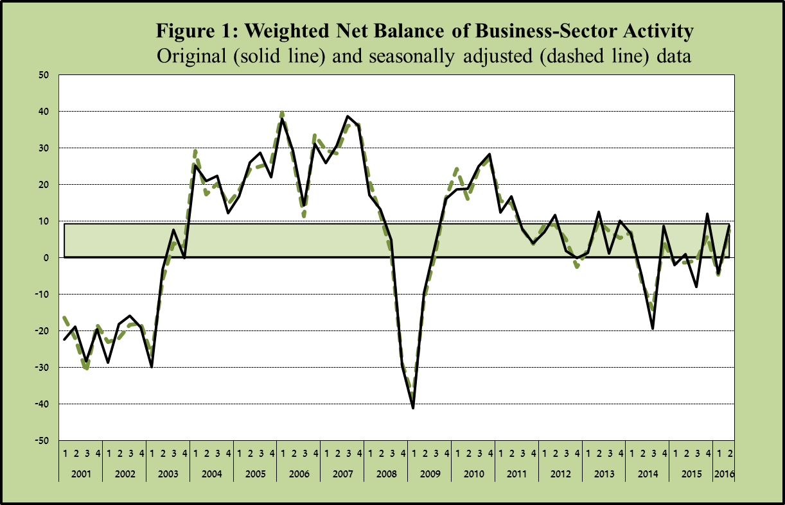

* The net balance is the difference between the share of companies and businesses reporting an increase in activity and the share of those reporting a decrease in activity, weighted according to size of the industry in the business sector.

**Table 1 - Economic activity in the principal industries, based on the net balance of reported activity**

(Original and seasonally adjusted data, percent)



The net balance of **manufacturing** industry output indicates that output and the number of employees have essentially not changed. Nonetheless, companies report a decline in sales to the domestic market and a moderate contraction in exports. Expectations in the industry are for an additional slight slowdown next quarter, based on the orders for the domestic market and for exports.

The net balance of **services** industry revenue also indicates no change in activity, due to stability in the sales of services in Israel, even as sales to abroad continue to contract. It appears that companies see the contraction as a temporary situation, as they are expanding their workforces and expect an increase in orders next quarter.

The net balance of sales in the **trade** industry was positive to a statistically significant extent, but was not accompanied by an increase in the number of employees. Expectations in the industry are that sales will continue to increase in the next quarter.

The net balance of overall activity in the **transport and communications** industry was also very positive, reflecting increases in sales of services to Israelis and in the utilization of equipment, alongside stability in sales of services to nonresidents. Expectations in the industry are that activity will continue to expand in the next quarter.

In the **construction** industry, the net balance of volume of activity was positive, reflecting an increase in activity in the construction of buildings alongside a contraction in infrastructure construction. Expectations in the industry are that activity will continue to expand in the next quarter as well.

The net balance of activity in the **hotels** industry is negative and indicates a decline in the level of activity. The balance reflects a further decline in the number of overnight stays by tourists from abroad alongside an increase in the number of overnight stays by Israelis. Expectations in the industry are that the decline in reservations will continue in the next quarter.

An examination of supply and demand constraints indicates that demand remains the main constraint on activity (excluding the construction industry); although demand constraints in all industries are not severe. In terms of the financing constraint, its level is low but it has become somewhat more severe among small companies, and is stable among medium and large companies (Figure 3).

In the second quarter of 2016, **companies’ expectations of the inflation rate over the coming 12 months increased** to 1.22 percent, with the median remaining at the lower bound (1 percent) of the price stability target range. Likewise, the share of companies that expect inflation over the coming 12 months to be within the target range indicating price stability (1–3 percent) increased to 70 percent. **Expectations for the next quarter regarding the exchange rate** remained stable, at NIS 3.89/$ for the next quarter, and at NIS 3.94 /$ for one year from now.

* * *

The Research Department notes that the findings of the Companies Survey for the second quarter of 2016 are based on the responses of about 330 companies and businesses in various industries.

The survey’s questions are qualitative: companies are asked to report the direction of changes in various variables—increase, decline, or stability—and to note the strength of the change—“great” or “slight”.

The Companies Survey data are generally in line with the trends of the macroeconomic data of the economy, and the findings’ advantage is in being readily available and providing information rapidly, relative to other sources of data.

**Other tables and figures**

**Table 2: Statistical analysis of 12-month inflation expectations**



* Skewness is calculated as the difference between average and mode.

**Table 3: Companies’ expectations for the NIS/$ exchange rate**

At the time of the survey, the average exchange rate was NIS 3.86/$



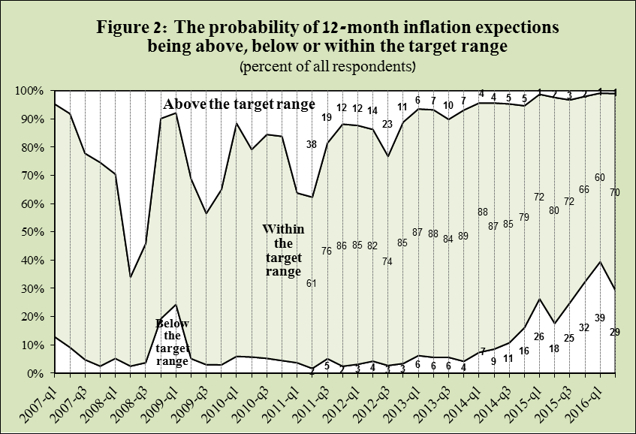

**Table 4: Manufacturing – net balances**



**Table 5: Trade – net balances**



**Table 6: Construction – net balances**



**Table 7: Transport and Communications – net balances**



**Table 8: Hotels – net balances**



**Table 9: Service industries – net balances**



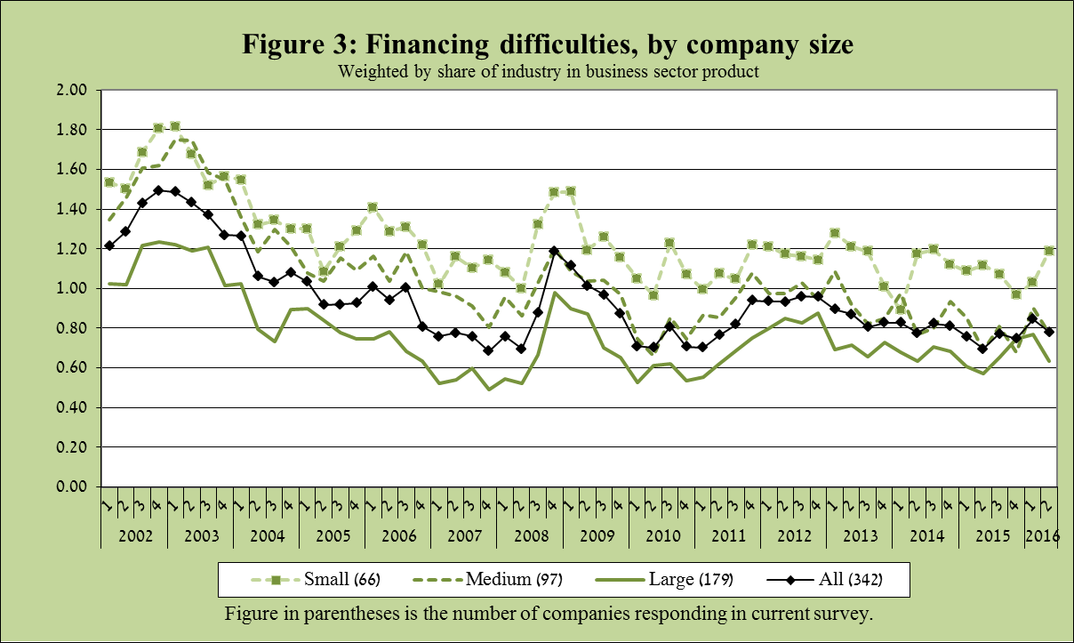

**Table 10.1: Net balance of the Manufacturing companies by size of company, 2016:Q1**

|  |  |  |  |  |
| --- | --- | --- | --- | --- |
| **Manufacturing companies** | | | | |
|  | Total | Small | Medium | Large |
| Output | 4-* | 23-* | 21-* | 6* |
| Total sales | 4-* | 13-* | 32- | 9* |
| Domestic sales | 11-* | 7-* | 47- | 2* |
| Exports | 5-* | 38-* | 27- | 5* |
| Number of companies | 136 | 15 | 34 | 87 |

**Table 10.1: The net balance of manufacturing companies classified by human-capital intensity and innovation**

(Original data, percent)





1 Industries in which fewer than 20 companies responded to the question regarding constraints.