

BANK OF ISRAEL

Office of the Spokesperson and Economic Information

September 7, 2023

Press Release:

Foreign Exchange Reserves at the Bank of Israel, August 2023

Israel’s foreign exchange reserves at the end of August 2023 stood at $202,856 million, a decrease of $1,809 million from their level at the end of the previous month. The level of the reserves relative to GDP was 38.9 percent (Figure 1).

The decrease was mainly the result of a revaluation that decreased the reserves by approximately $2,096 million.

In contrast, the increase was partly offset by government transfers from abroad totaling approximately $341 million.

**Israel's Foreign Exchange Reserves (**$ million)

|  |  |  |  |
| --- | --- | --- | --- |
| **Date** | **Reserves excluding IMF (including reserves bought under the natural gas purchase program)** | **Reserves at the IMF[1]** | **Total Foreign Exchange Reserves** |
| August 2023 | 198,338 | 4,518 | 202,856 |
| July 2023 | 200,086c | 4,579 | 204,665c |
| June 2023 | 197,363c | 4,513 | 201,876c |
| May 2023 | 195,100 | 4,521 | 199,621 |
| April 2023 | 197,390 | 4,505 | 201,895 |
| March 2023 | 195,951c | 4,535 | 200,486c |
| February 2023 | 191,987c | 4,292 | 196,279c |
| January 2023 | 196,460c | 4,525c | 200,985c |
| December 2022 | 189,742c | 4,476c | 194,218c |
| November 2022 | 189,997 | 4,421c | 194,418c |
| October 2022 | 184,531 | 4,311 | 188,842 |
| September 2022 | 181,720c | 4,274 | 185,994c |
| August 2022 | 187,804 | 4,347 | 192,151 |
| July 2022 | 193,011c | 4,458 | 197,469c |

**Figure 1**

**Level of foreign exchange reserves, and their ratio to GDP, 2007–2023**

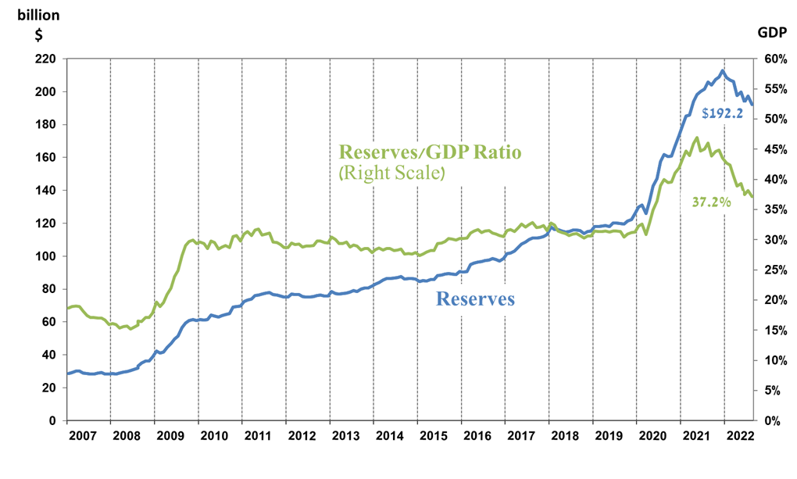

1. b This column includes Special Drawing Rights (SDRs), the balance of NAB loans, and the balance of Israel's reserve tranche at the IMF.

   c Updated after the original date of publication.