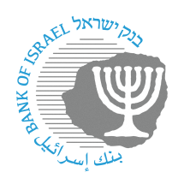

BANK OF ISRAEL

Office of the Spokesperson and Economic Information

Press release

January 23, 2023

**Prof. Moshe Hazan announces that he is stepping down from the Monetary Committee**

The Bank of Israel announces that Prof. Moshe Hazan sent the prime minister a letter last night in which he resigned from his position as member of the Monetary Committee representing the public, after having served in the position since October 2, 2017.[1] Prof. Hazan’s resignation comes in view of his intention to become involved in public-political activity.

Following Prof. Hazan’s resignation, the Monetary Committee now consists of five people, which is the required quorum for the Committee’s continued operation.

Bank of Israel Governor Prof. Amir Yaron expressed his appreciation for Prof. Hazan’s professional contribution, and announced that the search committee for appointing members to the Bank of Israel’s Monetary Committee will work quickly to advance the appointment of a public representative on the Monetary Committee.

1. The public representatives on the Bank of Israel Monetary Committee are appointed by the government at the recommendation of the Bank of Israel Governor, following a process conducted by the committee to identify candidates to serve as members from among the public on the Bank of Israel’s Monetary Committee and the Bank of Israel’s Supervisory Council.