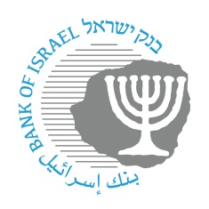

**BANK OF ISRAEL**

Office of the Spokesperson and Economic Information

August 26, 2024

Press release:

**Bank of Israel Governor Prof. Amir Yaron’s trip to the economic symposium at Jackson Hole, Wyoming**

The Governor of the Bank of Israel, Prof. Amir Yaron, returned to Israel yesterday from a working trip to Jackson Hole, Wyoming, in the US.

The Governor participated in the annual conference organized by the Federal Reserve Bank of Kansas City. It focused on the issue of monetary policy and the economic factors impacting on it.

Participating in the conference were senior officials from central banks around the world, as well as from the BIS and the economic academic world.