BANK OF ISRAEL
Office of the Spokesperson and Economic Information

November 6, 2025

Press Release:

Foreign Exchange Reserves at the Bank of Israel, October 2025

Israel’s foreign exchange reserves at the end of October 2025 stood at $231,954 million, an increase of $74 million from their level at the end of the previous month. The level of the reserves relative to GDP was 41.3 percent (Figure 1).

The increase was mainly explained by a revaluation of the reserves totaling approximately $607 million, which was partly offset by foreign exchange activity by the government totaling about $550 million.

Israel's Foreign Exchange Reserves ($ million)

Date | Reserves excluding IMF (including reserves bought under the natural gas purchase program) | Reserves at the IMF | Total Foreign Exchange Reserves
October 2025 | 227,295 | 4,659 | 231,954
September 2025 | 227,246 | 4,634 | 231,880
August 2025 | 225,694^{c} | 4,626 | 230,320^{c}
July 2025 | 222,157 | 4,611 | 226,768
June 2025 | 223,651 | 4,599 | 228,250
May 2025 | 219,086^{c} | 4,553 | 223,639^{c}
April 2025 | 217,489 | 4,546 | 222,035
March 2025 | 214,394^{c} | 4,416 | 218,810^{c}
February 2025 | 215,898^{c} | 4,356 | 220,254^{c}
January 2025 | 211,710^{c} | 4,358 | 216,068^{c}
December 2024 | 210,170^{c} | 4,400^{c} | 214,570^{c}
November 2024 | 212,684 | 4,416 | 217,100
October 2024 | 211,638 | 4,436 | 216,074

Figure 1
Level of foreign exchange reserves, and their ratio to GDP, 2008–2025

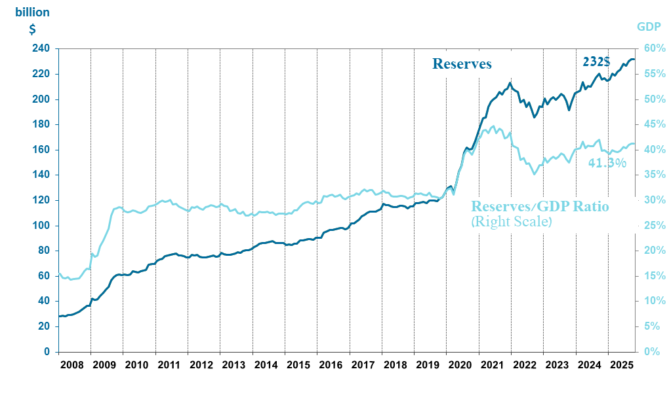

Including Bank of Israel payments and receipts in foreign currency.
^{b} This column includes Special Drawing Rights (SDRs), the balance of NAB loans, and the balance of Israel's reserve tranche at the IMF. c Updated after the original date of publication.

