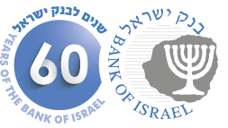

BANK OF ISRAEL

Office of the Spokesperson and Economic Information

June 8, 2014

Press Release

**Israel’s foreign currency market in May 2014**

**1. The Exchange Rate**

**The shekel weakened against the dollar, as the dollar strengthened against global currencies.**

In May, the shekel weakened by about 0.3 percent against the dollar, and strengthened by about 1.5 percent against the euro. Against the currencies of Israel's main trading partners, in terms of the nominal effective exchange rate of the shekel (i.e., the trade-weighted average shekel exchange rate against those currencies), the shekel strengthened by about 0.2 percent.

In May, the dollar strengthened against most currencies—including by about 1.8 percent against the Swiss franc, by about 1.8 percent against the euro, by about 0.7 percent against the British pound—while it weakened by about 0.9 percent against the Japanese yen.

**2. Exchange Rate Volatility**

**Actual volatility of the exchange rate declined along with a decline in the implied volatility of the exchange rate.**

The standard deviation of changes in the shekel-dollar exchange rate, which represents its actual volatility, decreased in May by about 0.8 percentage points to 3.8 percent.

The average level of implied volatility in over the counter shekel-dollar options––an indication of expected exchange rate volatility––declined to 6.3 percent at the end of May, compared with 6.7 percent in April.

At the same time, in May, the implied volatility in foreign exchange options in emerging markets also declined, reaching 7.7 percent on average. The implied volatility in foreign exchange options in advanced economies declined as well in May, to 6.2 percent at the end of the month.

**3. The Volume of Trade in the Foreign Currency Market**

**An increase in trading volume of conversion transactions and in nonresidents’ share of total trading volume**

**The total volume of trade in foreign currency** in May was about $106 billion, compared with about $98 billion in April. Average daily trading volume declined by about 3 percent in May, and reached about $5.3 billion.

**The volume of trade in spot and forward transactions (conversions)** was about $32 billion in May, compared with about $28 billion in April. The average daily trading volume in those transactions increased in May by about 1.7 percent compared with April. During May, the Bank of Israel bought $295 million through conversion transactions[1], as part of the purchase program intended to offset the effect of natural gas production on the exchange rate.

**The volume of trade in over the counter foreign currency options** (which are not traded on the stock exchange) totaled about $8.8 billion in May. The average daily trading volume in those options in May was about $440 million, an increase of about 30 percent from its level in April.

**The trading volume of swap transactions** was about $64 billion in May. Average daily turnover declined from the previous month, to around $3.2 billion.

**Nonresidents' share of total trade** (spot and forward transactions, options and swaps) increased in May, to about 32 percent, compared with about 27 percent in April.

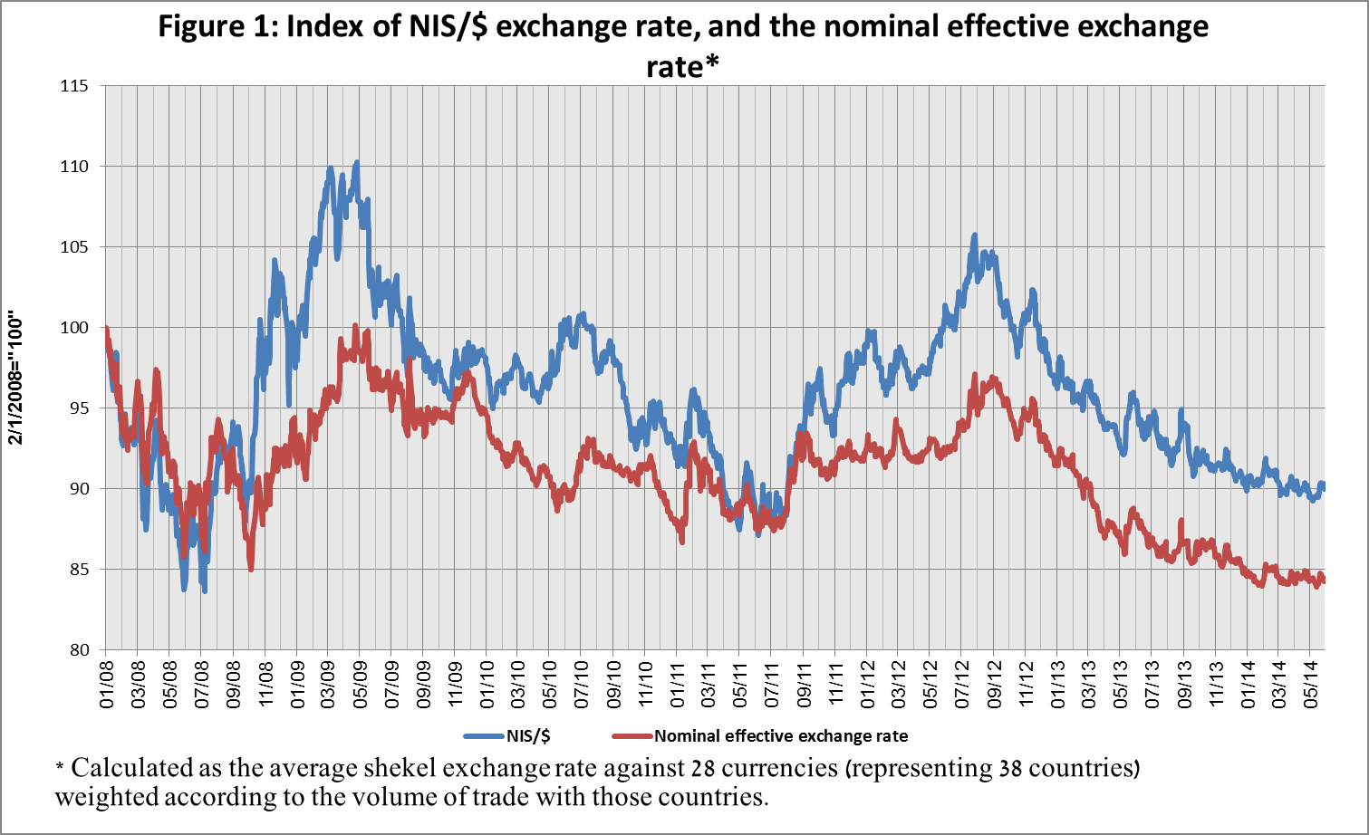

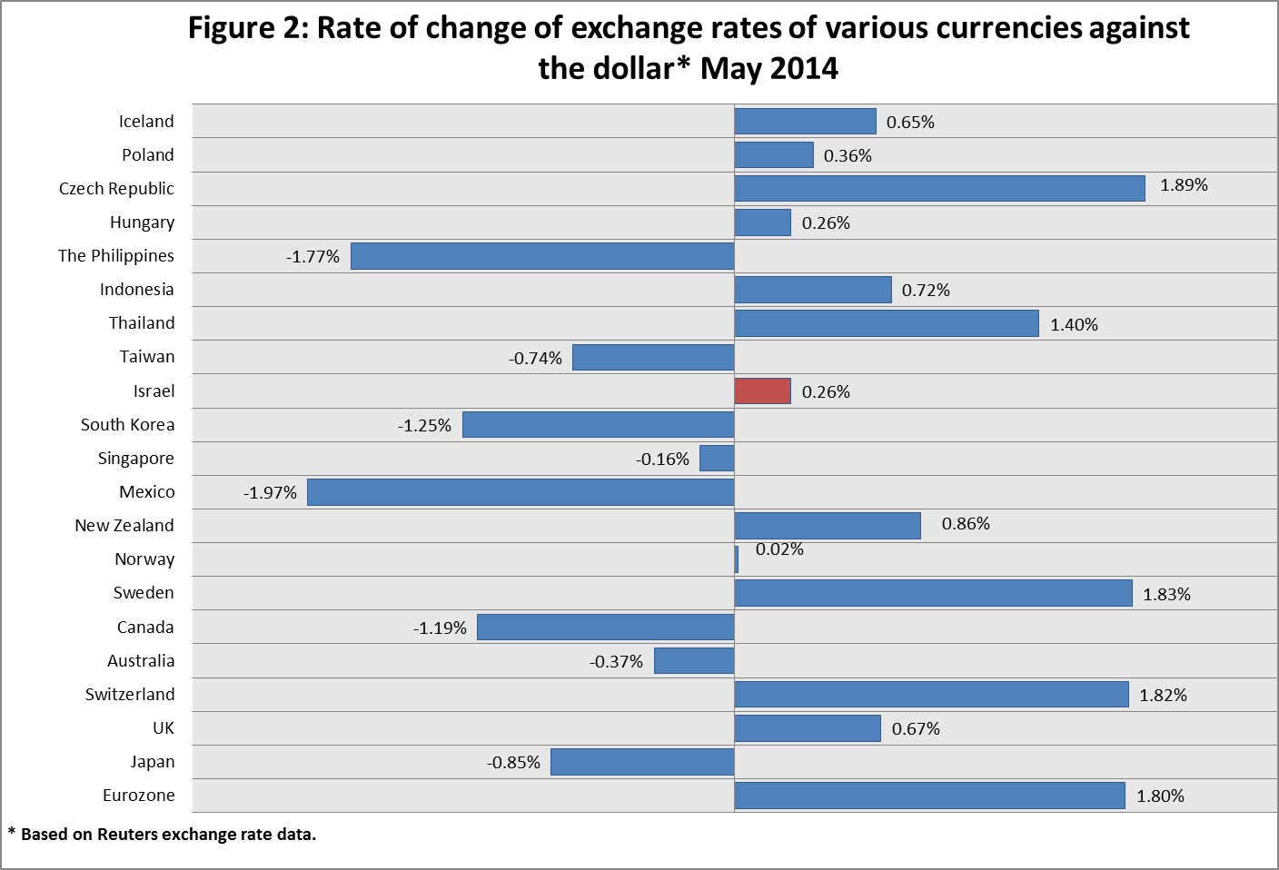

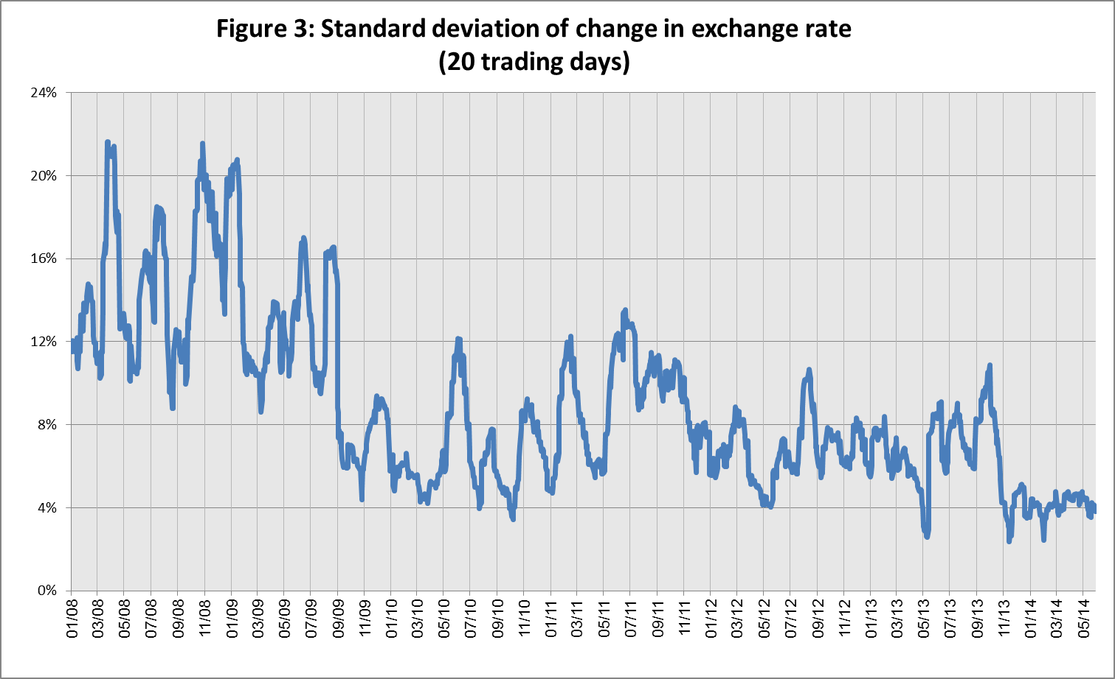

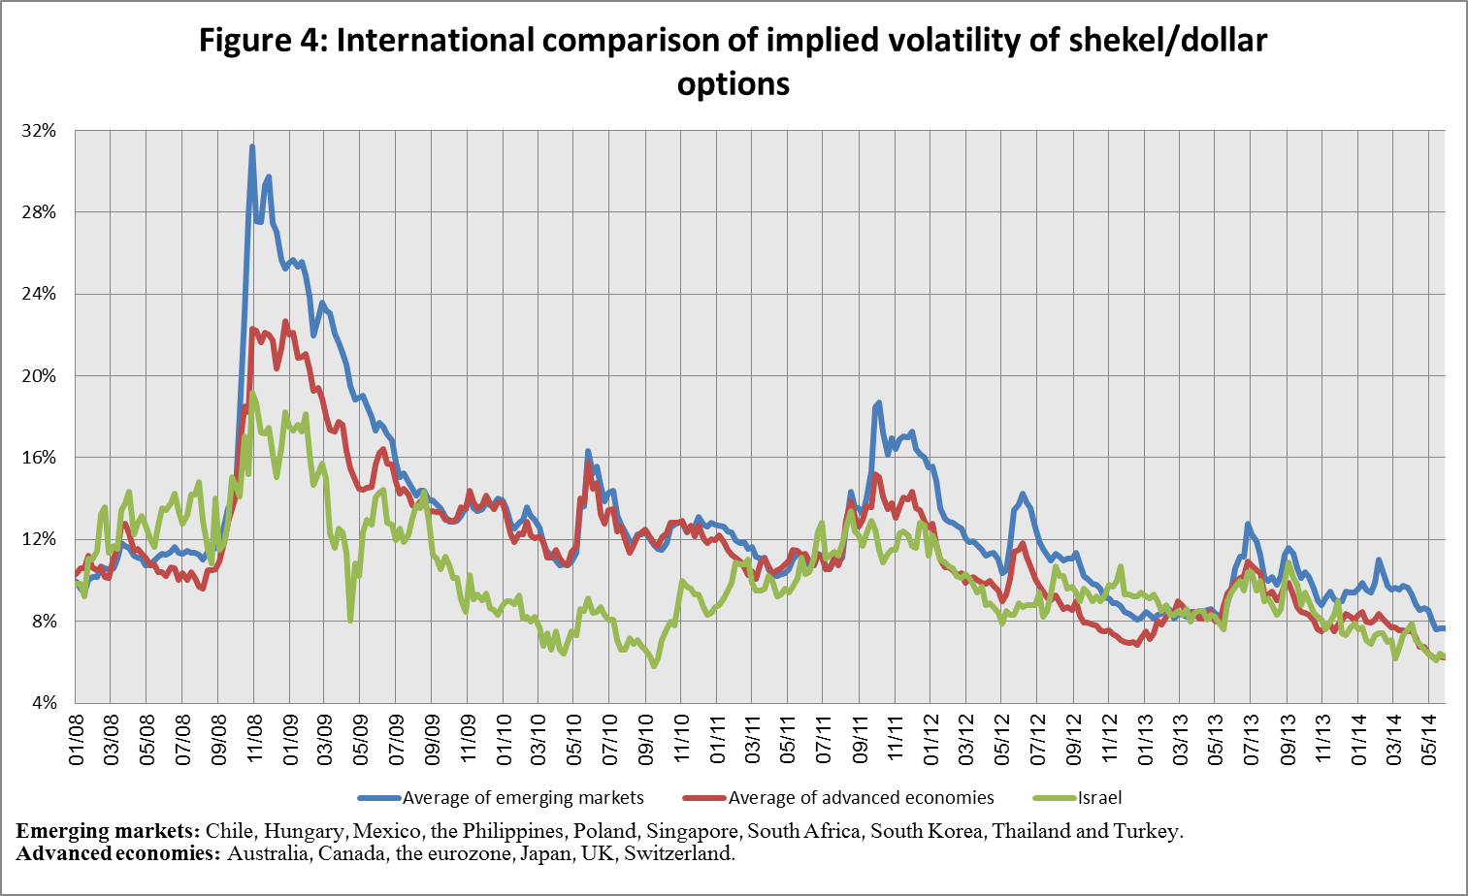

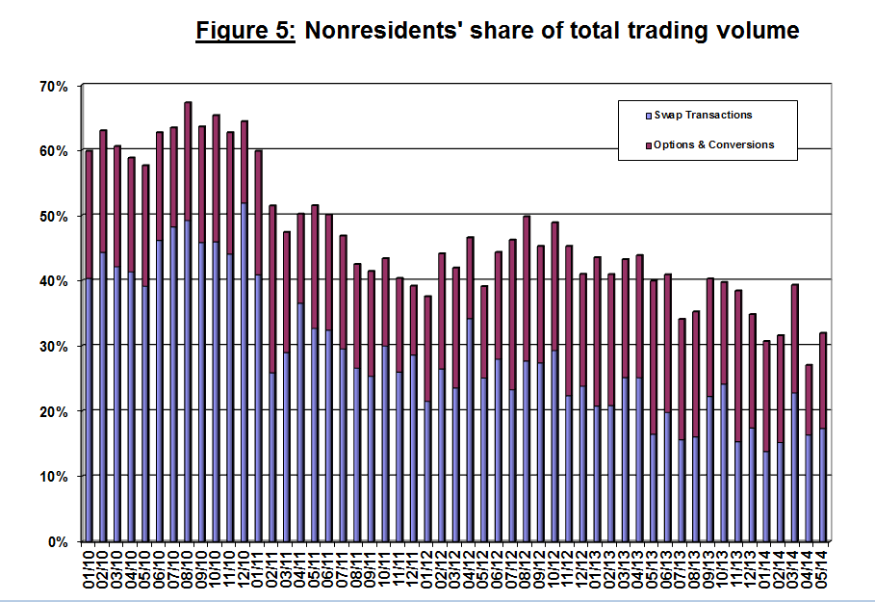

**Forex transactions with domestic banks, by instruments and sectors** ($ million)

|  |  |  |  |  |  |  |
| --- | --- | --- | --- | --- | --- | --- |
|  |  | **Conversions (1)** | **Swaps[2] (2)** | **Cross Currency swap[3] (3)** | **Options[4] (4)** | **Total volume of trade (1)+(2)+(3)+(4)** |
| **May**  **2014**  **(Not final)** | **Total** | **31,878** | **64,332** | **509** | **8,816** | **105,535** |
| **Daily average (20 days)** | **1,594** | **3,217** | **25** | **441** | **5,277** |
| **Nonresidents** | 12,359 | 18,220 | 0 | 2,962 | 33,541 |
| **of which** Foreign financial institutions | 11,758 | 18,191 | 0 | 2,840 | 32,789 |
| **Residents** | 19,519 | 46,112 | 509 | 5,854 | 71,994 |
| **of which** Real sector | 6,347 | 5,427 | 59 | 2,221 | 14,054 |
| **Financial sector** | 3,148 | 26,047 | 136 | 1,939 | 31,270 |
| **Institutions (incl. insurance companies)** | 2,640 | 6,056 | 0 | 1 | 8,697 |
| **Individuals and provident funds** | 800 | 747 | 0 | 518 | 2,065 |
| **The Bank of Israel** | 295 | 0 | 0 | 0 | 295 |
| ***of which*** within the program to offset the gas effect | 295 | 0 | 0 | 0 | 295 |
| **Other[5]** | 3,074 | 35 | 0 | 518 | 3,627 |
| **Domestic banks[6]** | 3,215 | 7,800 | 314 | 657 | 11,986 |
| **April**  **2014** | **Total** | **28,198** | **63,595** | **150** | **6,134** | **98,077** |
| **Daily average (18 days)** | **1,567** | **3,533** | **8** | **341** | **5,449** |
| **Nonresidents** | 8,793 | 16,017 | 0 | 1,651 | 26,461 |
| **of which** Foreign financial institutions | 8,055 | 15,799 | 0 | 1,644 | 25,498 |
| **Residents** | 19,405 | 47,578 | 150 | 4,483 | 71,616 |
| **of which** Real sector | 5,888 | 4,871 | 87 | 1,941 | 12,787 |
| **Financial sector** | 3,348 | 28,499 | 0 | 1,788 | 33,635 |
| **Institutions (incl. insurance companies)** | 3,680 | 6,516 | 0 | 1 | 10,197 |
| **Individuals and provident funds** | 700 | 654 | 0 | 202 | 1,556 |
| **The Bank of Israel** | 590 | 0 | 0 | 0 | 590 |
| ***of which*** within the program to offset the gas effect | 290 | 0 | 0 | 0 | 290 |
| **Other[7]4** | 2,767 | 20 | 0 | 17 | 2,804 |
| **Domestic banks[8]5** | 2,432 | 7,018 | 63 | 534 | 10,047 |

1. This figure reflects transactions by trade date, not settlement date. Therefore, it is not necessarily identical to the data published in the foreign exchange reserves notice, which reflects transactions by settlement date.
2. Only one leg of the swap, i.e., the nominal value of the transaction (in accordance with the BIS definition)
3. The exchanged founds through Cross Currency Swap transactions considered for the volume, as one leg only in cases where the two legs offset each other.
4. The national value, that includes purchases and sales of put and call options.
5. Including other entities such as portfolio managers, nonprofit organizations, national institutions, and those not include elsewhere.
6. Total interbank trade, divided in two.
7.
8.