|  |  |
| --- | --- |
| C:\Users\z862\AppData\Local\Microsoft\Windows\Temporary Internet Files\Content.Outlook\M6E9SVHT\Logo Bank of Israel 2 color (2).png  BANK OF ISRAEL  Office of the Spokesperson and Economic Information | MINISTRY OF FINANCE  Office of the Spokesperson |

February 1, 2023

Press Release

**Minister of Finance Betzalel Smotrich and Bank of Israel Governor Prof. Amir Yaron met yesterday evening to continue their discussion on the Economic Arrangements Bill and State Budget for 2023-2024**

At the meeting, the parties agreed on the importance of maintaining a responsible fiscal framework when passing the budget and Economic Arrangements Bill, and of consistency between the fiscal and monetary policies being adopted at this time.

The meeting was a broad working discussion with the participation of professionals from both offices, further to the working meeting the Minister and the Governor held two weeks ago as part of the preparation of the Economic Arrangements Bill.



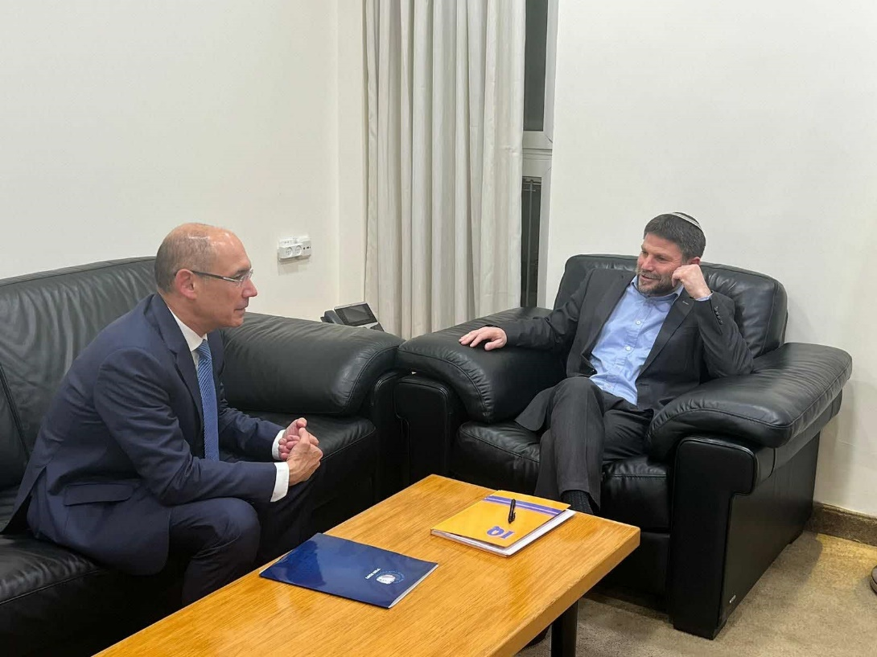

Photos credit: Ministry of Finance Office of the Spokesperson.