

BANK OF ISRAEL

Office of the Spokesperson and Economic Information

Press release

June 23, 2025

Debt Developments in the Nonfinancial Private Sector, First Quarter of 2025

The following is a summary of developments in nonfinancial private sector debt in the first quarter of 2025:

* In the first quarter of 2025, the balance of **nonfinancial private sector debt (both** **business and household)** increased to approximately NIS 2.3 trillion (1.3 percent). The annual growth rate of outstanding debt continued to be positive, at about 6.8 percent in the quarter, although it was lower than the previous quarter’s rate of 7 percent.
* The balance of **business sector debt** increased by about 1.5 percent (about NIS 21 billion) during the first quarter, to about NIS 1.4 trillion. This was mainly due to net debt raised, made up of bank loans and debt raised through tradable bonds in Israel.
* Bond issuances in the **business sector** in Israel totaled about NIS 16 billion during the first quarter, similar to the quarterly average of the previous four quarters. About half of the bond issuances in the quarter were by companies in the construction and real estate industry, which continues to lead bond issuances similar to previous years.
* The balance of **household debt** also continued to increase during the quarter, to about NIS 855 billion, mainly due to an increase in the balance of **housing debt** (about NIS 7 billion, 1.2 percent), which was due to new mortgage volume from banks. The balance of **nonhousing debt** also grew, by about 0.7 percent, to NIS 237 billion.

**The nonfinancial business sector’s[1] debt**

* In the first quarter of 2025, the **balance of business sector debt** increased, by about NIS 21 billion to about NIS 1.4 trillion, a growth rate of 1.5 percent, similar to the growth rate of the previous quarter.
* The increase in the balance derived from net debt raised totaling NIS 14 billion, a total lower than those in the preceding 2 months (about NIS 33 billion per quarter, on average). This debt raised was made up mostly of bank loans taken out and in addition from funds raised via tradable bonds in Israel, which were partially offset by net redemptions in debt raised abroad and in nontradable bonds in Israel. a depreciation of 1.9 percent in the shekel vis-à-vis the dollar and an increase of about 0.3 percent in the CPI[2] contributed as well to the increase in the value of debt denominated in and indexed to foreign currency.
* These effects led to an increase in the annual growth rate of the balance of bank debt – about 10 percent compared to 8 percent in the previous quarter while the annual growth rate of debt to nonbank lenders remained positive but declined in the quarter- about 3 percent compared to 6 percent (Figures 1, 2).
* In the first quarter of the year, the **business sector** **issued** about NIS 16 billion in bonds, similar to the quarterly average of funds raised in the previous four quarters. About half of the issuances in the first quarter were carried out by companies in the construction and real estate industry, which continues to lead in bond issuances, similar to previous years (Figure 3).

In April 2025, companies from the business sector issued bonds totaling about NIS 5 billion. Half of the sum was raised by companies from the construction and real estate industry.

* In the first quarter of 2025, **the spread[3] between yields on corporate bonds that are included in the Tel Bond 60 Index and the yields on CPI-indexed government bonds** continued to narrow, to about 0.94 percentage points, and it continued to decline in April–May 2025, to about 0.92 percentage points, a level relatively low level compared to the past three years (Figure 4).

**Table 1: The Composition of Business Sector Debt**



**Figure 1: Estimated Net Quarterly Quantitative Change in Business Sector Debt**

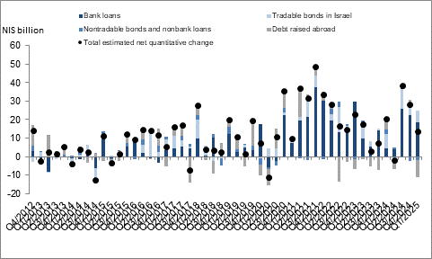

**Figure 2: Rate of Change (Year on Year) in the Business Sector's Bank and Nonbank Debt**

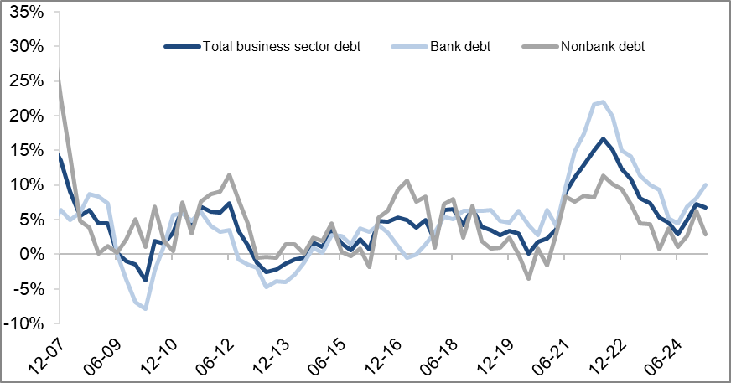

**Figure 3: Nonfinancial Business Sector Bond Issuance during the quarter, by Industry**

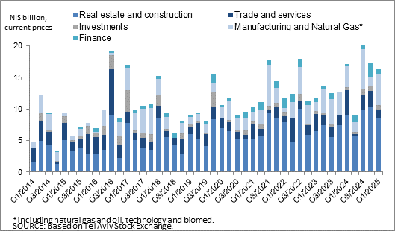

**Figure 4: Spread between Indexed Corporate Bonds (Tel-Bond 60) and Indexed Government Bonds (monthly average)**

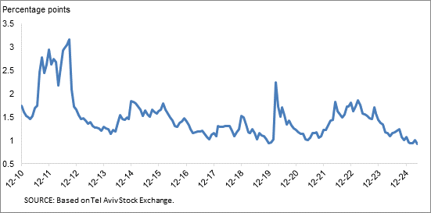

**Household debt**

* In the first quarter of 2025, the **balance of households’ outstanding debt** continued to increase, to approximately NIS 855 billion, an increase of NIS 9 billion, though there was some slowing in the growth rate of the balance this quarter, abut 1.1 percent compared to 1.8 percent in the previous quarter. Most of the increase (about NIS 7 billion, 1 percent) derives from an increase in **housing debt,** almost all of it to banks, to about NIS 618 billion; **Nonhousing debt** increased slightly as well in the first quarter, by about 0.7 percent (NIS 2 billion) to about NIS 237 billion, with most of the growth focused on the balance of debt to banks and credit card companies.
* Due to these effects, the annual growth rate of housing debt increased slightly in the quarter - 8 percent compared to 7 percent in the previous quarter - while the annual growth rate of nonhousing debt remained positive, but declined slightly to 4 percent compared to 5 percent in the previous quarter (Figure 5).
* The increase in housing debt is the result of continued new mortgage borrowing from the banks, which began at the end of 2023, and they totaled in the first quarter of the year, after seasonal adjustment, about NIS 26 billion, higher than the corresponding period of the previous year (about NIS 18 billion).

In April and May 2025 as well, the increase in new mortgage borrowing from banks continued, and totaled, after seasonal adjustment, about NIS 9 billion per month on average (Figure 6).

**Table 2: Outstanding Debt Balances of Households1**



**Figure 5: Rates of Change in Households’ Housing and Nonhousing Debt, Current Quarter vs. Corresponding Quarter of Previous Year**

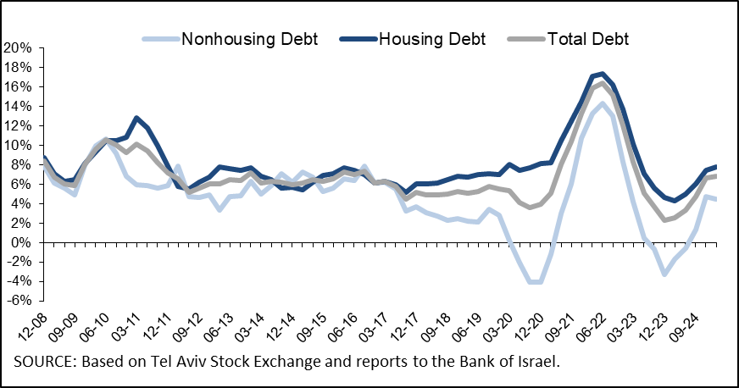

**Figure 6 :Amount of New Home Purchase Loans Provided by Banks to the Public (Mortgages)**

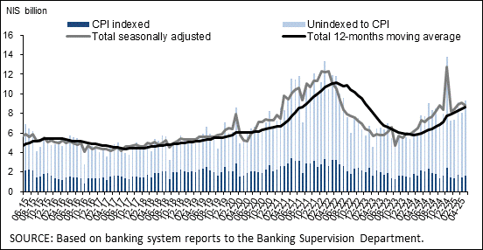

Links to Data and Statistics on the Bank of Israel website:

<https://www.boi.org.il/en/economic-roles/data-and-statistics/money-and-debt-aggregates/debt-and-credit/>

1. Israeli corporations, excluding banks, credit card companies, and insurance companies.
2. CPI-indexed balances are calculated according to the known CPI on the date the financial statements are published, so that a change in the CPI refers to the change between the known CPI and the CPI of the preceding month.
3. The change in the spread from one quarter to the next is calculated as the difference between the average spread in the final month of the reviewed quarter and the average spread in the final month of the previous quarter.