

BANK OF ISRAEL

Office of the Spokesperson and Economic Information

March 30, 2025

Press Release:

Debt Developments in the Nonfinancial Private Sector,

Fourth Quarter of 2024

The following is a summary of developments in nonfinancial private sector debt[1] in the fourth quarter of 2024:

* In the fourth quarter of 2024, the balance of **nonfinancial private sector debt (both** **business and household)** increased to approximately NIS 2.2 trillion (2 percent). The annual growth rate of outstanding debt increased to about 7 percent, further to an increase in the previous quarter, and following a downward trend that began in the third quarter of 2022. This rate is lower than the growth rates recorded in previous years.
* The balance of **business sector debt** increased by about 2 percent (about NIS 26 billion) during the fourth quarter, to about NIS 1.4 trillion. This was mainly due to net debt raised, mostly via bank loans, which were concentrated in the large business segment, and debt raised through tradable bonds in Israel.
* Bond issuances in the **business sector** in Israel totaled about NIS 17 billion during the fourth quarter, higher than the quarterly average of the previous four quarters. About two-thirds of the bond issuances in the quarter were by companies in the construction and real estate industry, which continues to lead bond issuances similar to previous years.
* The balance of **household debt** also continued to increase during the quarter, to about NIS 845 billion, mainly due to an increase in the balance of **housing debt** (about NIS 13 billion, 2 percent), which was due to new mortgage volume from banks. The balance of **nonhousing debt** also grew, by about 0.3 percent, to NIS 235 billion.

**The nonfinancial business sector’s[2] outstanding debt**

* In the fourth quarter of 2024, the **balance of business sector debt** increased, by about NIS 26 billion (2 percent), to about NIS 1.4 trillion. The increase in the debt balance this quarter derived from significant net debt raised totaling about NIS 32 billion, further to the high debt raised in the previous quarter, and were made up mainly from bank loans, which were concentrated in the large business segment. Regarding tradable bonds in Israel, there was also a positive movement of about NIS 6 billion in the fourth quarter. The increase in outstanding debt was partly offset by an appreciation of the shekel by about 1.7 percent against the US dollar and by a decline of 0.1 percent in the CPI[3], which reduced the value of debt denominated in and indexed to foreign currency.
* Due to these effects, the annual rate of growth of outstanding business sector debt continued to increase in the fourth quarter as well, to about 8 percent, following the downward trend since the second half of 2022. This was reflected in both bank and nonbank debt (Figures 1 and 2).
* In the fourth quarter of the year, the **business sector** **issued** about NIS 17 billion in bonds, higher than the quarterly average of the previous four quarters (about NIS 15 billion). About two-thirds of the issuances in the fourth quarter were carried out by companies in the construction and real estate industry, which continues to lead in bond issuances, similar to previous years (Figure 3).

In January 2025, companies from the business sector issued bonds totaling about NIS 6 billion, similar to the monthly average in the third quarter. Companies from the construction and real estate industry accounted for about 57 percent of funds raised in January.

* In the fourth quarter of 2024, **the spread[4] between yields on corporate bonds that are included in the Tel Bond 60 Index and the yields on CPI-indexed government bonds** narrowed to about 1.08 percentage points, and it continued to decline in January–February 2025 to about 0.94 percentage points, a level relatively lower than the past three years (Figure 4).

**Table 1: The Composition of Business Sector Debt**



**Figure 1: Estimated Net Quarterly Quantitative Change in Business Sector Debt**

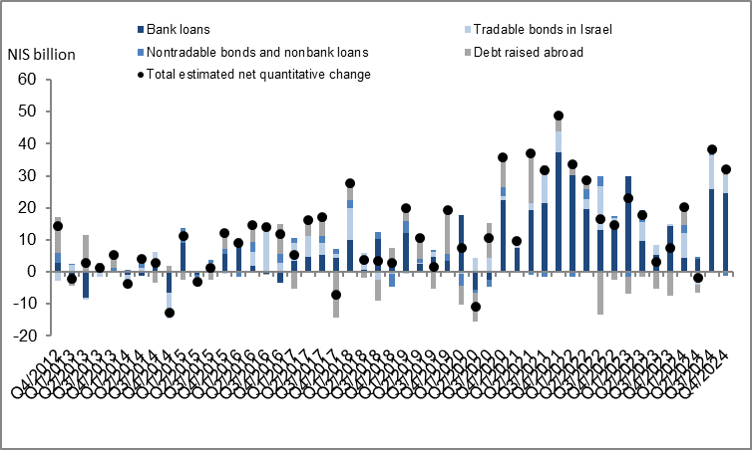

**Figure 2: Rate of Change (Year on Year) in the Business Sector's Bank and Nonbank Debt**

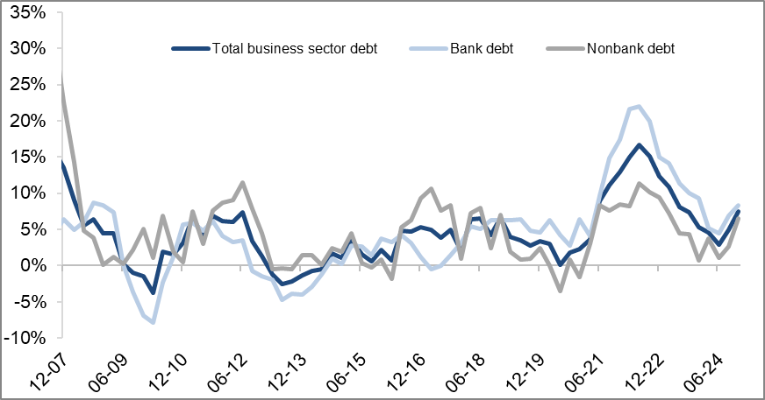

**Figure 3: Nonfinancial Business Sector Bond Issuance during the quarter, by Industry**

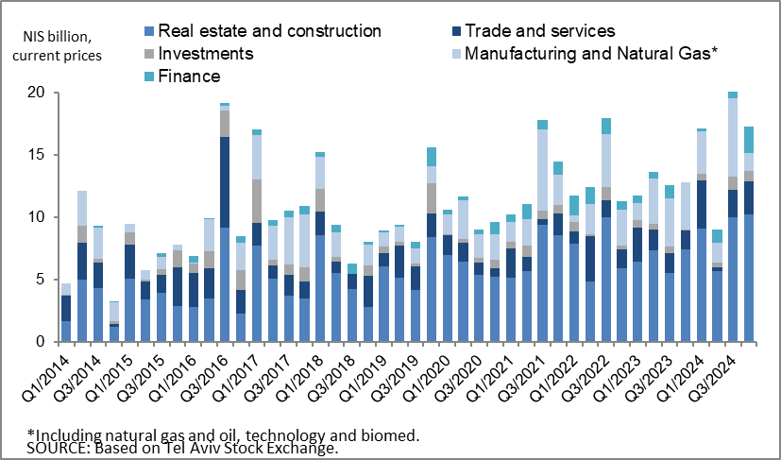

**Figure 4: Spread between Indexed Corporate Bonds (Tel-Bond 60) and Indexed Government Bonds (monthly average)**

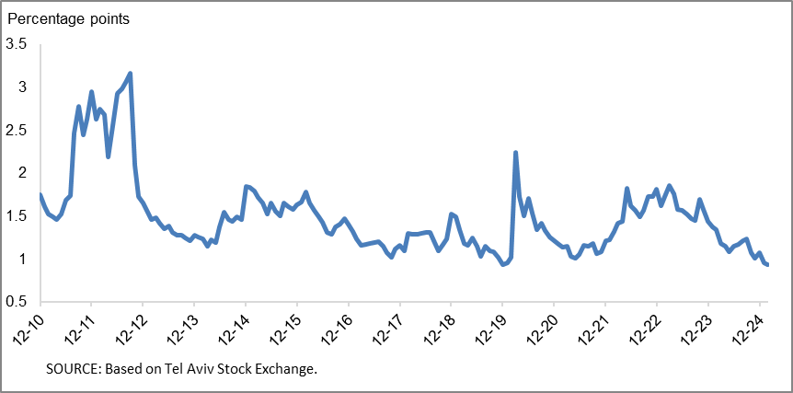

**Household debt**

* In the fourth quarter of 2024, the **balance of households’ outstanding debt** continued to increase, by about NIS 14 billion (about 2 percent) to approximately NIS 845 billion. Most of the increase was in the balance of **housing debt,** mostly to banks, which increased at a rate similar to the previous quarter—about 2.2 percent, to about NIS 610 billion; **Nonhousing debt** increased slightly as well in the fourth quarter, by about 0.3 percent (NIS 1 billion) to about NIS 235 billion.
* Due to these effects, the annual growth rate of household debt, both housing and nonhousing, to 7 percent and 4 percent, respectively, continued, a trend that began in the beginning of 2024 (Figure 5).
* The increase in housing debt is a result of the recovery in new mortgage borrowing from the banks, which began at the end of 2023. In the fourth quarter of 2024, after adjusting for seasonal effects, new mortgage borrowing totaled about NIS 30 billion, higher than the corresponding period of the previous year (about NIS 16 billion). About 43 percent of the amount taken out in December was in view of the expectation of an increase in VAT in January 2025. In January–February 2025 as well, the increase in new mortgages from banks continued, and totaled, after seasonal adjustment, about NIS 8 billion per month, on average. (Figure 6).

**Table 2: Outstanding Debt Balances of Households1**



**Figure 5: Rates of Change in Households’ Housing and Nonhousing Debt, Current Quarter vs. Corresponding Quarter of Previous Year**



**Figure 6 :Amount of New Home Purchase Loans Provided by Banks to the Public (Mortgages)**

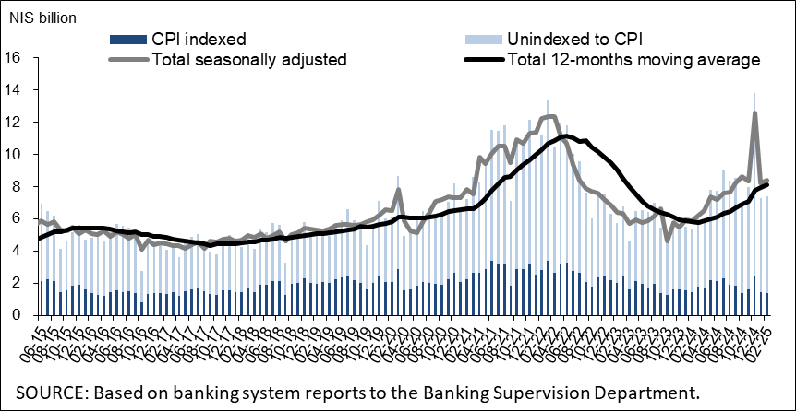

Links to Data and Statistics on the Bank of Israel website:

<https://www.boi.org.il/en/economic-roles/data-and-statistics/money-and-debt-aggregates/debt-and-credit/>

1. Data on debt to banks are based on monthly balance sheet figures and not on the annual financial statement figures, because as of the date this notice is published, the 2024 financial statement data have not yet been published.
2. Israeli firms, excluding banks, credit card companies, and insurance companies.
3. CPI-indexed balances are calculated according to the known CPI on the date the financial statements are published, so that a change in the CPI refers to the change between the known CPI and the CPI of the preceding month.
4. The change in the spread from one quarter to the next is calculated as the difference between the average spread in the final month of the reviewed quarter and the average spread in the final month of the previous quarter.