BANK OF ISRAEL

Office of the Spokesperson and Economic Information

June 6, 2024

Press Release:

Foreign Exchange Reserves at the Bank of Israel, May 2024

Israel’s foreign exchange reserves at the end of May 2024 stood at $210,508 million, an increase of $2,399 million from their level at the end of the previous month. The level of the reserves relative to GDP was 41.4 percent (Figure 1).

The increase was mainly the result of a revaluation[1] that increased the reserves by approximately $3,743 million. This increase was partly offset by the government’s foreign exchange activities totaling approximately $1,359 million.

**Israel's Foreign Exchange Reserves** ($ million)

|  |  |  |  |
| --- | --- | --- | --- |
| **Date** | **Reserves excluding IMF (including reserves bought under the natural gas purchase program)** | **Reserves at the IMF[2]** | **Total Foreign Exchange Reserves** |
| May 2024 | 206,033 | 4,475 | 210,508 |
| April 2024 | 203,656 | 4,453 | 208,109 |
| March 2024 | 209,261c | 4,480 | 213,741c |
| February 2024 | 202,326c | 4,495 | 206,821c |
| January 2024 | 201,597 | 4,528 | 206,125 |
| December 2023 | 200,090c | 4,604c | 204,694c |
| November 2023 | 193,590 | 4,579 | 198,169 |
| October 2023 | 186,675 | 4,560 | 191,235 |
| September 2023 | 194,025 | 4,528c | 198,553c |
| August 2023 | 198,338 | 4,518 | 202,856 |
| July 2023 | 200,086c | 4,579 | 204,665c |
| June 2023 | 197,363c | 4,513 | 201,876c |
| May 2023 | 195,100 | 4,521 | 199,621 |
| April 2023 | 197,390 | 4,505 | 201,895 |

**Figure 1**

**Level of foreign exchange reserves, and their ratio to GDP, 2007–2024**

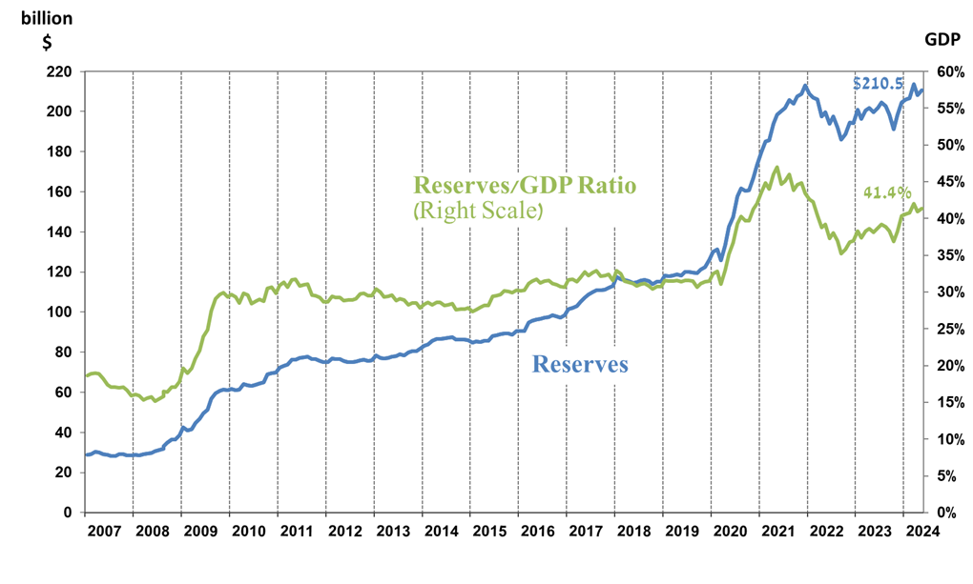

1. a Includes Bank of Israel payments and receipts in foreign currency.
2. b This column includes Special Drawing Rights (SDRs), the balance of NAB loans, and the balance of Israel's reserve tranche at the IMF.

   c Updated after the original date of publication.