

BANK OF ISRAEL

Office of the Spokesperson and Economic Information

Press release

June 18, 2025

Israel’s International Investment Position (IIP), first quarter of 2025

* **The economy’s outstanding liabilities to abroad decreased by approximately $1 billion (about 0.2 percent) in the first quarter, to about $553 billion at the end of the quarter. Nonresidents continued to make net investments in Israel, mainly in the tradable securities portfolio. These investments were fully offset by a decline in the prices of Israeli securities held by nonresidents.**
* **In the first quarter of 2025, the balance of assets held abroad by Israeli residents increased by approximately $3.3 billion (about 0.4 percent), to about $779 billion at the end of March. The increase was mainly due to net investments abroad by Israeli residents and weakening of the dollar vis-à-vis other currencies. In contrast there was a decline in the prices of foreign securities held by Israeli residents.**
* **During the first quarter, there were sharp declines in the prices of securities worldwide and in Israel. These declines caused a decline in the balance of the economy’s liabilities and also reduced the economy’s asset balance.**
* **The surplus of assets over liabilities vis-à-vis abroad increased during the first quarter of 2025 by $4.2 billion (1.9 percent), to about $226 billion at its end.**
* **The surplus of assets over liabilities vis-à-vis abroad in debt instruments alone (negative net external debt) increased by about $5.8 billion (2.1 percent) during the first quarter, to approximately $285 billion at the end of first quarter.**
* **The ratio of gross external debt to GDP declined by about 0.4 percentage points in the first quarter, to about 27 percent at the end of March.**

Table 1: Asset and liability balances, and changes in them



1. **The balance of Israelis’ assets abroad**

In the first quarter of 2025, the value of the assets held abroad by Israeli residents increased by about $3.3 billion (about 0.4 percent), to approximately $779 billion at the end of March.

* **The value of direct investments** increasedby about $2.3 billion (approximately 2 percent) in the first quarter, mainly as a result of net investments by Israeli residents.
* **The value of the securities portfolio** decreased during the first quarter by about $8.9 billion (about 3.1 percent), mainly as a result of a decline in prices of foreign securities held by Israeli residents totaling about $8.3 billion, and of net realizations by Israeli residents of foreign securities totaling approximately $1 billion. (Figure 1).

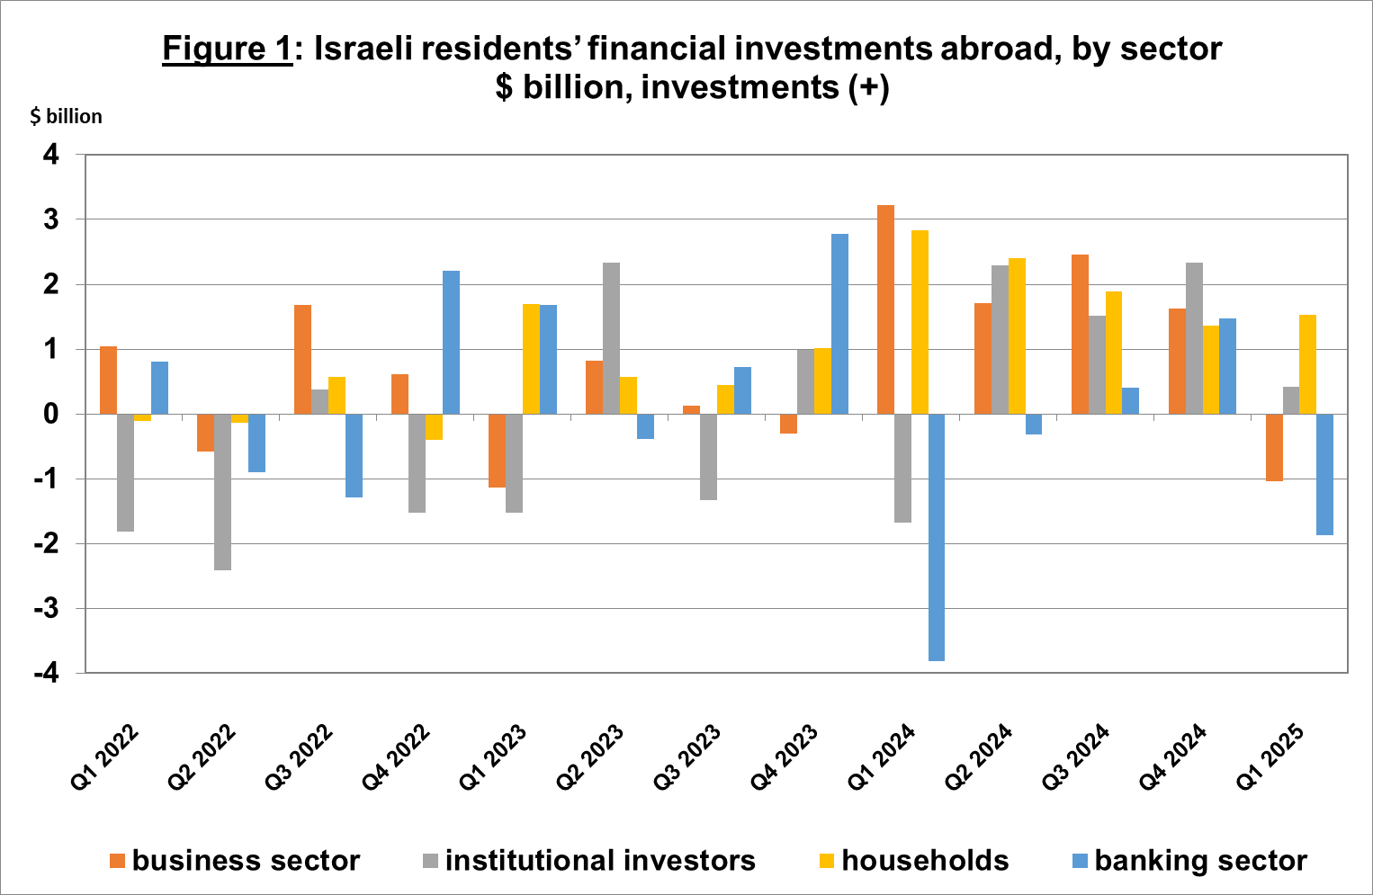

Source: Bank of Israel data and processing1.

* **The value of other investments** abroad increased during the first quarter by about $6.7 billion (4.1 percent), mainly as a result of net investments totaling about $4.4 billion. Israeli residents (including banks) deposited a net $6 billion in deposits abroad. Most of the deposits were made by the government, which issued bonds abroad during the quarter. In contrast, there was a decline in customers’ credit to nonresidents, totaling $2 billion.
* **The value of the reserve assets** increased by about $4.2 billion (about 2 percent) during the first quarter, to about $219 billion at the end of March. The increase in the balance derived mainly from the weakening of the dollar vis-à-vis other currencies worldwide, which led to an increase in the value of the reserve assets totaling about $4.2 billion. In addition, government activities contributed to an increase of $1.7 billion. In contrast, foreign security price declines led to a decrease of $1.6 billion in reserve asset values.
* **The composition of Israelis’ securities portfolio abroad**: During the first quarter, the share of equity instruments in Israeli residents’ portfolio abroad remained unchanged, and at the end of March it was 46 percent. Accordingly, the share of debt instruments was 54 percent at the end of the quarter.

1. **Israel’s liabilities to abroad**

The balance of Israel's liabilities to abroad decreased by about $1 billion (about 0.2 percent) during the first quarter, to approximately $553 billion at the end of the quarter. The decrease was mainly due to a decline in prices of Israeli securities held by nonresidents. This decline was partly offset by net investments by nonresidents in Israel.

* **The value of direct investments in the economy** increased by about $1 billion (about 0.4 percent) during the first quarter, due to net investments by nonresidents totaling about $4.4 billion, which was offset by a decline in the prices of Israeli equities held by nonresident parties at interest (Figure 2).
* **The value of the securities portfolio** increased by about $0.9 billion (about 0.4 percent) in the first quarter. Nonresidents invested about a net $2.2 billion in Israeli equities and invested about a net $6.3 billion in Israeli bonds (due to an offering abroad by the government). In contrast, these investments were offset by a decline in the prices of Israeli equities totaling about $6 billion.
* **The value of nonresidents' financial portfolio on the Tel Aviv Stock Exchange,** (which makes up a part of nonresidents’ investments in Israel,) increased by about $2.6 billion in the first quarter of 2025, to about $79 billion at the end of March. The increase in the value of the portfolio derived mainly from net investments by nonresidents (Figure 3 and Figure 4).

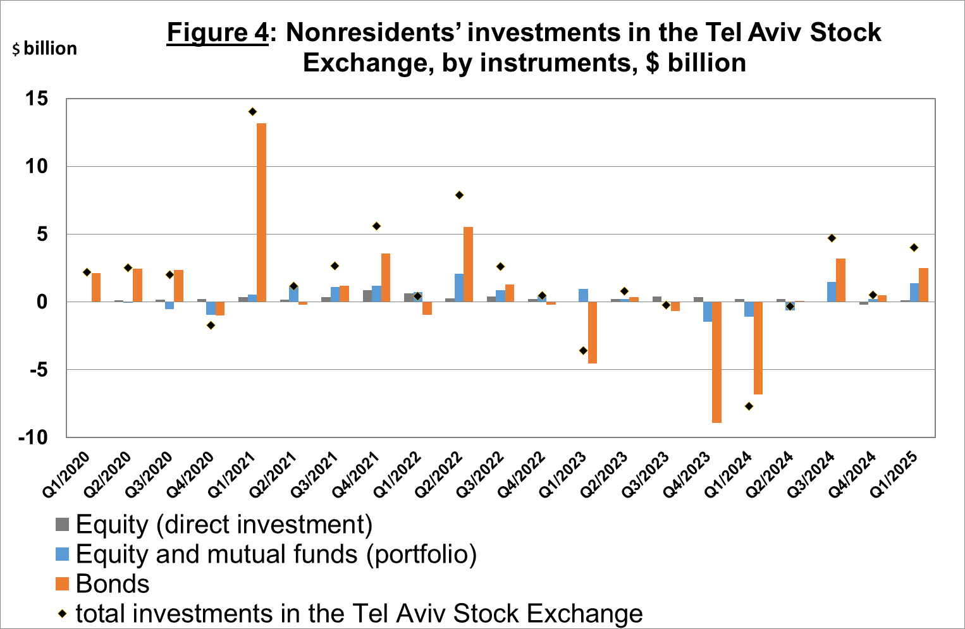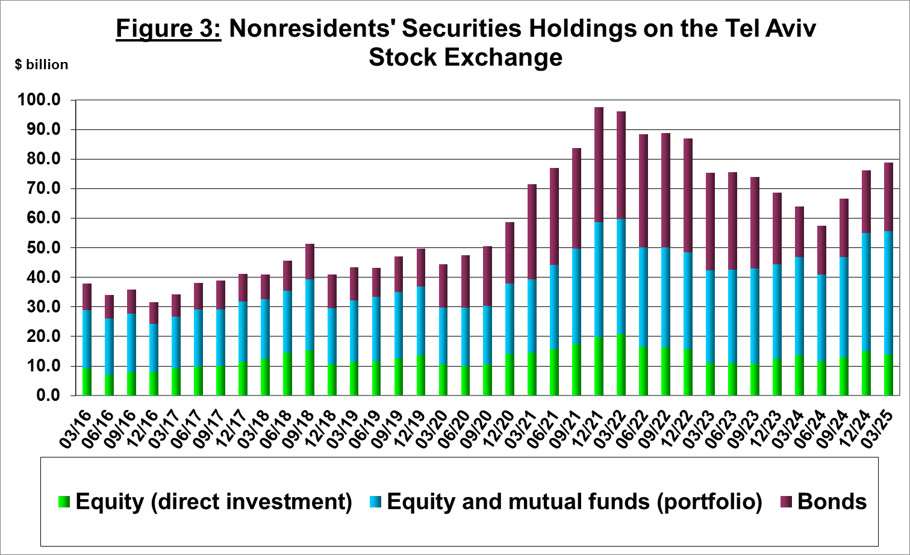

Source: Israel Securities Authority, and Bank of Israel data and processing1.

**The value of other investments in the economy** decreased by about $2.9 billion (about 4.1 percent) in the first quarter, to about $67 billion. The decrease derived mainly from a decline in suppliers’ credit totaling approximately $1.7 billion, and by net withdrawals by nonresidents (including banks) from deposits with Israeli banks totaling about $1 billion.

**The balance of liabilities in debt instruments alone,** which makes up Israel's gross external debt, increased by about $2.5 billion (1.7 percent) in the first quarter, to about $150 billion.

**The ratio of gross external debt to GDP** declined by about 0.4 percentage points in the first quarter, to about 27 percent at the end of March. The decrease in the external debt to GDP ratio reflected an increase in the balance of gross external debt at a lower pace than the increase in GDP in dollar terms (Figure 5).

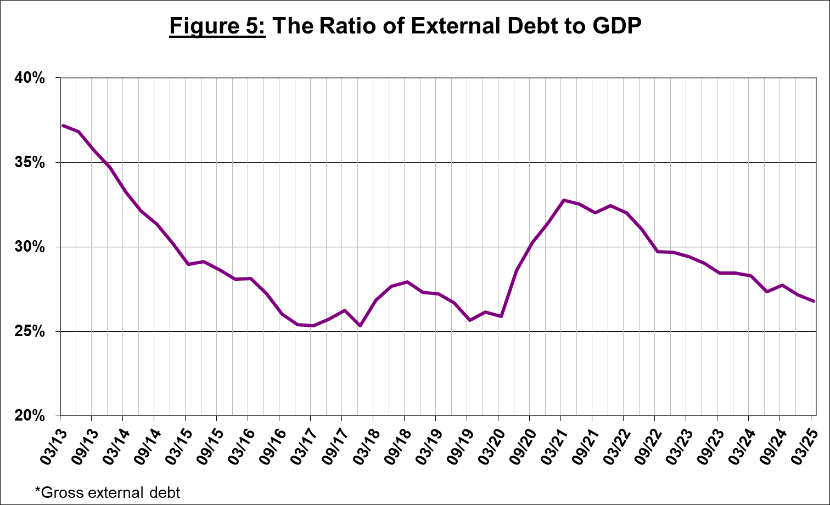

Source: Israel’s Ministry of Finance, Israel’s Central Bureau of Statistics, and Bank of Israel data and processing.1

1. **Israel’s surplus assets over liabilities vis-à-vis abroad**

The increase in the balance of assets and the decrease in the balance of liabilities led to an increase of about $4 billion (1.9 percent) in the surplus of assets over liabilities vis-à-vis abroad, which totaled about $226 billion at the end of March (Figure 6).

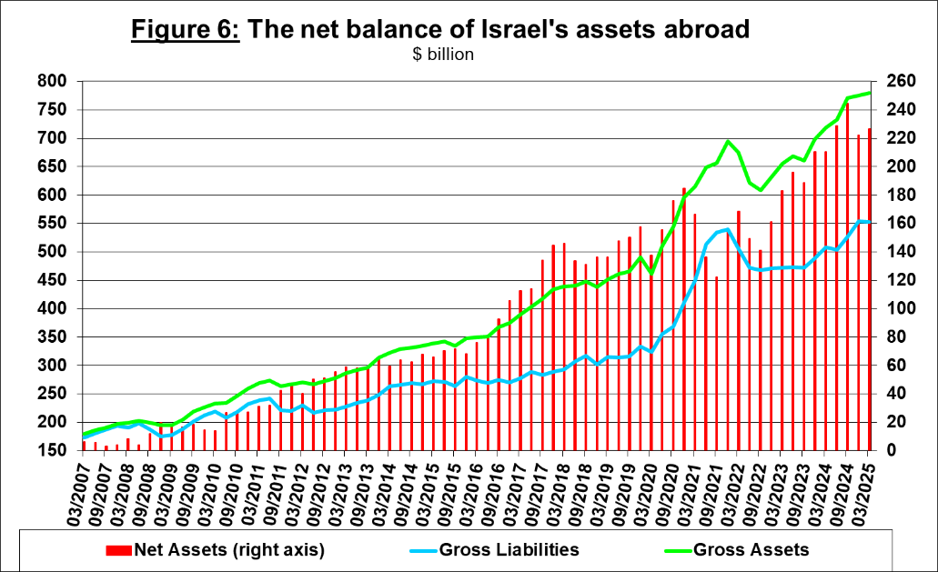

Source: Bank of Israel data and processing1.

1. **Net external debt**

The surplus of assets over liabilities vis-à-vis abroad in debt instruments alone (negative net external debt) increased by approximately $5.8 billion (about 2.1 percent) in the first quarter, to about $285 billion at the end of March (Figure 7).

**The balance of assets in debt instruments** increased by about $8.2 billion in the first quarter, to about $434 billion at the end of the quarter, of which about $219 billion is the Bank of Israel's foreign exchange reserves. This balance reflects a coverage ratio of 2.9 times the gross external debt.

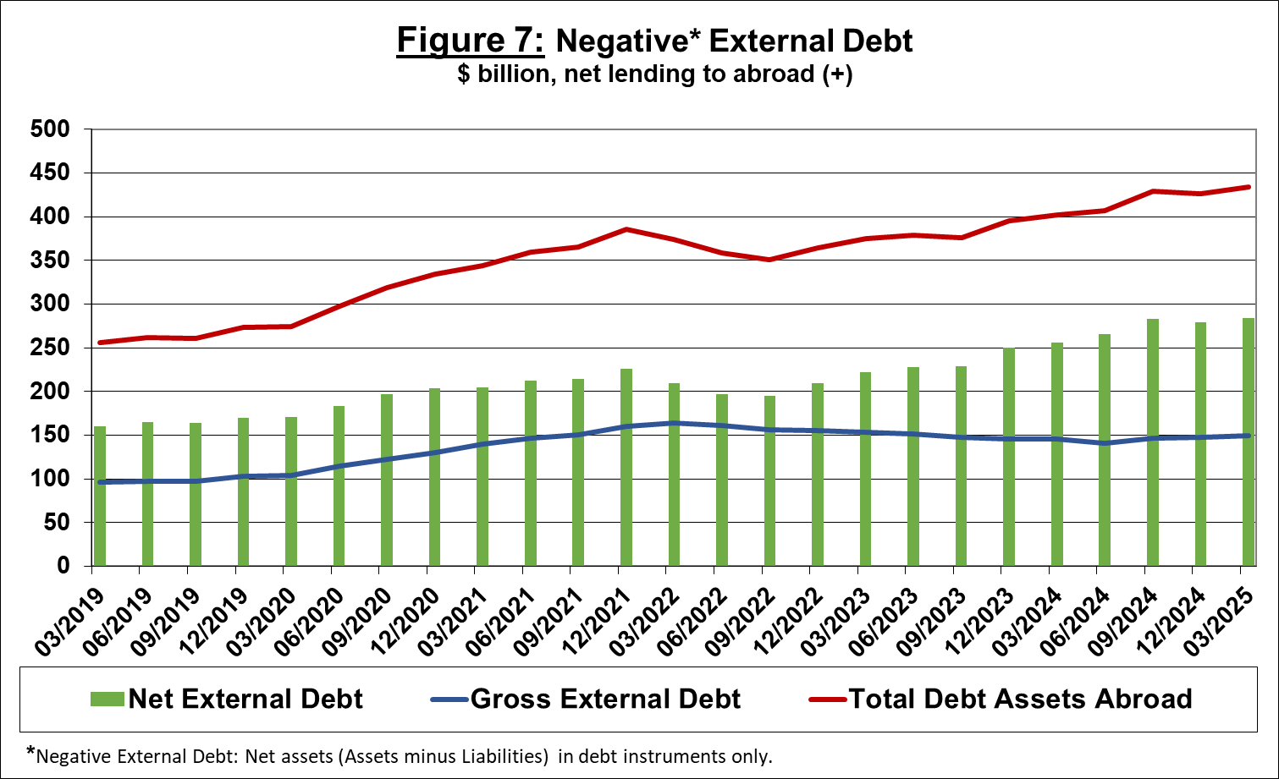

Source: Israel’s Ministry of Finance, and Bank of Israel data and processing[1].

[For the complete data file, click here](http://www.bankisrael.gov.il/deptdata/pik_mth/pikmth_e.htm).

1. Bank of Israel data and processing: The Bank of Israel’s Information and Statistics Department collects data from numerous varied sources. Most of the data on the economy’s activity vis-à-vis abroad are received by force of a Bank of Israel Order, from direct reports by corporations and individuals to the Bank of Israel. (See: Information Regarding Foreign Exchange Market Developments in Israel, 5770–2010). Additional data used for measuring economic activity vis-à-vis abroad are received by reports from the Bank of Israel’s Accounting Division, the Ministry of Finance, the Central Bureau of Statistics, the Israel Securities Authority, domestic banks and other financial intermediaries, and institutional investors. The Department carries out estimations and processing on data received from the various sources.