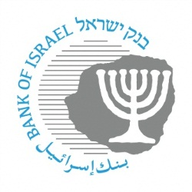

BANK OF ISRAEL

Office of the Spokesperson and Economic Information

March 14, 2019

Press Release

**The Bank of Israel’s Information and Statistics Department publishes the Statistical Bulletin for 2018[1]**

First publication of the main financial data and aggregates for 2018

**Part One** of the Statistical Bulletin for 2018 is intended to provide the public with easy and friendly access to the main data and aggregates regarding financial activity in Israel, together with information and explanations about the data, definitions and calculations, regarding four main topics in Israel’s financial statistics: the public’s financial assets portfolio; nonfinancial private sector debt; Israel’s economic activity vis-à-vis abroad; and foreign exchange activity of the principal sectors.

**a. The public’s financial assets portfolio**

* 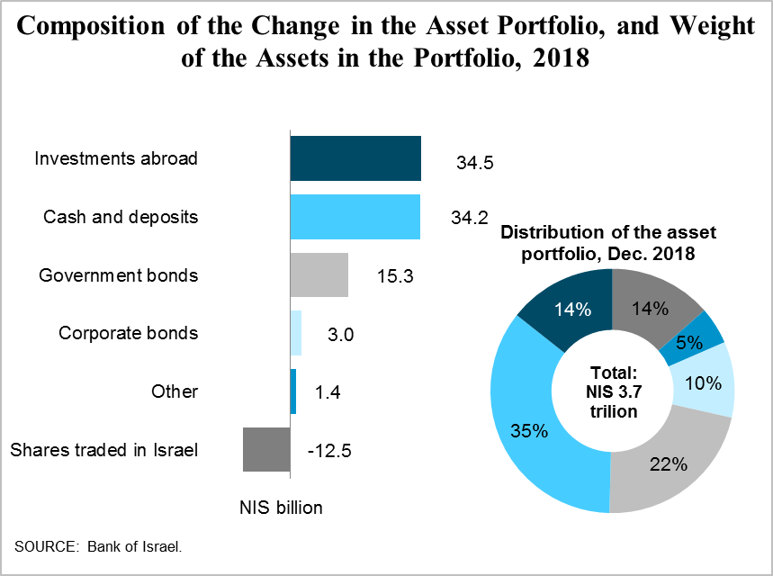The balance of the public’s financial assets portfolio increased by about 2.1 percent in 2018, to about NIS 3.7 trillion, a lower rate of growth than in past years (Figure 1.1 in the report).
* The main contributor to the increase was the investments abroad component, as a result of net investments in stocks and bonds, and the shekel’s depreciation against the dollar, and despite the decline in global asset prices (Figure 1.5).
* The balance of shares traded in Israel declined, in view of the declines that took place in the last month of the year, most of which were corrected by price increases at the beginning of 2019 (Figure 1.8).
* During the year, the upward trend of the share of the portfolio managed by the institutional investors continued, against the decline in the share managed directly by the public (Figure 1.2).

**b. Nonfinancial private sector debt**

* 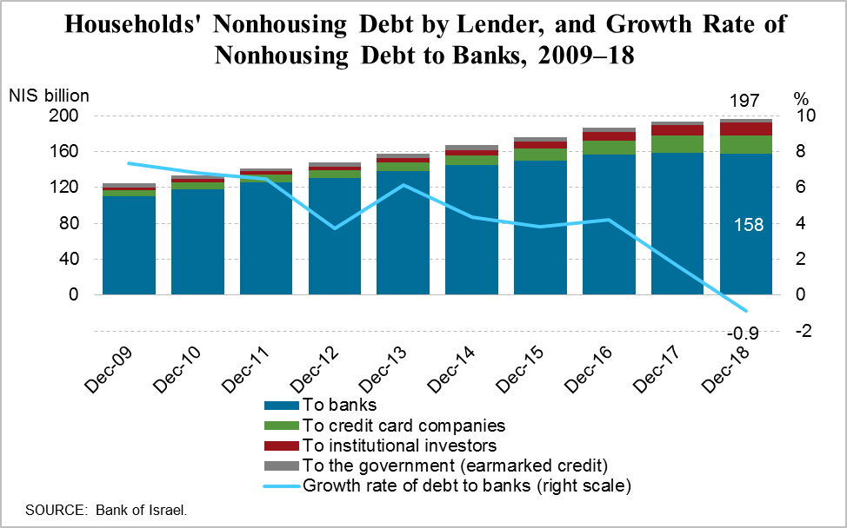In household debt, there was a significant decline in the growth rate of nonhousing debt, as a result of the decline in this debt to banks, for the first time in a long time.
* At the same time, the increase in housing debt continued, to about NIS 360 billion (Figure 2.11).
* Business sector debt increased at a higher rate than in the previous year (6.8 percent compared with 1.5 percent) to about NIS 919 billion. The growth rates of both debt to the banks and debt to nonbank entities increased (Figure 2.7).

**c. Israel’s economic activity vis-à-vis abroad**

* 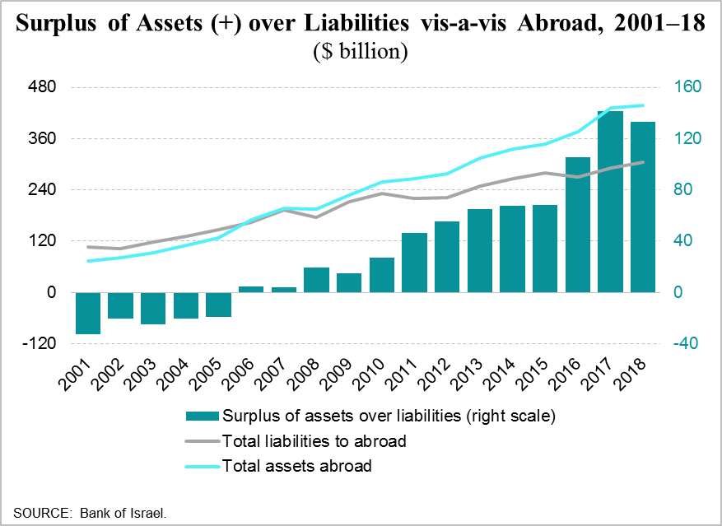In 2018, the surplus of assets over liabilities vis-à-vis abroad declined, for the first time in 8 years, due to a larger increase in the balance of liabilities than in the balance of assets. However, the economy has a marked surplus of assets, and it is a net lender to abroad by about $133 billion.
* The balance of Israel’s assets abroad increased in 2018, at a more moderate rate than the previous year, to about $438 billion. The increase was concentrated in direct investments in foreign shares by Israelis. In contrast, financial investments abroad by Israelis, which were concentrated in shares, were offset by price declines of those assets (Figures 3.2, 3.3, and 3.4).
* The balance of Israel’s liabilities to abroad increased in 2018 to about $304 billion, continuing the increase of the previous year. The increase resulted from direct investments in Israel by nonresidents, mainly in shares (Figure 3.9).

**d. Foreign exchange activity of the principal sectors**

* 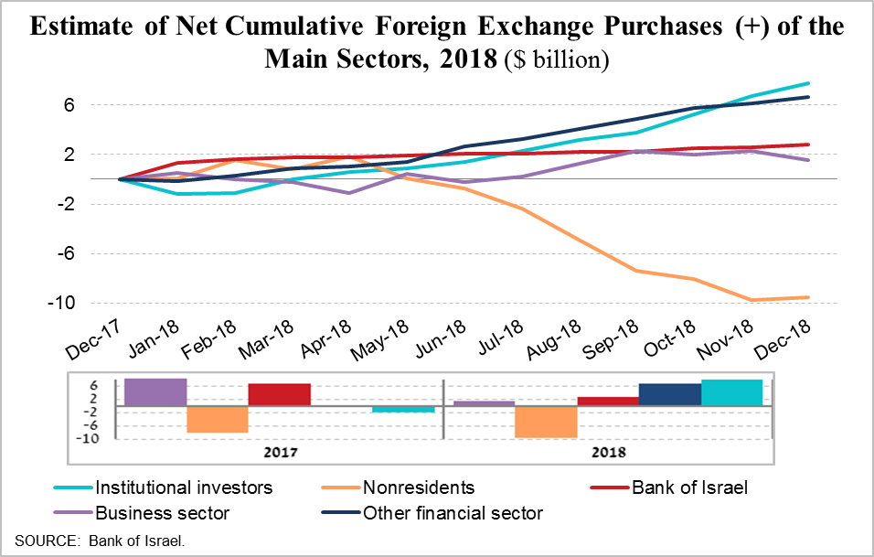The foreign exchange activity of the principal sectors featured the transition to net foreign exchange purchases (sales of shekels) by institutional investors and the other financial sector[2]1 against net foreign exchange sales (purchase of shekels) by nonresidents.
* In 2018, there was a change in the trend of the exchange rate. The shekel weakened against the dollar, in parallel with the significant strengthening of the dollar against major global currencies. In terms of the nominal effective exchange rate, which represents the currencies of Israel’s major trading partners, the shekel weakened more moderately, mainly from September onward (Figures 4.1 and 4.2).

**Part two** of the bulletin presents two studies in the field of statistical methodology:

**a. Database of shekel/forex market activity**

The Bank of Israel’s Information and Statistics Department manages a database of shekel/forex transactions divided by sector and by instrument. Transaction data, gathered on a daily basis, are processed into foreign exchange trading turnover, conversions, and exposures. The data make it possible to monitor developments in the active sectors in the foreign exchange market, and assist the bank in making policy decisions. The study outlines the various dimensions of the database and the methodological framework of the main aggregates calculated from it. It also illustrates how the data are used, including an international comparison.

**b. The Bank of Israel’s current reports to the international institutions**

The international financial institutions, chiefly the International Monetary Fund, define and develop detailed methodologies for calculating, reporting, and metadata, so that the data provided by the various countries will be consistent over time and comparable. The Bank of Israel’s Information and Statistics Department fulfills the central bank’s statistical reporting requirements to the international organizations. As part of this, the Department creates and produces the various reports, keeps up to date on changes in the international standards, and adapts the statistical systems to the changing information needs. This study presents an overview of the reports that the Bank of Israel sends to the international institutions, directly or through the Central Bureau of Statistics.

The full publication ([in Hebrew](http://www.boi.org.il/he/NewsAndPublications/RegularPublications/Pages/MabatStat2018.aspx)) can be accessed on the Bank of Israel’s website, including—for the convenience of users—the main data on each topic, in separate files, as well as links to regularly updated data on the Bank’s website.  The English version of the bulletin will be published in the near future.

1. In Hebrew. The English version of the Statistical Bulletin for 2018 will be published at a later date.
2. 1 Financial firms excluding the banking system and excluding the institutional investors.