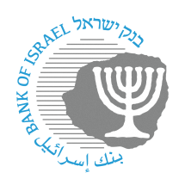
BANK OF ISRAEL
Office of the Spokesperson and Economic Information

Press release

November 19, 2023

Loyalty program activity in the payment systems

The Bank of Israel announced that many consumer clubs have begun taking advantage of a measure adopted last year to allow the clubs’ technology providers to enable the utilization of club benefits through end-point technology at merchants outside the clubs, using the same infrastructure that enables payment card transactions. This measure has opened a technological and business track that has generated a series of advantages for customers, including benefits at various stores and chains. This is particularly the case during the current complex period, when the public is dealing with significant economic challenges.

The use of existing infrastructure enables more merchants to participate in the benefits offered by consumer clubs. This allows the merchants to attract more customers, increase their revenue, incur savings on the costs involved in establishing and maintaining special infrastructure to realize the benefits, and in the case of small businesses, it helps them compete against marketing chains and larger businesses.

Oded Salomy, Director of the Bank of Israel Payment and Settlement Systems Department, said: “After announcing that consumer clubs would now have access to existing infrastructure in the payment card system operated by SHVA, we are now marking a milestone in which a large number of businesses are making benefits and economic streamlining available for consumers and merchants. I welcome this, and invite additional merchants to leverage this change that we have led.”

