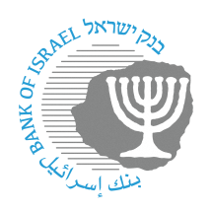

BANK OF ISRAEL

Office of the Spokesperson and Economic Information

Press release

September 10, 2024

**Bank of Israel Governor Prof. Amir Yaron participated in a BIS meeting with other central bank governors in Basel, Switzerland**

Bank of Israel Governor Prof. Amir Yaron returned to Israel after participating in a meeting of central bank governors from around the world who are members of the Bank for International Settlements (BIS) in Basel, Switzerland.

During the meeting, the Governor, who serves as Chairman of the Small and Open Economies Forum, led a discussion with other governors in the forum on updated macroeconomic forecasts.

* Background:

The BIS (Bank for International Settlements) is the bank regulating international financial settlements. It is the oldest international financial organization. Its role is to promote cooperation between central banks, of which 63 are currently members. The BIS’s activities include the development of international banking supervision standards and criteria (the “Basel” regulations), monitoring the stability of the international financial system, providing banking services to central banks, and assisting various financial institutions in performing their functions. The Bank of Israel joined the BIS as a full member in September 2003.