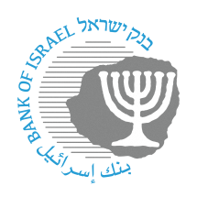

BANK OF ISRAEL

Office of the Spokesperson and Economic Information

Press release

July 18, 2024

**Presidium of the Israeli Business Sector Conference**

Bank of Israel Governor Prof. Amir Yaron delivered remarks at the Presidium of the Israeli Business Sector Conference held in Tel Aviv to mark the inclusion of employer organizations under the Presidium. The Governor welcomed the step to bring together many employer organizations, and noted its importance at this time of significant economic challenges.

During the conference, the Governor made a presentation on “The Israeli Economy at this Time: Challenges and Opportunities”.

In his remarks, the Governor discussed the responsible fiscal policy that has been implemented in the past two decades. This policy led to a persistent decline in the debt to GDP ratio to below 60 percent, which was a strategic asset for the Israeli economy and helped it deal with significant economy-wide challenges such as the COVID-19 pandemic and the current war.

The Governor noted the tremendous importance of continuing to maintain fiscal responsibility, and called on the government to act now the plan a downward path for the debt to GDP ratio in the coming two years. In order to meet this target, the Governor emphasized that permanent budgetary adjustments of about NIS 30 billion are necessary.

The Governor again emphasized that the government must make these adjustments even if they are not popular, since not fully meeting the necessary fiscal adjustments, or a delay in approving the budget, may lead to a further increase in Israel’s risk premium and increase the interest payments on government debt, and harm economic growth.