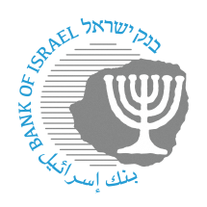

BANK OF ISRAEL

Office of the Spokesperson and Economic Information

Press release

October 29, 2024

**Bank of Israel Governor Prof. Amir Yaron traveled to the annual meeting of the IMF and World Bank**

Bank of Israel Governor Prof. Amir Yaron returned to Israel from a trip to the annual meeting of the International Monetary Fund and the World Bank in the US.

The Governor held a series of meetings with senior IMF officials, central bank governors, and leading economists. The meetings focused on discussions regarding the current situation in Israel and the impact of the war, measures taken by the Bank of Israel, various global economic developments, and global inflation challenges.

The Governor also met with leading financial investors and held discussions with them on Israeli and global economic developments.