

BANK OF ISRAEL

Office of the Spokesperson and Economic Information

December 8, 2016

Press Release

Israel’s foreign currency market in November 2016

**1. The Exchange Rate**

**Strengthening of the shekel against the euro and dollar, in contrast with a strengthening of the dollar worldwide.**

In November, the shekel strengthened by about 0.3 percent against the dollar and by about 3.1 percent against the euro.

Against the currencies of Israel's main trading partners, in terms of the nominal effective exchange rate of the shekel (i.e., the trade-weighted average shekel exchange rate against those currencies), the shekel strengthened by about 2.3 percent in November.

Worldwide, the US dollar strengthened considerably against most major currencies in November. The dollar strengthened by 2.9 percent against the euro, by 8 percent against the Japanese yen, and by 2.7 percent against the Swiss franc. In contrast, the dollar weakened by 2.3 percent against the British pound.

**2. Exchange Rate Volatility**

**An increase in actual volatility of the exchange rate in parallel with an increase in implied volatility.**

The standard deviation of changes in the shekel-dollar exchange rate, which represents its **actual** volatility, decreased by about 1.6 percentage points in November, to 5.8 percent at the end of the month.

The average level of implied volatility in over the counter shekel-dollar options––an indication of **expected** exchange rate volatility––increased by about 0.2 percentage points, to 7.3 percent at the end of November.

In parallel, the implied volatility in foreign exchange options in emerging markets also increased, to an average of about 11.6 percent, and the implied volatility in foreign exchange options in advanced economies also increased, to about 10.1 percent at the end of November (Figure 4).

**3. The Volume of Trade in the Foreign Currency Market**

**Total trading volume increased, in parallel with an increase in nonresidents’ relative share of total trading volume.**

**Total trading volume in foreign currency** in November was about $160 billion, compared with about $107 billion in October. Average daily trading volume increased by about 2 percent, to about $7.3 billion.

**The trading volume in spot and forward transactions (conversions)** was about $36 billion in November. Average daily trading volume in those transactions increased in November by about 2 percent compared with October.

**The trading volume in over the counter foreign currency options** (which are not traded on the stock exchange) totaled about $4.9 billion in November. The average daily trading volume in those options increased compared with October, to about $224 million.

**The trading volume of swap transactions** was about $119 billion in November, compared with about $80 billion in October. Average daily trading volume increased by about 2 percent from the previous month, to around $5.4 billion.

**Nonresidents' share of total trade** (spot and forward transactions, options and swaps) increased to about 32.2 percent at the end of November. The increase derived from an increase in the volume of activity by nonresidents in conversion (spot and forward), swap and options transactions.

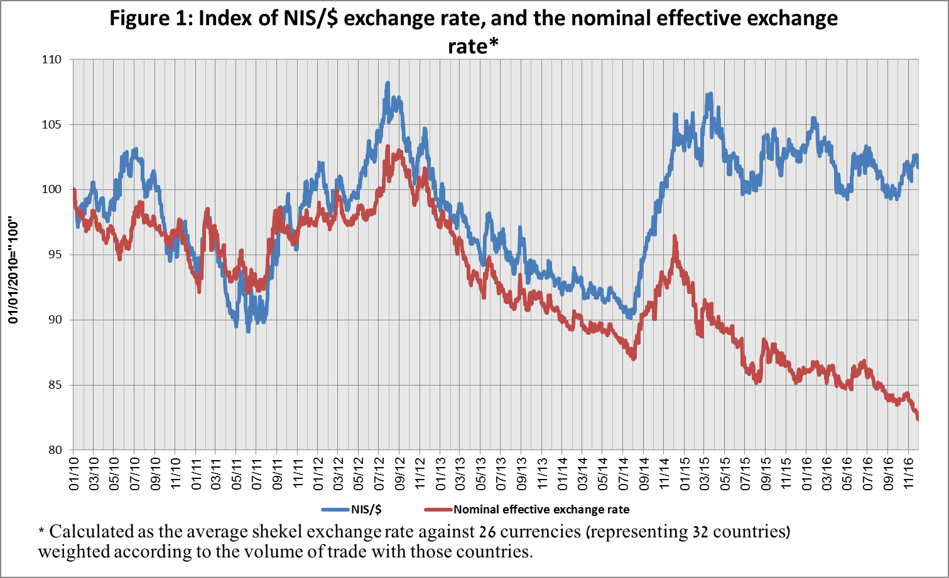

Figure 2: Rate of change of exchange rates of various currencies against the dollar* November 2016


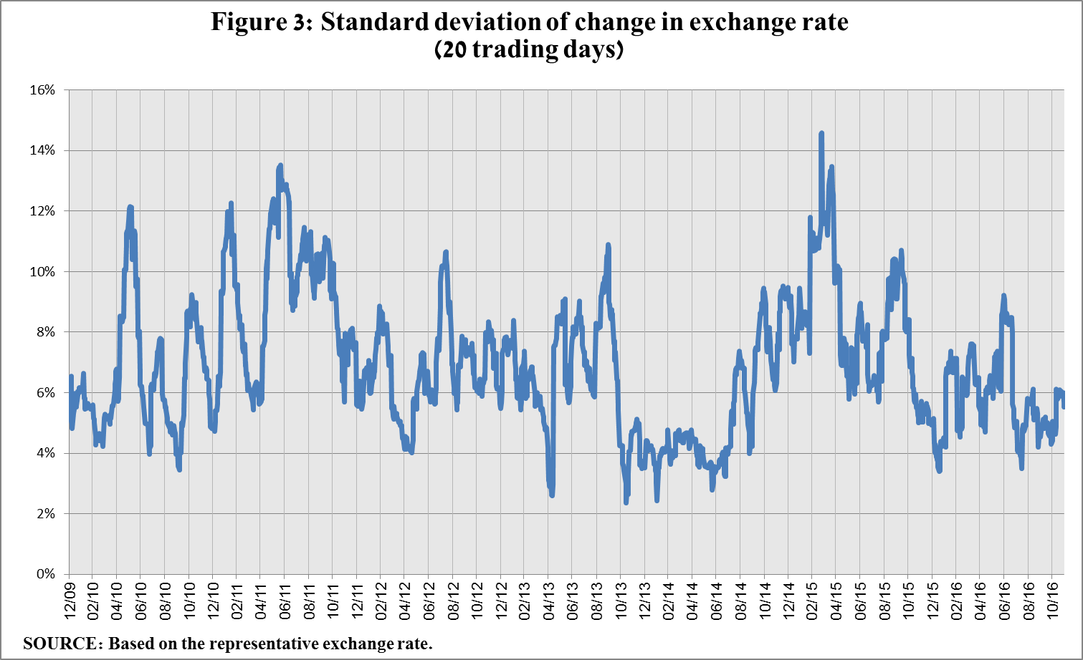

Figure 4: International comparison of implied volatility of shekel/dollar options


Figure 5: Nonresidents' share of total trading volume 


Forex transactions with domestic banks, by instruments and derivatives ($ million)