

BANK OF ISRAEL

Office of the Spokesperson and Economic Information

August 7, 2025

Press Release:

Foreign Exchange Reserves at the Bank of Israel, July 2025

Israel’s foreign exchange reserves at the end of July 2025 stood at $226,768 million, a decline of $1,481 million from their level at the end of the previous month. The level of the reserves relative to GDP was 41.4 percent (Figure 1).

The decline was mainly explained by:

1. A revaluation[1] of the reserves totaling approximately $1,170 million.
2. Foreign exchange activity by the government totaling about $208 million.

**Israel's Foreign Exchange Reserves** ($ million)

|  |  |  |  |
| --- | --- | --- | --- |
| **Date** | **Reserves excluding IMF (including reserves bought under the natural gas purchase program)** | **Reserves at the IMF[2]** | **Total Foreign Exchange Reserves** |
| July 2025 | 222,157 | 4,611 | 226,768 |
| June 2025 | 223,651 | 4,599 | 228,250 |
| May 2025 | 219,086c | 4,553 | 223,639c |
| April 2025 | 217,489 | 4,546 | 222,035 |
| March 2025 | 214,394c | 4,416 | 218,810c |
| February 2025 | 215,898c | 4,356 | 220,254c |
| January 2025 | 211,710c | 4,358 | 216,068c |
| December 2024 | 210,170c | 4,400c | 214,570c |
| November 2024 | 212,684 | 4,416 | 217,100 |
| October 2024 | 211,638 | 4,436 | 216,074 |
| September 2024 | 215,807 | 4,570 | 220,377 |
| August 2024 | 212,847c | 4,538 | 217,385c |
| July 2024 | 209,141 | 4,493 | 213,634 |

**Figure 1: Level of foreign exchange reserves, and their ratio to GDP, 2008–2025**

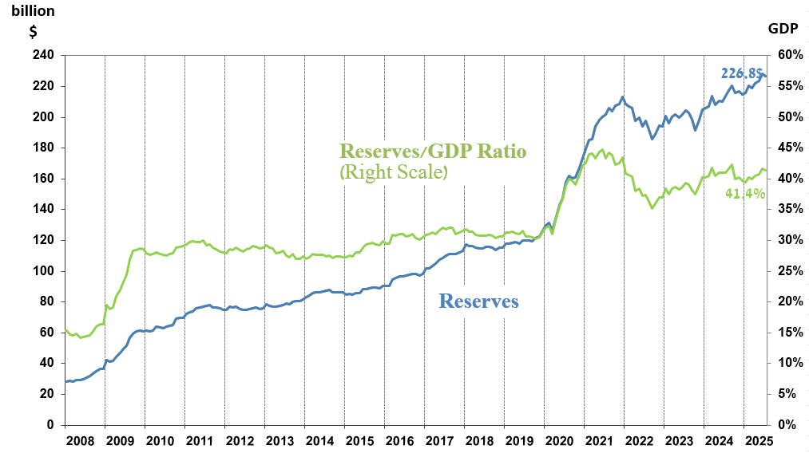

1. Including Bank of Israel payments and receipts in foreign currency.
2. b This column includes Special Drawing Rights (SDRs), the balance of NAB loans, and the balance of Israel's reserve tranche at the IMF.

   c Updated after the original date of publication.