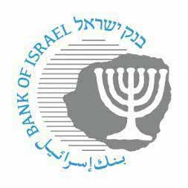

BANK OF ISRAEL

Office of the Spokesperson and Economic Information

# January 05, 2023

Press Release:

**The Bank of Israel Monetary Committee meets with financial forecasters**

Bank of Israel Governor Prof. Amir Yaron and members of the Bank of Israel Monetary Committee today held their quarterly meeting with the group of forecasters that regularly provides the Bank of Israel with forecasts for inflation, the interest rate, and the exchange rate. The meeting provides an opportunity for exchanging opinions and assessments between the Bank of Israel and leading financial institutions in the economy.

Prof. Yaron opened the meeting by discussing various economic developments.

Inon Gamrasni, an economist in the Bank of Israel Research Department, presented and explained the Research Department’s assessment as published on January 2, 2023, in parallel with the recent interest rate announcement.

The forecasters responded and conveyed their assessments of developments.