

BANK OF ISRAEL

Office of the Spokesperson and Economic Information

Press release

September 16, 2024

**New study: Wage and price inflation – Industry analysis**

* A new Bank of Israel study examines the pass-through from wages to prices, and vice-versa, using industry-level data from Israel between 2006 and 2022.
* Using various methodologies to identify the wage inflationary effect, the study identifies a consistent range of estimations for the pass-through from wages to prices. A 10 percent increase in wages, relative to the previous month, leads to a limited cumulative increase of 1–3 percent in prices in the following year.
* In the opposite direction, wages respond significantly to unexpected price increases, but with a lag of one year.
* The period following the recovery from the COVID-19 pandemic featured a high inflation environment and a tight labor market. This study points to preliminary evidence that the mutual connections between wages and prices strengthened during that period.

The significant increase in the inflation environment in recent years, alongside the tight labor market, in Israel and in other countries, is reigniting the discussion over inflationary pressure from the labor market. A new Bank of Israel study examines both potential directions of the wage-price spiral—the pass-through from wages to prices, and the pass-through from prices to wages.

In this study, conducted by Shira Bozaglo-Briss from the Research Division, various methods were used, based on industry-level data on wages, prices, and labor productivity, to estimate how prices are affected by wage changes. In order to precisely identify the effect of wages on prices, the study uses two sources for wage increases: competition between industries over similar workers, and legislative measures to increase the minimum wage. The study identifies a consistent range of estimates for the pass-through from wages to prices: A 10 percent increase in wages, relative to the previous month, leads to a limited cumulative increase in prices of 1–3 percent after 12 months. This effect diminishes in the following months. In the opposite direction, the study examines how wages respond to unexpected price changes. The response to a shock in the monthly Consumer Price Index (relative to the average projections of professional forecasters) is fully reflected only 12 months later.

The study points to empirical evidence that the mutual connections between wages and prices strengthened following the recovery from the COVID-19 crisis, but these findings feature a high level of uncertainty in view of data limitations.

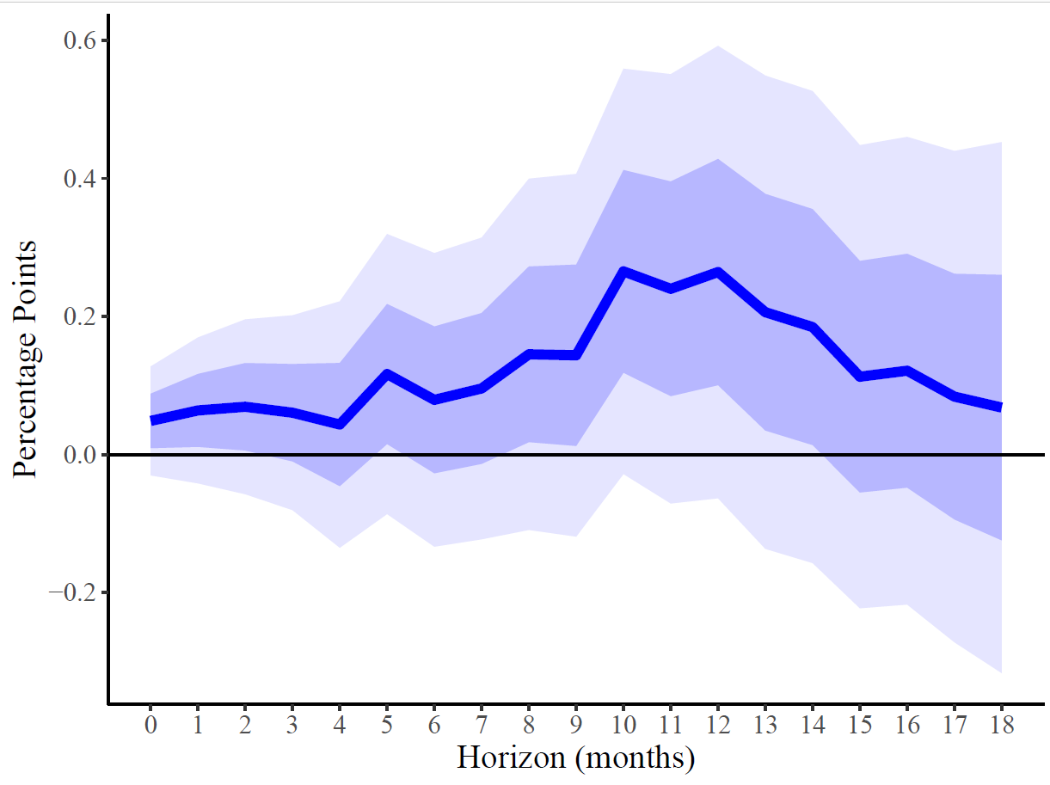

**Estimated Pass-Through from Wages to Prices**

Cumulative response of prices to a 1 percent increase in wages, relative to the previous month

The figure shows an estimation of the pass-through from wages to prices estimated by a panel local projection. The estimation included 12 lags of wage, productivity, and prices, alongside inflation expectations and time and industry fixed effects (FE). The coefficient on the y-axis shows the cumulative price response, h months ahead, to a 1 percent increase in wages. The change in wages in the industry is identified using wage growth in an industry competing for the same workers, which is defined by the flow of workers between industries from micro-data. All observations are weighted by the industry's weight in employment. Standard deviations are cluster by time. The dark and light blue shaded areas show confidence intervals of 68 and 95 percent (one or two standard deviations, respectively). The estimation is based on data from 2006–2022, while the observations from the COVID-19 period are excluded.

SOURCE: Based on Central Bureau of Statistics.