

BANK OF ISRAEL

Office of the Spokesperson and Economic Information

October 9, 2023

Press Release:

Foreign Exchange Reserves at the Bank of Israel, September 2023

Israel’s foreign exchange reserves at the end of September 2023 stood at $198,555 million, a decrease of $4,301 million from their level at the end of the previous month. The level of the reserves relative to GDP was 38.1 percent (Figure 1).

The decline was mainly the result of a revaluation[1] that decreased the reserves by approximately $3,912 million, and by government transfers to abroad totaling approximately $409 million.

**Israel's Foreign Exchange Reserves (**$ million)

|  |  |  |  |
| --- | --- | --- | --- |
| **Date** | **Reserves excluding IMF (including reserves bought under the natural gas purchase program)** | **Reserves at the IMF[2]** | **Total Foreign Exchange Reserves** |
| September 2023 | 194,025 | 4,530 | 198,555 |
| August 2023 | 198,338 | 4,518 | 202,856 |
| July 2023 | 200,086c | 4,579 | 204,665c |
| June 2023 | 197,363c | 4,513 | 201,876c |
| May 2023 | 195,100 | 4,521 | 199,621 |
| April 2023 | 197,390 | 4,505 | 201,895 |
| March 2023 | 195,951c | 4,535 | 200,486c |
| February 2023 | 191,987c | 4,292 | 196,279c |
| January 2023 | 196,460c | 4,525c | 200,985c |
| December 2022 | 189,742c | 4,476c | 194,218c |
| November 2022 | 189,997 | 4,421c | 194,418c |
| October 2022 | 184,531 | 4,311 | 188,842 |
| September 2022 | 181,720c | 4,274 | 185,994c |

**Figure 1**

**Level of foreign exchange reserves, and their ratio to GDP, 2007–2023**

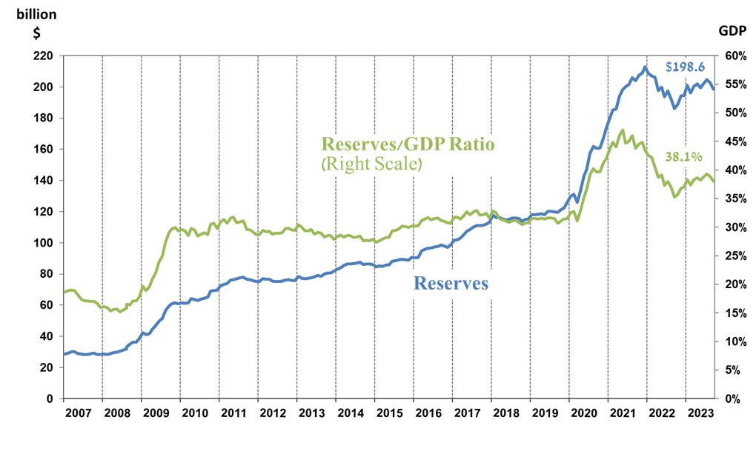

1. Includes Bank of Israel payments and receipts in foreign currency.
2. b This column includes Special Drawing Rights (SDRs), the balance of NAB loans, and the balance of Israel's reserve tranche at the IMF.

   c Updated after the original date of publication.