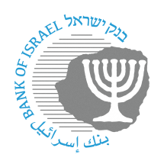

BANK OF ISRAEL

Office of the Spokesperson and Economic Information

September 12, 2023

Press release:

**The Bank of Israel held an international conference today marking the publication of the Project "Sela" project**

Today, the Bank of Israel held an international conference in Tel Aviv on the occasion of the publication of the report of Project "Sela", an proof of concept that tested the feasibility of a retail central bank digital currency (CBDC) a new type of payment service providers that do not hold the end users' funds at any stage, while maintaining the cyber security of the system. The experiment was led by the BIS Innovation Hub, in collaboration with the Bank of Israel and the Hong Kong Monetary Authority. The project's summary report was published this morning (link).

Senior Speakers at the conference was honored were Governor of the Bank of Israel, Prof. Amir Yaron, Deputy Governor of the Bank of Israel, Mr. Andrew Abir, Deputy Chief Executive of the Hong Kong Monetary Authority, Mr. Howard Lee, and head of the Hong Kong Centre of the BIS Innovation Hub, Ms. Benedict Nolans. The main learnings from the project were presented, followed by a demo of the main operations that can be performed in the experimental CBDC system built as part of the project.

The second part of the conference was dedicated to the work of the various partners of the project in the field of CBDC and digital payments. The Bank of Israel and the Hong Kong Monetary Authority presented the progress in the CBDC projects in both countries - the digital shekel project at the Bank of Israel, and the e-HKD project as well as other projects of the HKMA. The BIS Innovation Hub presented the main lessons from various CBDC projects that the Hub has conducted in recent years. The private sector vendors that participated in the project also presented the aspects of their work in the space.

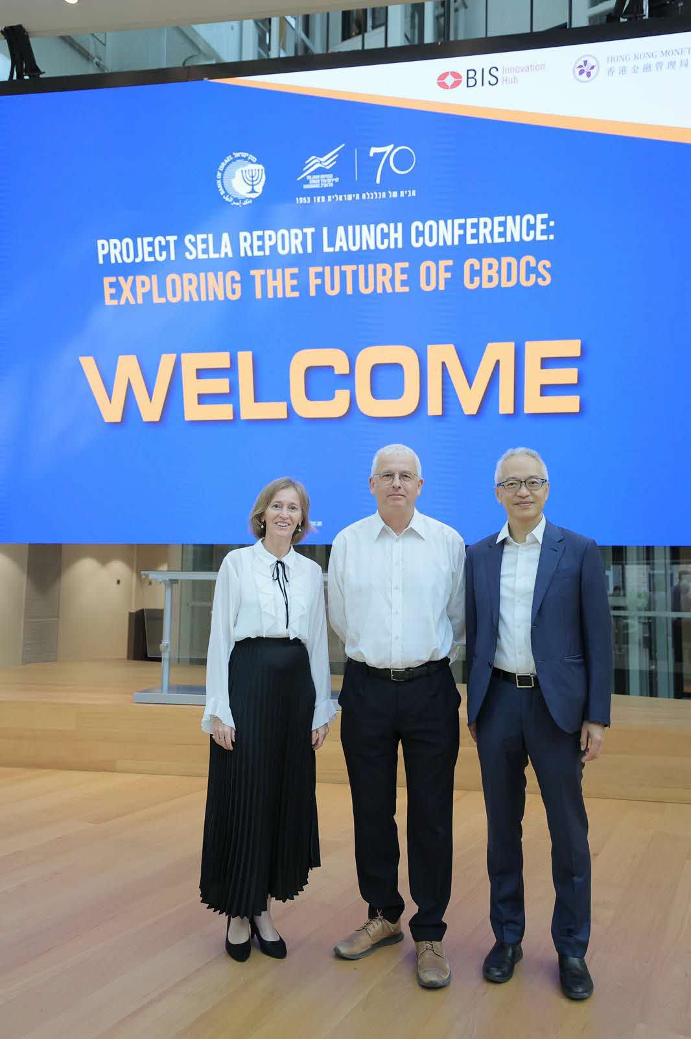

Attached hereto:

Opening Remarks:

* [Andrew Abir, Deputy Governor, Bank of Israel](Opening%20remarks%20Deputy%20Governor%20Abir.docx)
* [Howard Lee, Deputy Chief Executive, HKMA](Opening%20remarks%20Howard%20Lee.docx)

Closing Remarks:

* [Amir Yaron, Governor, Bank of Israel](Closing%20remarks%20by%20Governor%20Yaron%20CBDC.docx)

Presentations:

* [Opening remarks: Bénédicte Nolens, Head of Hong Kong Centre, BIS Innovation Hub](23%2009%20Sela%20BISIH%20Intro%20-%20Benedicte%20(002).pptx)
* Spotlight on Project Sela : Daniel Eidan, BISIH, Leanne Zhang, BISIH, Marten Nelson, M10.
* [Bank of Israel: Where we stand with the digital shekel project – Yoav Soffer](Yoav%20-%20Project%20Sela%20Confrence.pptx)
* [BIS Innovation Hub: Stocktaking from BIS Projects on CBDCs –Bénédicte Nolens](Benedicte%202%20-%2023%2009%20Sela%20BISIH%20Intro%202.pptx)
* [FIS - Digital Regulated Money– Julia Demidiva](Julia%20-%2012092023-Digital-Regulated-Money-Julia-Demidova.pdf)
* [Checkpoint – Guardians of Digital Trust - Dan Karpati](005%20%20Project%20Sela%20-%20TLV%20Conference%20Sep%2012%20(1).pdf)
* [Clifford Chance - Changes in the payment landscape - a lawyer's perspective – Diego Ballon Ossio](Diego%20-%20Project%20Sela%20-%20CC%20presentation%20-%20Changes%20in%20the%20payment%20landscape%20-%20a%20lawyers%20perspective.pptx)

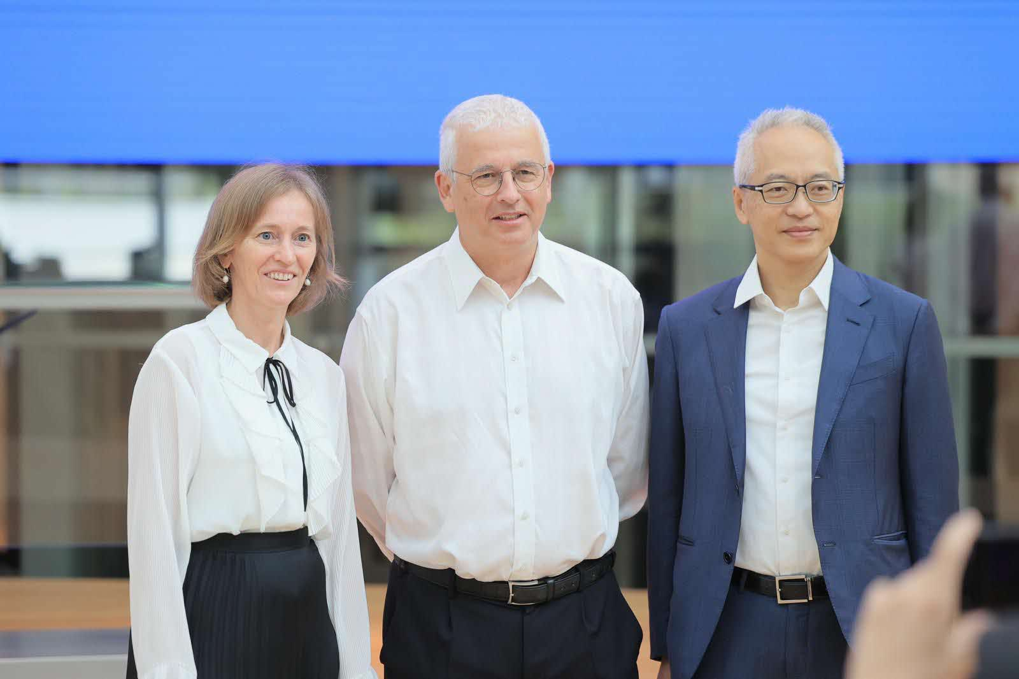Credit: Oz Schechter