

BANK OF ISRAEL

Office of the Spokesperson and Economic Information

March 25, 2025

Press Release:

Israel’s International Investment Position (IIP), fourth quarter of 2024

* **Outstanding liabilities to abroad increased by approximately $27.5 billion (about 5.2 percent) in the fourth quarter, to about $554 billion at the end of the quarter. The increase was primarily due to a combination of an increase in the prices of Israeli securities held by nonresidents and the continued flow of net investments in Israel by nonresidents.**
* **In the fourth quarter of 2024, the balance of assets held abroad by Israeli residents increased by approximately only $2.8 billion (about 0.4 percent), to about $774 billion at the end of December. The increase was mainly due to net investments abroad by Israeli residents and an increase in the prices of foreign securities held by Israeli residents.**
* **Israel’s surplus of assets over liabilities vis-à-vis abroad decreased by approximately $25 billion (10 percent) in the fourth quarter, to about $220 billion at the end of the quarter.**
* **The surplus of assets over liabilities vis-à-vis abroad in debt instruments alone (negative net external debt) decreased by about $6 billion (2.2 percent) during the fourth quarter, to approximately $277 billion at the end of December.**
* **The ratio of gross external debt to GDP declined by about 0.7 percentage points in the fourth quarter, to about 27 percent at the end of December.**

**Summary of 2024**

* **In 2024, there was a sharp increase in the scope of net investments in the economy by nonresidents. The scope of net investments was about $27 billion compared to only $8 billion in 2023.**
* **In the second half of 2024, nonresidents resumed net investments in Israeli securities, in contrast with the realizations of the past two years.**
* **In the second half of 2024, nonresidents also resumed direct investments, which totaled about $17 billion in 2024 overall, slightly higher than their 2023 level.**
* **In addition, the scope of net investments abroad by Israeli residents in 2024 was markedly higher than its scope in 2023, totaling about $47 billion.**

Table 1: Asset and liability balances, and changes in them

1. **The balance of Israelis’ assets abroad**

In the fourth quarter of 2024, the value of the assets held abroad by Israeli residents increased by about $2.8 billion (about 0.4 percent), to approximately $774 billion at the end of December.

* **The value of direct investments** increasedby about $2 billion (approximately 1.8 percent) in the fourth quarter, mainly as a result of net investments by Israeli residents.
* **The value of the securities portfolio** increased during the fourth quarter by about $12 billion (about 4.4 percent), mainly as a result of net investment in foreign securities by Israeli residents totaling about $6.7 billion, and price increases totaling approximately $5.5 billion on foreign securities held by Israeli residents,. (Figure 1). The investments were made by all the segments (Figure 1).

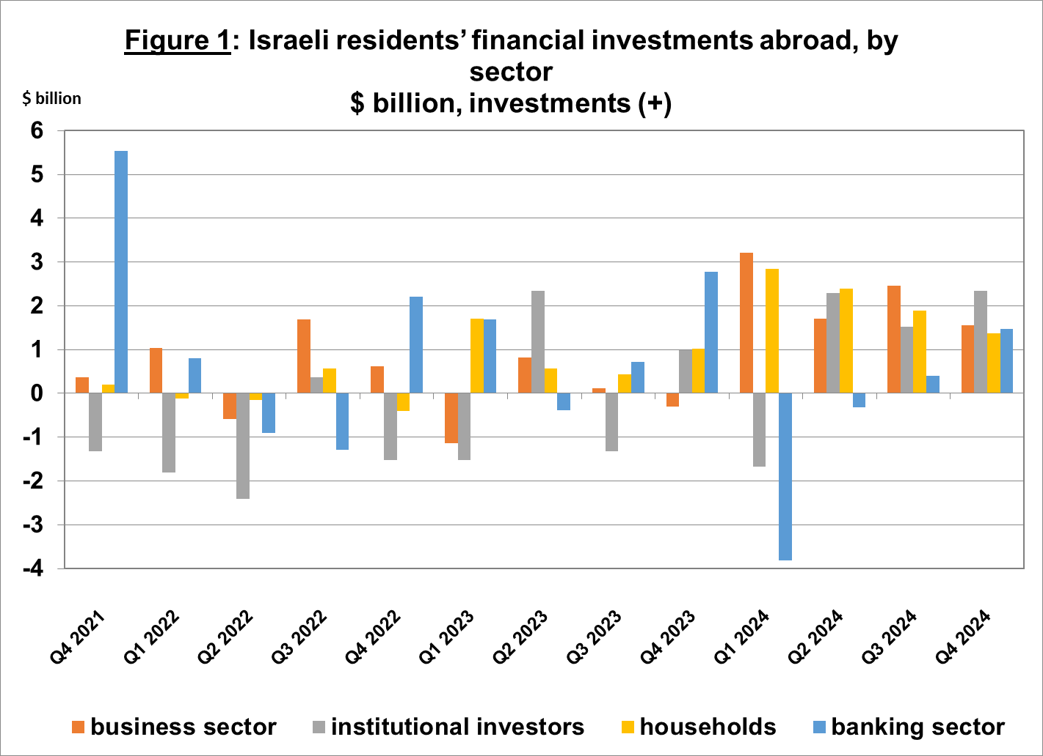

Source: Bank of Israel data and processing1.

* **The value of other investments** abroad increased was unchanged. Israeli residents invested a net $1.2 billion. Most of the investments were made via the provision of customers credit to nonresidents, totaling $2.5 billion and the provision of loans to nonresidents totaling $3.9 billion. These investments were fully offset by the strengthening of the shekel vis-à-vis the dollar.
* **The value of the reserve assets** decreased by about $5.8 billion (about 2.6 percent) during the fourth quarter, to about $216 billion at the end of December. The decline in the balance derived mainly from the strengthening of the dollar vs. other currencies worldwide, which led to a decline in the value of the reserve assets totaling about $5.3 billion. In addition, there were declines in foreign securities prices. These declines were partly offset by government activities totaling about $2.2 billion.
* **The composition of Israelis’ securities portfolio abroad**: During the fourth quarter, the share of equity instruments in Israeli residents’ portfolio abroad remained unchanged, and was 45 percent at the end of December. Accordingly, the share of debt instruments was 55 percent at the end of the quarter.

1. **Israel’s liabilities to abroad**

The balance of Israel's liabilities to abroad increased by about $27.5 billion (about 5.2 percent) during the fourth quarter, to approximately $554 billion at the end of the quarter. The increase was mainly due to an increase in prices of Israeli securities held by nonresidents, and the continued flow of net investments in Israel by nonresidents.

* **The value of direct investments in the economy** increased by about $7.3 billion (about 2.8 percent) during the fourth quarter, due to net investments by nonresidents totaling about $3.5 billion and an increase in the prices of Israel shares held by nonresident parties at interest. In 2024, the volume of net direct investments was similar to the volume in the same period in the previous year (Figure 2).

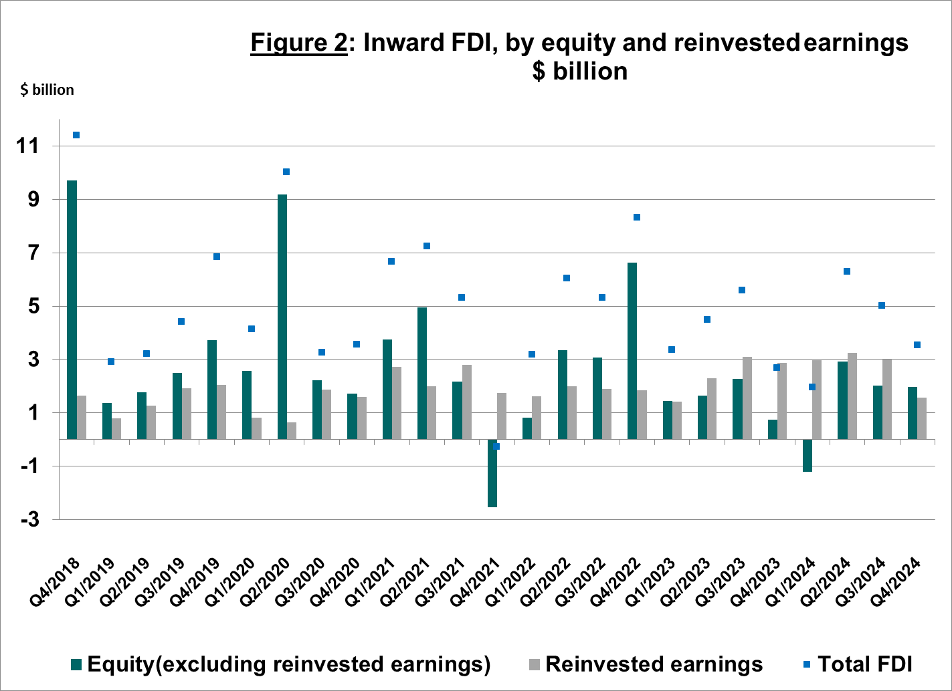

Source: Bank of Israel data and processing1.

* **The value of the securities portfolio** increased by about $16.8 billion (about 8.3 percent) in the fourth quarter, mainly due to an increase of about $14.8 billion in the prices of Israeli securities. Nonresidents’ invested about a net $2.8 billion in Israeli equities, mainly in equities traded on global exchanges. In parallel, nonresidents realized a net $2.1 billion in Israeli bonds (mostly private).
* **The value of nonresidents' financial portfolio on the Tel Aviv Stock Exchange,** which makes up a part of nonresidents’ investments in Israel, increased by about $10 billion in the fourth quarter of 2024, to about $76 billion at the end of December. The increase in the value of the portfolio derived mainly from an increase in the prices of securities held by nonresidents (Figure 3 and Figure 4).

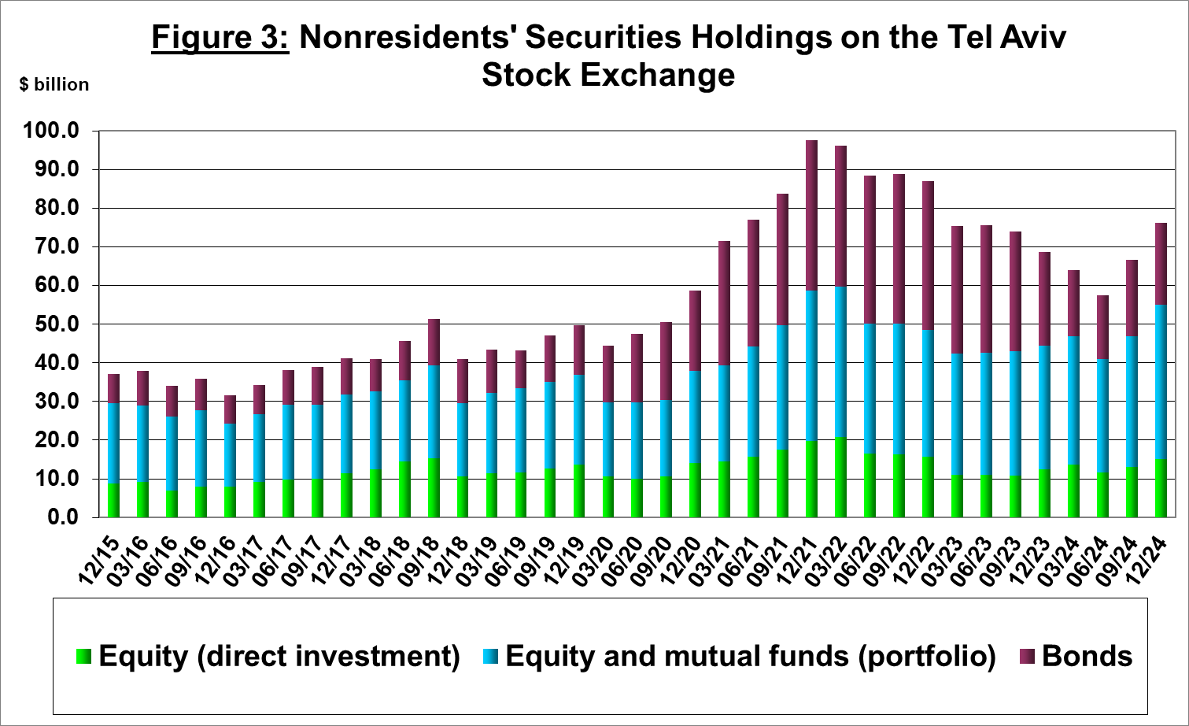

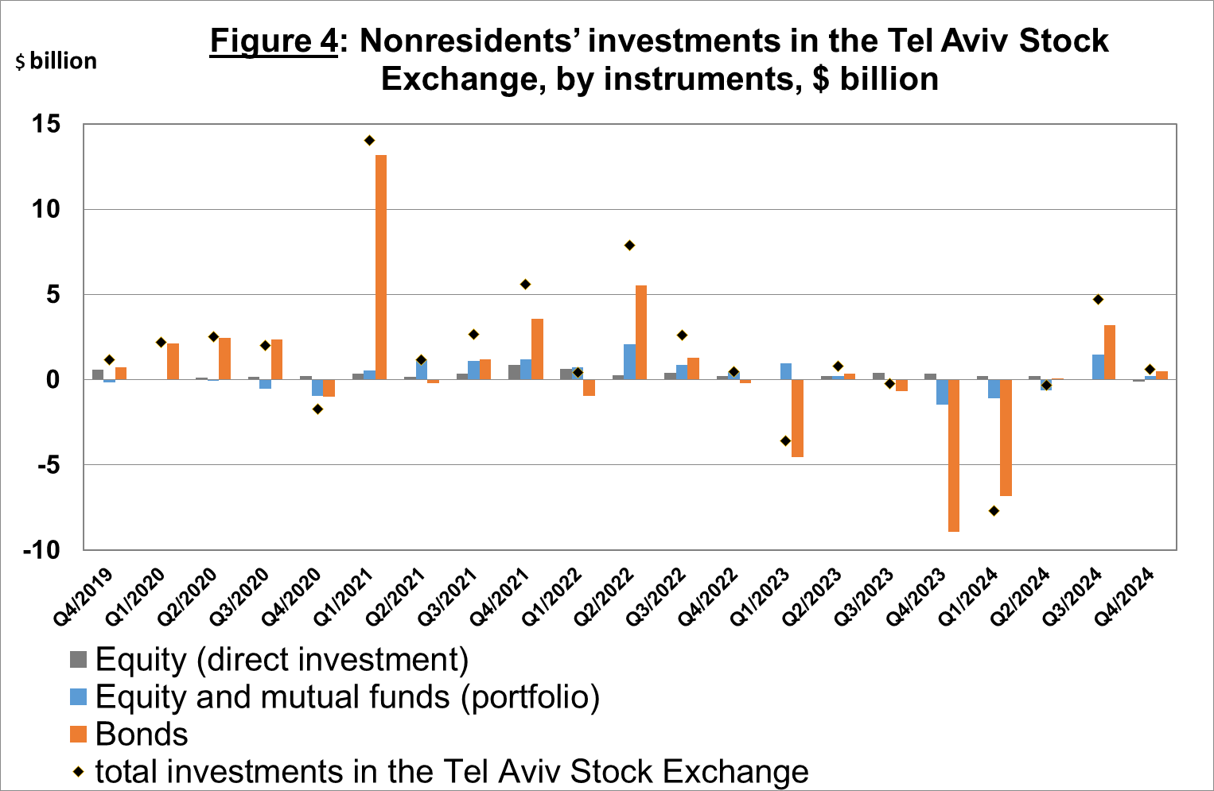

Source: Israel Securities Authority, and Bank of Israel data and processing1.

**The value of other investments in the economy** increased by about $3.4 billion (about 5.1 percent) in the fourth quarter, to about $70 billion. The increase derived mainly from an increase in suppliers’ credit totaling approximately $3.6 billion, and by net deposits by nonresidents (including banks) in deposits with Israeli banks totaling $1.2 billion, which were partly offset by loan repayments by nonresidents totaling about $0.7 billion.

**The balance of liabilities in debt instruments alone,** which makes up Israel's gross external debt, increased by about $5.8 billion (4.1 percent) in the fourth quarter, to about $147 billion.

**The ratio of gross external debt to GDP** declined by about 0.7 percentage points in the fourth quarter, to about 27 percent at the end of December (Figure 5). The increase in the external debt to GDP ratio reflected an increase in the balance of gross external debt at a higher pace than the increase in GDP in dollar terms (Figure 5).

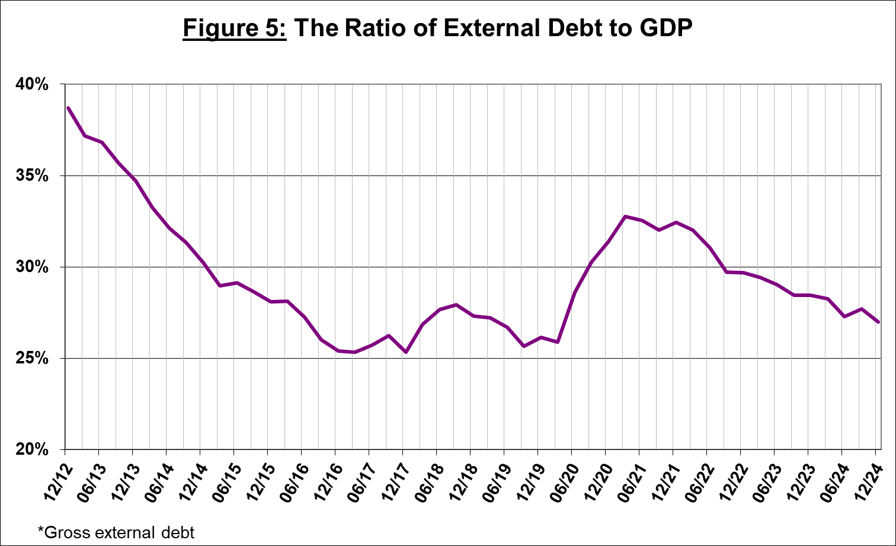

Source: Israel’s Ministry of Finance, Israel’s Central Bureau of Statistics, and Bank of Israel data and processing.1

1. **Israel’s surplus assets over liabilities vis-à-vis abroad**

The increase in the balance of assets was smaller than the increase in the balance of liabilities, which led to a decrease of about $25 billion (10 percent) in the surplus of assets over liabilities vis-à-vis abroad, which totaled about $220 billion at the end of December (Figure 6).

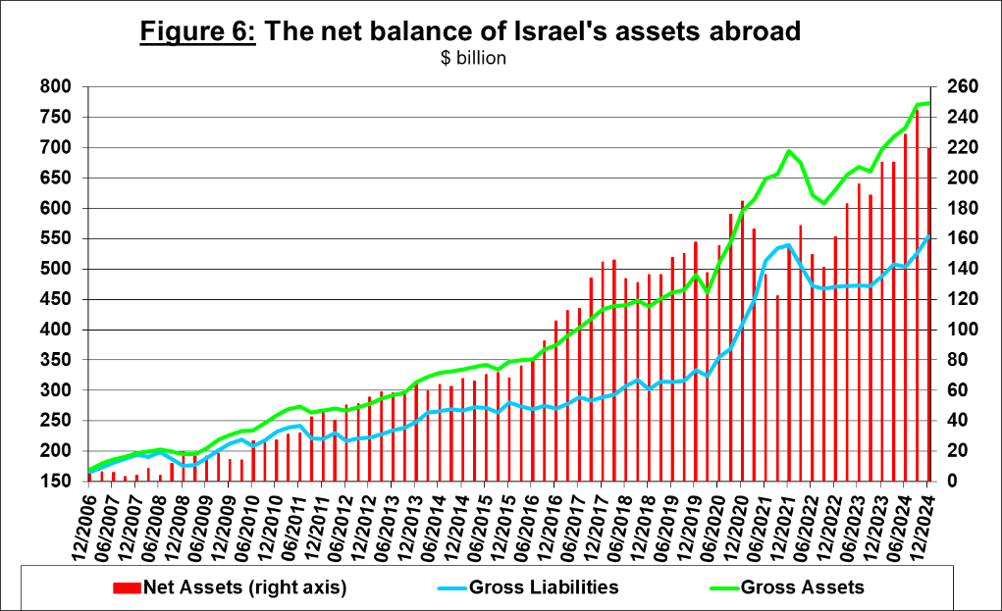

Source: Bank of Israel data and processing1.

1. **Net external debt**

The surplus of assets over liabilities vis-à-vis abroad in debt instruments alone (negative net external debt) declined by approximately $6.2 billion (about 2.2 percent) in the fourth quarter, to about $277 billion at the end of December (Figure 7).

**The balance of assets in debt instruments** declined by about $5 billion in the fourth quarter, to about $424 billion at the end of the quarter, of which about $215 billion is the Bank of Israel's foreign exchange reserves. This balance reflects a coverage ratio of 2.9 times the gross external debt.

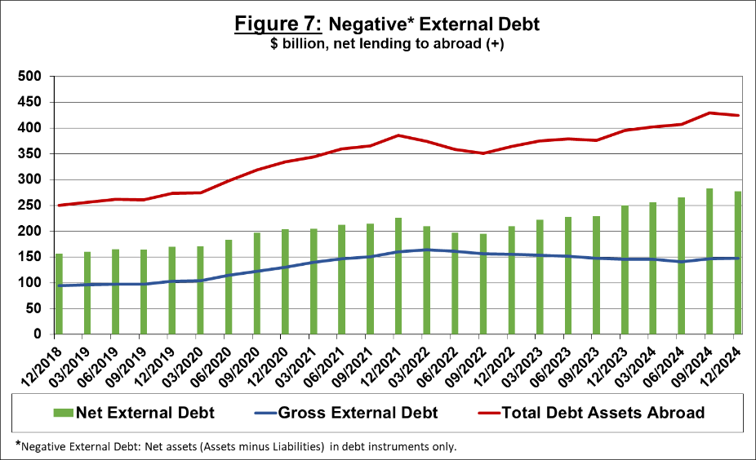

Source: Israel’s Ministry of Finance, and Bank of Israel data and processing

[For the complete data file, click here](http://www.bankisrael.gov.il/deptdata/pik_mth/pikmth_e.htm).