

BANK OF ISRAEL

Office of the Spokesperson and Economic Information

June 20, 2018

Press Release

Debt Developments in the Nonfinancial Private Sector,

First Quarter of 2018

In the first quarter of 2018, the balance of **business sector debt** increased markedly, by approximately NIS 33 billion (3.8 percent), to NIS 888 billion. Outstanding **household debt** increased by about NIS 4.7 billion (0.9 percent) during the first quarter, to about NIS 536 billion at the end of the quarter.

**The business sector’s outstanding debt**

* In the first quarter of 2018, the balance of business sector debt increased markedly, by approximately NIS 33 billion (3.8 percent), to NIS 888 billion. The increase was a result of a significant quantitative increase in all debt-raising channels, totaling about NIS 30 billion, and was comprised mainly of net debt raised in tradable bonds in Israel, against the background of high issuances during the quarter, and an increase in bank loans. The increase was also a result of a 1.4 percent depreciation of the shekel against the dollar, which increased the value of the debt denominated in and indexed to foreign exchange (Figure 1).
* In the first quarter, the **business sector** (excluding banks and insurance companies) issued about NIS 15.2 billion in bonds, further to high issuances in the past two years. There were notable issuances in the quarter by companies in the real estate and construction industry (about 56 percent of total issuances). However, in April 2018, issuances by the business sector moderated, and totaled about NIS 2.1 billion, all in tradable bonds. This is lower than the average monthly issuance in the first quarter (about NIS 5.1 billion).
* In the first quarter, **the spread between yields on CPI-indexed corporate bonds, as measured by the Tel Bond 60 index, and the yield on CPI-indexed government bonds** widened by about 0.11 percentage points to about 1.21 percentage points, further to the expansion in the previous quarter. In April 2018, this spread continued expanding, to about 1.24 percentage points.

**Table 1: The Composition of Business Sector Debt**



**Figure 1: Estimated Net Quarterly Quantitative Change in Business Sector Debt,**

**NIS billion**

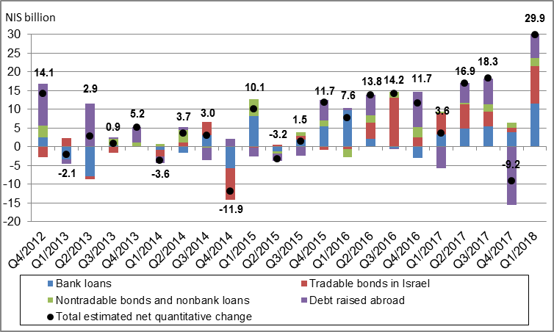

**Table 2: Debt by Indexation**



**Figure 2: Nonfinancial Business Sector Bond Issuance**

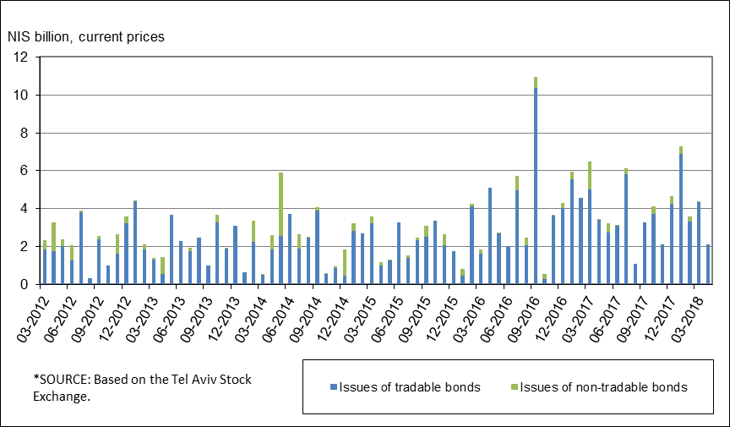

**Figure 3 : Spread between Indexed Corporate Bonds (Tel-Bond 60) and Indexed Government Bonds (monthly average)**

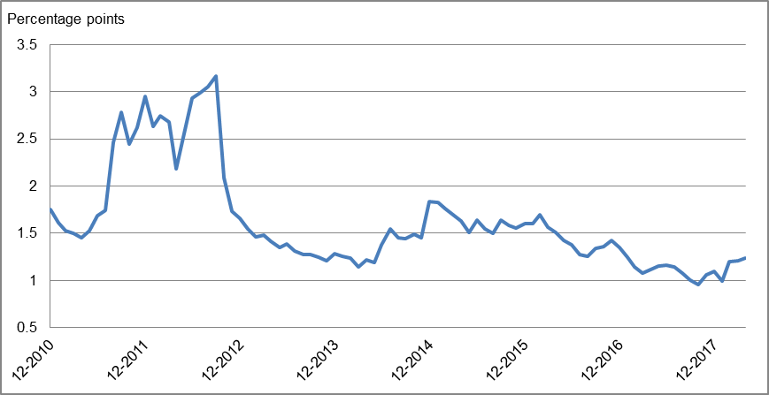

**Household debt**

* **Households’ outstanding debt** increased by approximately NIS 4.7 billion (about 0.9 percent) in the first quarter of 2018, to about NIS 536 billion. Outstanding housing debt increased in the first quarter by about NIS 4.1 billion (1.2 percent), to about NIS 341 billion. Outstanding non-housing debt increased by only about NIS 0.6 billion (0.3 percent), to NIS 194 billion. However, the decline in the annual growth rate of this balance, which began at the end of 2016, continued. (Figure 4).
* In the first quarter of 2018, new mortgages taken out totaled about NIS 14.1 billion, higher than the corresponding period last year (about NIS 13.1 billion). However, in April 2018 there was a decline, mostly seasonal, in new mortgages taken out, which totaled about NIS 4.1 billion—slightly lower than the average monthly total in the first quarter (about NIS 4.7 billion) (Figure 5).

**Table 3: Outstanding Debt Balances of Households1**



**Figure 4: Rates of Change in Households’ Housing and Non-housing Debt, Current Quarter vs. Corresponding Quarter of Previous Year**

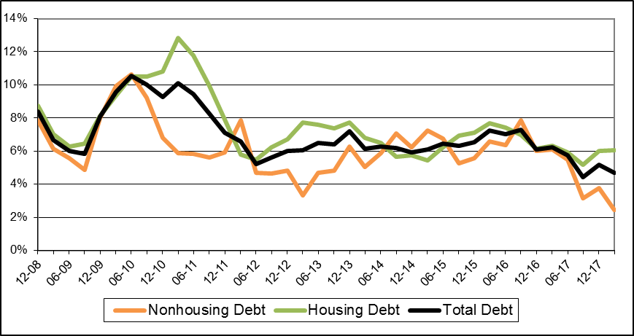

**Figure 5 : Total New Housing Credit from Banks (Mortgages)**

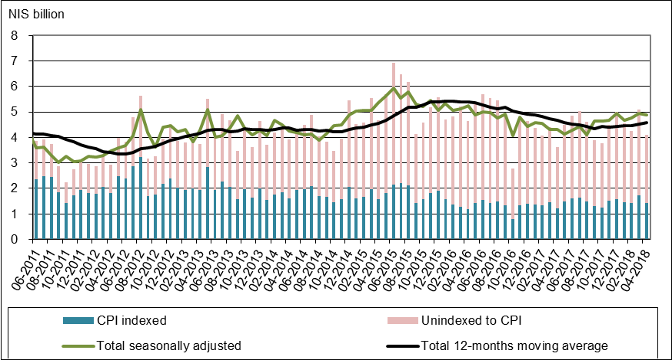

For links to Data and Statistics on the Bank of Israel website:

[http://www.boi.org.il/en/dataandstatistics/pages/default.aspx](https://e.boi.org.il/en/dataandstatistics/pages/default.aspx)

[http://www.boi.org.il/en/bankingsupervision/data/pages/tables.aspx?chapterid=13](https://e.boi.org.il/en/bankingsupervision/data/pages/tables.aspx?chapterid=13)

[http://www.boi.org.il/en/BankingSupervision/Data/Pages/Tables.aspx?ChapterId=19](https://e.boi.org.il/en/BankingSupervision/Data/Pages/Tables.aspx?ChapterId=19)