March 26, 2024

Press Release:

Israel’s International Investment Position (IIP),

fourth quarter of 2023

* **In the fourth quarter of 2023, the balance of assets held abroad by Israeli residents increased by approximately $39.5 billion (about 6 percent), to about $702 billion at the end of December. The increase was mainly due to an increase in the prices of foreign securities held by Israeli residents, and by net investments abroad by Israeli residents.**
* **Outstanding liabilities to abroad increased by approximately $15 billion (about 3.1 percent) in the fourth quarter, to about $497 billion at the end of the quarter. The increase was primarily due to an increase in the prices of Israeli securities traded abroad and held by nonresidents. In parallel, in view of the Swords of Iron War, nonresidents realized about $6.2 billion of their investments in the tradable securities portfolio. Most of the realizations were of bonds (including makam). In addition, there was a slowdown in the scope of direct investments in Israel.**
* **For the year overall[1], there was a marked decline in the scope of investments in Israel by nonresidents, mainly in direct investments. In the tradable securities portfolio, nonresidents even realized government bonds and makam.**
* **Israel’s surplus of assets over liabilities vis-à-vis abroad increased by approximately $24.5 billion (13.6 percent) in the fourth quarter, to about $205 billion at the end of the quarter.**
* **The surplus of assets over liabilities vis-à-vis abroad in debt instruments alone (negative net external debt) increased by about $20.6 billion (9.3 percent) during the fourth quarter, to approximately $242 billion at the end of December.**
* **The ratio of gross external debt to GDP increased by about 0.3 percentage points in the fourth quarter, to about 30.5 percent at the end of December.**

Table 1: Asset and liability balances, and changes in them



1. **The balance of Israel’s assets abroad**

In the fourth quarter of 2023, the value of the assets held abroad by Israeli residents increased in the quarter by about $39.5 billion (about 6 percent), to approximately $702 billion at the end of December.

* **The value of direct investments** increasedby about $2.9 billion (approximately 2.8 percent) in the fourth quarter, mainly as a result of earnings accrued for investment.
* **The value of the securities portfolio** increased by about $16.8 billion (about 7.6 percent) during the fourth quarter, mainly as a result of approximately $10 billion in price increases on foreign securities held by Israeli residents, and by net investments in foreign securities by Israeli residents.

During the fourth quarter, there were net investments of about $6.1 billion in Israeli residents’ securities portfolio abroad. Banks invested about $3.2 billion in foreign securities, and other sectors combined invested a similar amount (Figure 1).

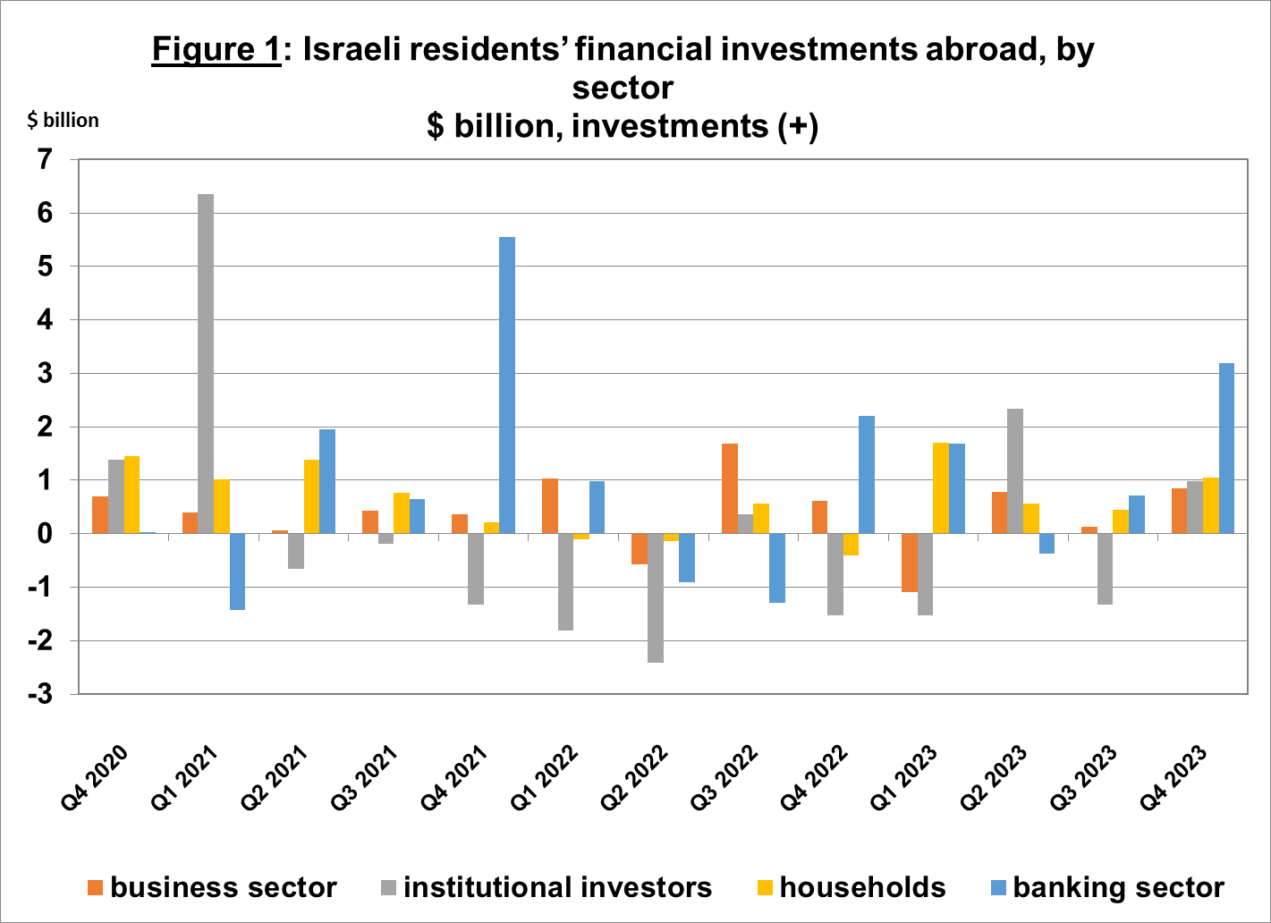

Source: Bank of Israel data and processing1.

* **The value of other investments** abroad increased by about $7.8 billion (5.6 percent) in the fourth quarter. The increase derived mainly from net deposits abroad by Israelis (including banks) totaling about $2.8 billion, and from investments in other assets totaling about $1.9 billion, mainly by institutional investors in foreign investment funds. In addition, there was an increase of $1.5 billion in customers’ credit.
* **The value of reserve assets increased** by about $6.1 billion (about 3.1 percent) during the fourth quarter, to about $205 billion at the end of December. The increase derived mainly from price increases totaling about $5.7 billion, and from the strengthening of the dollar vis-à-vis other currencies by about $3.9 billion. This increase was partly offset by realizations totaling $3.4 billion.
* **The composition of Israelis’ securities portfolio abroad**: During the course of the fourth quarter, the share of equity instruments in Israeli residents’ portfolio abroad remained unchanged, and was 43 percent at the end of December. Accordingly, the share of debt instruments remained at 57 percent at the end of the quarter.

1. **Israel’s liabilities to abroad**

The balance of Israel's liabilities to abroad increased by about $15 billion (3.1 percent) during the fourth quarter, to approximately $497 billion at the end of the quarter. The increase was mainly due to an increase in prices of Israeli securities traded abroad and held by nonresidents and by the strengthening of the shekel vis-à-vis the dollar. In contrast, for the first time in 9 years, there were realizations by nonresidents in Israel of about $1 billion.

* **The value of direct investments in the economy** increased by about $6.3 billion (about 2.6 percent) during the fourth quarter, mainly due to net direct investments in share capital totaling about $4 billion, of which about $2 billion was in respect of reinvested earnings. The rest of the investments were spread out over a large number of companies. For the year overall, there was a notable decline in the scope of direct investments by nonresidents in the economy compared to previous years.
* **The value of the securities portfolio** increased by about $6.6 billion (about 3.6 percent) in the fourth quarter, mainly as a result of an increase in prices of Israeli securities traded abroad at a scope of $8.5 billion and by the shekel’s appreciation against the dollar during the quarter, which increased the dollar value of the investment portfolio by about $3.8 billion. In contrast, against the background of the Swords of Iron War, there were net realizations by nonresidents at a significant scope of $6.2 billion, mainly in bonds (including makam).
* **The value of nonresidents' financial portfolio on the Tel Aviv Stock Exchange,** which makes up a part of nonresidents’ investments in Israel, declined by about $4.6 billion in the fourth quarter, to about $77.8 billion at the end of December. The decrease in the portfolio value derived mainly from nonresidents’ realizations of investments in bonds (including makam), at a scope of about $8.3 billion.

(Figure 2 and Figure 3).

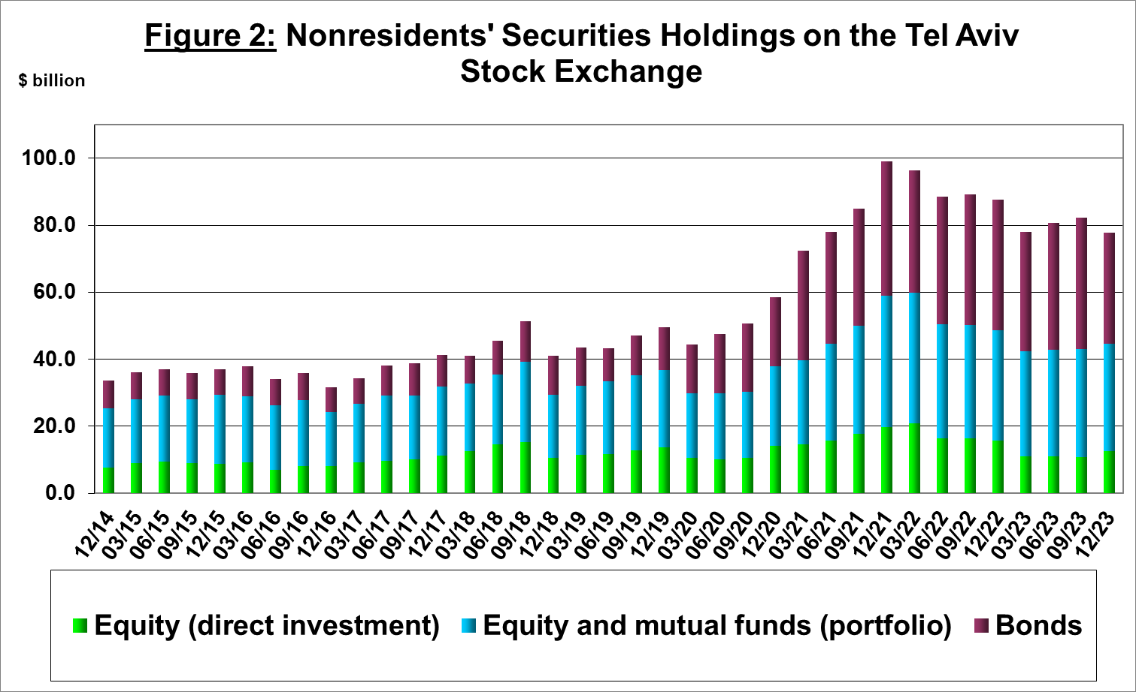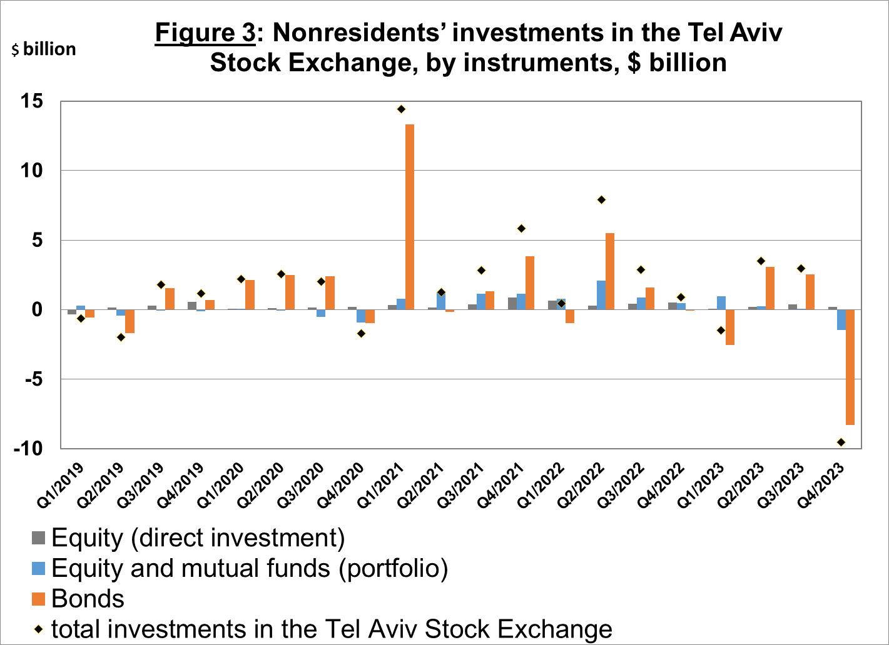

Source: Israel Securities Authority, and Bank of Israel data and processing1.

**The value of other investments in the economy** increased by about $2.1 billion (about 3.5 percent) in the fourth quarter, to about $61.7 billion. The increase was mainly due to an increase of about $1.9 billion in nonresidents’ net deposits (including banks) in deposits at Israeli banks. This increase was partly offset by a decline in suppliers’ credit totaling about $1.1 billion.

**The balance of liabilities in debt instruments alone,** which makes up Israel's gross external debt, declined by about $0.5 billion (0.3 percent) in the fourth quarter, to about $155 billion.

**The ratio of gross external debt to GDP** increased by about 0.3 percentage points in the fourth quarter, to about 30.5 percent at the end of December (Figure 4).

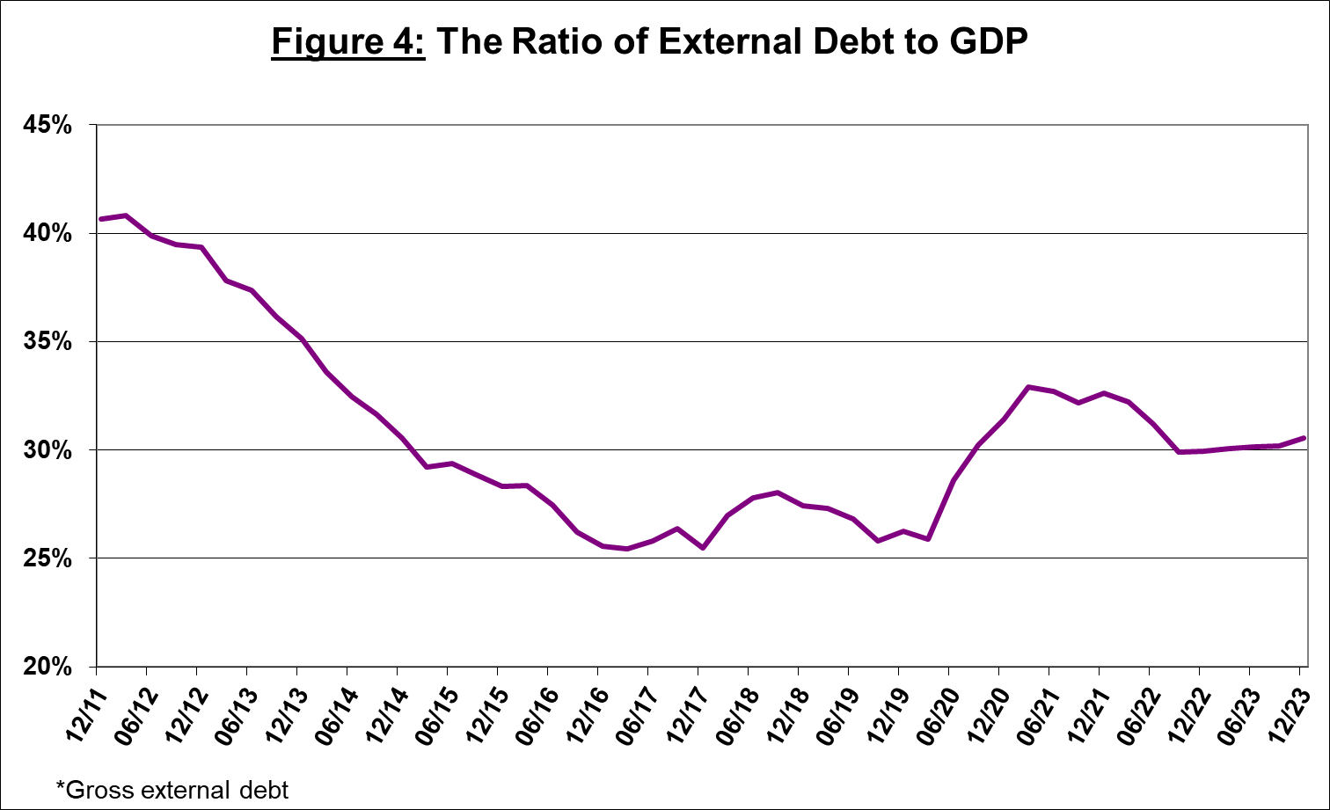

Source: Israel’s Ministry of Finance, Israel’s Central Bureau of Statistics, and Bank of Israel data and processing1.

1. **Israel’s surplus assets over liabilities vis-à-vis abroad**

An increase in the balance of assets that was greater than the increase in the balance of liabilities led to an increase of about $24.5 billion (13.6 percent) in the surplus of assets over liabilities vis-à-vis abroad, which totaled about $205 billion at the end of December (Figure 5).

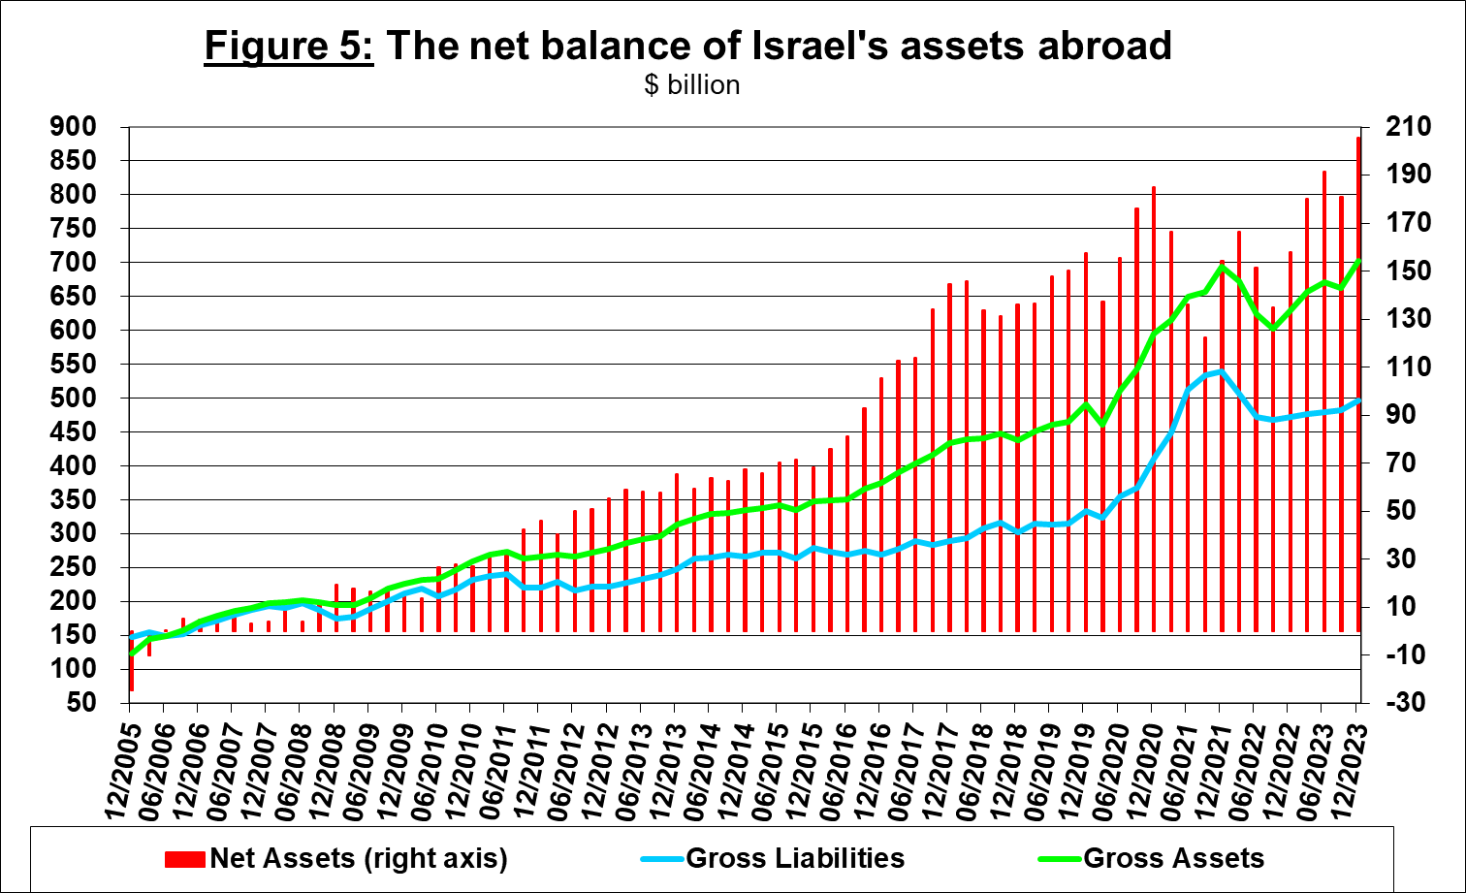

Source: Bank of Israel data and processing1.

1. **Net external debt**

The surplus of assets over liabilities vis-à-vis abroad in debt instruments alone (negative net external debt) increased by approximately $20.6 billion (about 9.3 percent) in the fourth quarter, to about $242 billion at the end of December (Figure 6).

**The balance of assets in debt instruments** increased by about $20 billion in the fourth quarter, to about $397 billion at the end of the quarter, of which about $207 billion is the Bank of Israel's foreign exchange reserves. This balance reflects a coverage ratio of 2.7 times the gross external debt.

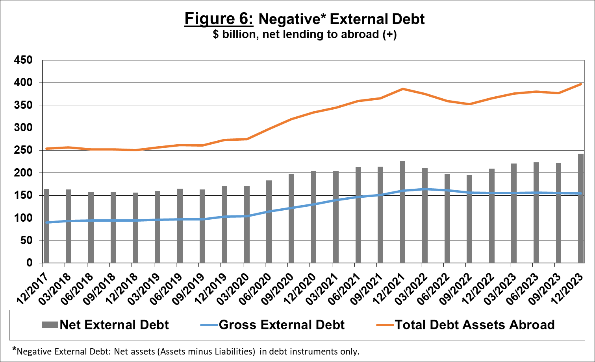

Source: Israel’s Ministry of Finance, and Bank of Israel data and processing.

[For the complete data file, click here](http://www.bankisrael.gov.il/deptdata/pik_mth/pikmth_e.htm).

1. For an expanded discussion, see the “Statistical Bulletin” for 2023:

   <https://boi.org.il/publications/pressreleases/14-3-24>. (Currently in Hebrew, the English translation will be available in several months.