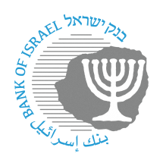

BANK OF ISRAEL

Office of the Spokesperson and Economic Information

Press release

March 12, 2024

**Governor of the Bank of Israel Prof. Amir Yaron participated in a BIS meeting in Basel with central bank governors from around the world**

Governor of the Bank of Israel Prof. Amir Yaron returned to Israel after participating in a meeting of governors from central banks around the world, who are members of the Bank for International Settlements (BIS[1]*). The meeting was held in Basel, Switzerland.

Within the framework of the BIS meeting, the Governor participated in a panel discussion on “From Financial Inclusion to Economic Health”, with the participation of Queen Maxima of the Netherlands.

The Governor also participated in a discussion with governors from small open economies on “Monetary Policy in SOE Countries: Recent Developments and A Look Forward”.

1. * Background:

   The BIS (Bank for International Settlements) is the bank regulating international financial settlements. It is the oldest international financial organization. Its role is to promote cooperation between central banks, of which 63 are currently members. The BIS’s activities include the development of international banking supervision standards and criteria (the “Basel” regulations), monitoring the stability of the international financial system, providing banking services to central banks, and assisting various financial institutions in performing their functions. The Bank of Israel joined the BIS as a full member in September 2003.