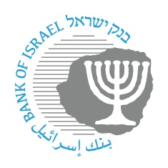

**BANK OF ISRAEL**

Office of the Spokesperson and Economic Information

April 18, 2023

Press Release:

**Governor’s trip to the US for IMF spring meetings**

The Governor of the Bank of Israel returned last night from the US, where he participated in the spring meetings of the International Monetary Fund and the World Bank. Within the framework of the conference, the Governor held work meetings with senior IMF and the World Bank officials, central bank governors, policy makers, and senior economists from various countries.