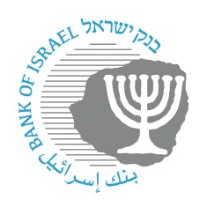
BANK OF ISRAEL
Office of the Spokesperson and Economic Information

Press release:

Israel’s International Investment Position (IIP), First quarter of 2026
- The economy’s outstanding liabilities to abroad increased by approximately $6 billion (about 0.8 percent) in the first quarter, to about $658 billion at the end of the quarter. During the quarter, nonresidents’ direct investments in Israel, including in share capital, increased relative to the previous 4 quarters. At the same time, the prices of Israeli securities held by nonresidents increased.
- In the first quarter of 2026, the balance of assets held abroad by Israeli residents declined by approximately $5 billion (about 0.5 percent), to about $909 billion at the end of March. The decline in the balance was mainly due to price declines and net realizations of foreign securities by Israeli residents.
- During the first quarter, there were a number of large-scale transactions that affected both assets and liabilities, including transfers between various investment channels. These transactions led to a decline in financial investments and an increase in direct investments by foreign residents in the economy. They also led to a decrease in direct investments by Israeli residents abroad.
- The surplus of assets over liabilities vis-à-vis abroad declined by $11 billion (4 percent) during the first quarter of 2026, to about $250 billion at the end of the quarter.
- The surplus of assets over liabilities vis-à-vis abroad in debt instruments alone (negative net external debt) declined by about $5 billion (1.5 percent) during the fourth quarter, to approximately $325 billion at the end of March.
- The ratio of gross external debt to GDP (in dollar terms) increased by 0.3 percentage points in the first quarter, to about 27 percent at the end of March.

Table 1: Asset and liability balances, and changes in them
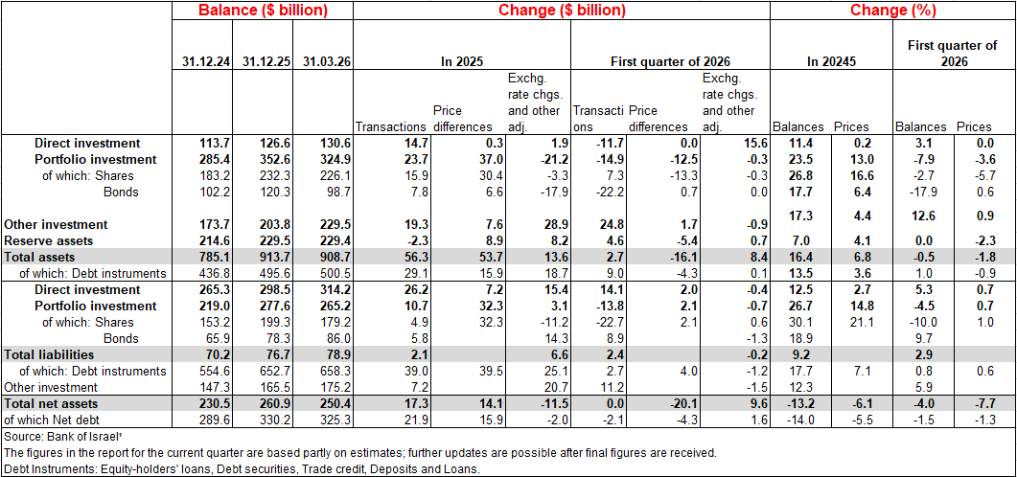

1. Balance of Israeli residents’ assets abroad
The balance of Israeli residents’ assets abroad declined by about $5 billion (approximately 0.5 percent) in the first quarter of 2026 to $909 billion at the end of March.
- The value of direct investments increased by $4 billion (about 3 percent) in the first quarter.
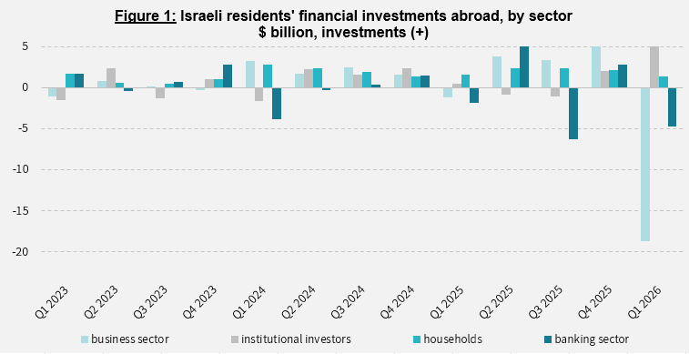
- The value of the securities portfolio declined by about $28 billion (about 7.9 percent) during the fourth quarter, mainly the result of net realizations of foreign securities by Israeli residents totaling about $15 billion, and of declines in the prices of foreign securities held by Israeli residents, totaling approximately $13 billion. The business sector and the banking sector realized about $23 billion combined. In contrast, institutional investors and households invested about $8 billion combined (Figure 1).
- The value of other investments abroad increased by about $26 billion (about 13 percent) in the first quarter. In parallel, Israeli residents (including banks) made net deposits of about $17 billion abroad. Some of these deposits originated in money received as a result of the realization of direct investments by Israeli residents. In parallel, Israeli residents issued totaling about $5 billion to nonresidents. In addition, there was an increase of about $2.4 billion in customer credit.
- The value of reserve assets remained unchanged in the first quarter at about $230 billion at the end of March. Government activity contributed to an increase of about $5 billion in the value of the reserves, which was fully offset by declines in the prices of foreign securities.
- The composition of the portfolio abroad: During the first quarter, the share of capital instruments in Israeli residents’ asset portfolio abroad remained unchanged, at 46 percent at the end of March. Accordingly, the share of debt instruments at the end of the quarter was 54 percent.
2. The balance of the economy’s liabilities to abroad
In the first quarter of 2026, the value of the economy’s liabilities to abroad increased by about $6 billion (about 0.8 percent), to approximately $658 billion at the end of the quarter. The increase in the balance derived mainly from nonresidents’ direct investments in Israel and from an increase in the prices of Israeli securities held by nonresidents.
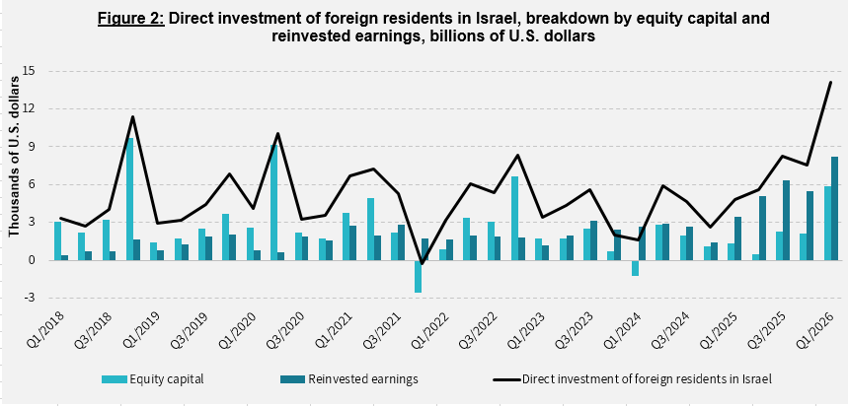
- The value of direct investments in the economy increased by about $16 billion (approximately 5 percent) in the first quarter, a result of net investments of $14 billion by nonresidents (mainly undistributed profits) and an increase in the prices of Israeli equities held by nonresident parties at interest (Figure 2).

- The value of the securities portfolio declined by about $12 billion (about 4.5 percent) during the first quarter. Nonresidents made net realizations of about $23 billion in Israeli equities, and made net investments of about $9 billion in Israeli bonds. A significant part of the realizations of securities was offset by direct investments of a similar volume.
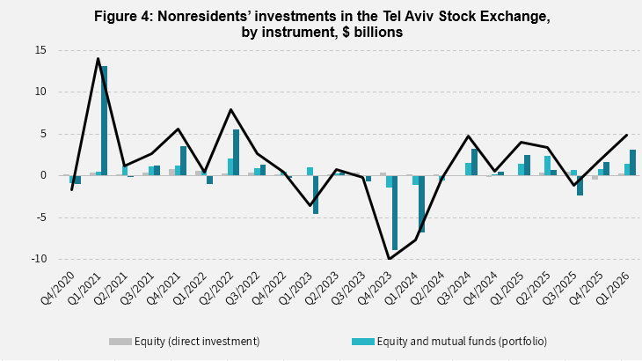
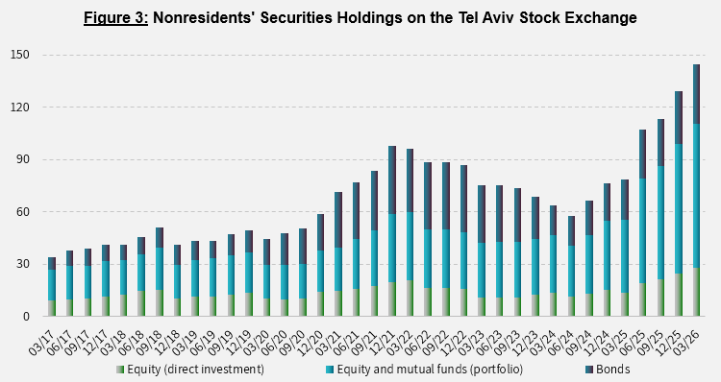
- The portfolio value of nonresidents on the Tel Aviv Stock Exchange (which makes up part of the balance of nonresidents’ investments in the economy), increased by about $15 billion in the first quarter, to about $115 billion at the end of March (Figure 3 and Figure 4).
Source: Bank of Israel data and processing¹.

- The value of other investments in the economy increased by about $2 billion (about 2.9 percent) during the fourth quarter, to $79 billion. The increase derived mainly from net deposits by nonresidents (including banks) in Israeli bank deposits.
- The balance of liabilities in debt instruments alone, making up the economy’s gross external debt, increased by about $10 billion (5.9 percent) during the first quarter, to about $175 billion.
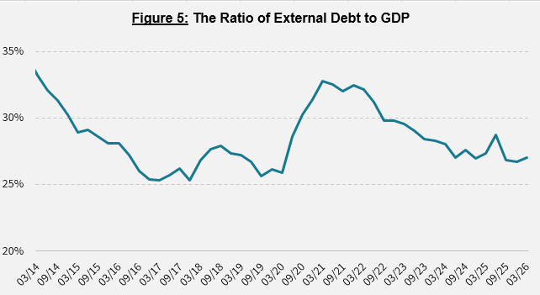
- The ratio of gross external debt to GDP increased by 0.3 percentage points during the first quarter, to about 27 percent at the end of March. The increase in the ratio of gross external debt to GDP reflected an increase in the balance of gross external debt that was greater than the increase in GDP in dollar terms. (Figure 5)

3. The economy’s surplus of assets over liabilities vis-à-vis abroad

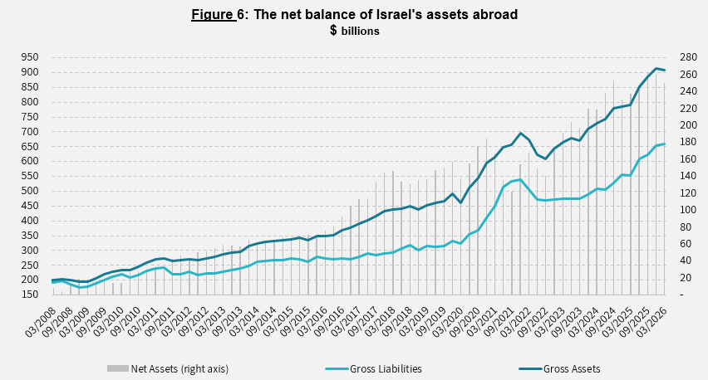
The decline in the balance of assets and the increase in the balance of liabilities led to a decline of about $11 billion (4 percent) in the economy’s surplus of assets over liabilities vis-à-vis abroad, which was $250 billion at the end of March (Figure 6).
Source: Bank of Israel data and processing¹.

4. Israel’s surplus of assets over liabilities vis-à-vis abroad in debt instruments alone
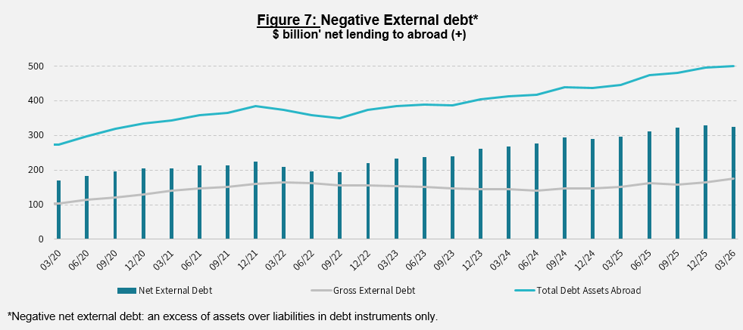
The surplus of assets over liabilities in debt instruments alone (negative net external debt) declined by about $5 billion (1.5 percent) during the first quarter, to $325 billion at the end of March (Figure 7).
The balance of assets in debt instruments increased by $5 billion in the first quarter, to around $500 billion, of which about $230 billion are the Bank of Israel’s foreign exchange reserves. This balance reflects a coverage ratio of 3 times the gross external debt.
Source: Israel’s Ministry of Finance, and Bank of Israel data and processing.

For the complete data file, click here.

Bank of Israel data and processing: The Bank of Israel’s Information and Statistics Department collects data from numerous varied sources. Most of the data on the economy’s activity vis-à-vis abroad are received by force of a Bank of Israel Order, from direct reports by corporations and individuals to the Bank of Israel. (See: Information Regarding Foreign Exchange Market Developments in Israel, 5770–2010). Additional data used for measuring economic activity vis-à-vis abroad are received by reports from the Bank of Israel’s Accounting Division, the Ministry of Finance, the Central Bureau of Statistics, the Israel Securities Authority, domestic banks and other financial intermediaries, and institutional investors. The Department carries out estimations and processing on data received from the various sources.

